AFA Rule Notification No. 72 - December 2018.

This Notification deals with:

- Rule changes re Fouling in the ring;

- Rule changes to allow introduction of ulna measuring system;

- Amendment to Rule 4.3 (e) to increase Preferred ring length from 110 ft to 120 ft.

- Change in wording to replace “Competition” with “Race Meeting” wherever it appears in Rules.

Fouling in the ring (On Trial from 1st January 2019) – amended wording as shown below:

Amendment to Rule 7 (f)

(f) Forfeit for Infringement of the Rules of a Race Meeting.
A team will forfeit a heat of a race in which any of the following infringements apply:
  - Second or subsequent incident of “distraction” during a race (refer 9.2 (k))
  - Second malfunction of box during a race or claimed malfunction not agreed by Judge or malfunction with no replacement box available (refer 9.2 (d))
  - Box loader infringement (refer 9.2 (h))
  - Training in the ring except for practice run period or approved re run after interference (refer 8 (c))
  - Team jumping incorrect height in a round robin Race Meeting format (in this case the team forfeits all heats run at the incorrect jump height (refer 9.1 (b))
  - A dog fouls (defecates or urinates) in the ring. If the fouling occurs during a heat, the dog’s team forfeits that heat. If the fouling occurs before a heat (including during the warm up period), the dog’s team forfeits the next heat.
  - Sandbagging. Note: this applies to the entire race (refer 9.5).
In all of the above heat forfeit situations except box malfunction (ii) (above) both teams (if present) shall run or complete the heat. The forfeiting team cannot win or receive title points. All other Rules of Race Meeting apply. For Item (ii) Second box malfunction or no fault found with box, the unaffected team shall be awarded one title point for each run so affected except where they have completed their run before the heat was stopped. In this case they shall be awarded points in accordance with the Rules of Race Meetings.

Amendment to Rule 9.2 (f) - If a dog fouls (defecates or urinates) in the ring at any time from the commencement of the warm up period for a race until the last heat of the race is declared by the Judge the dog’s team will forfeit a heat in accordance with Section 7(f).”

- The above changes clarify both the offence and the penalty associated with fouling in the ring. It should be noted that where a dog fouls after the last heat of the race has been declared there is no penalty applied.

2. Ulna Measuring System - change to Rules.

The Membership voted to adopt the ulna measuring system at the 2018 AGM and an associated conversion chart. This change has involved a major rewrite of the Rules involving measuring and height cards and the development of a suitable ulna measuring tool for conversion of the dogs ulna leg measurement to a jump height. The revised Rules and amendments to Height Card application forms will be available on the AFA Web site by Mid- December and the introduction date is provisionally set for competitions scheduled from 1st January 2019 onward. Changes to the Rules involve the following Sections of the Rules 2.7 Definitions; 3.3 Jumps; 6.1 to 6.5, 7 (f), 9.1 and Appendix F.
In an effort to assist members to understand the main changes involved the following questions and answer are provided:
Q How will dogs jump heights be decided in future; A - by measuring the ulna leg length and converting the length to the appropriate jump height using the following conversion table:
Dog Jump Height Measurement Chart
Ulna Length | Jump Height
Up to 5" | 7"
Over 5" up to 5 ½ " | 8"
Over 5.5" up to 6" | 9"
Over 6"up to 6 ½" | 10"
Over 6.5" up to 7" | 11"
Over 7" up to 7 ½" | 12"
Over 7.5" up to 8" | 13"
Over 8" | 14"

Q Who will be able to measure dogs –A. the plan is to have all Judges equipped with measures as quickly as is possible. Immediate plans are aiming to have one measure available in every State by mid- January. Measuring will be witnessed by a second official – another Judge, AFA Rep or Committee member. At least one of the officials must be from a different club to that of the dog being measured.
Q Under the new Rules do I have to get my dog measured – A – no – its up to you to decide if you should get your dog measured. If your dog is unlikely to ever be a team height dog then there is no need to measure – but it’s up to you.
Q When will the new Rules be up on the web A – it is hoped to have the new version of the Rules available on the web by mid- December.
Q When will the new Rules start – the current plan is to aim for a 1st January implementation – we should know if that is achievable within next two weeks when we hope to have initial measure tools available.
Q If I have paid for a height card under the old system will I be charges again for a new card – A No – where a member has an existing height card the new card will be issued at no charge.
Q How many measures will my dog need to get a height card A. – one measure only – of both ulnas and with the shortest ulna being used for the conversion.
Q How old must my dog be to get a measure – A 18 months if age known or at least 12 months after started racing if age not available.
Q What should I put on any entry form as my dog’s height if it has not been officially measured. A. In the same way that dog’s heights are determined by a member under the old system – the member should consult club instructors or take they own measure.
Q Will clubs be able to purchase official measure tools in order to assist members. A. Yes that is planned once we have sufficient measures to equip all Judges.
Q Will there still be a challenge process if a dog does not seem to be jumping the correct height A. Yes - a process similar to the prior challenge process will apply.
Q Where is the ulna bone – A. It’s the bone that runs from the elbow to the wrist. 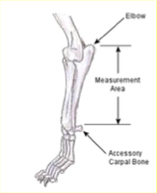
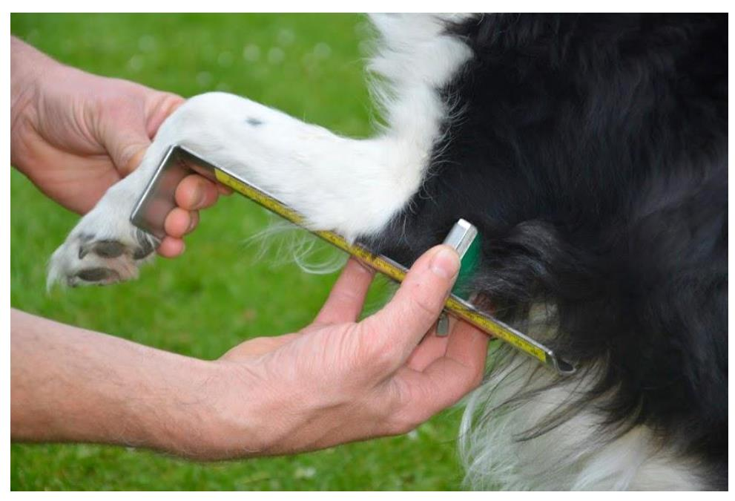

Q Will a new Jump Height Application Form be available for members to use A. yes – the new Form should be available on the web shortly.
Q Will I have to wait till I enter the first competition after 1st January 2019 to get my dog measured. A – the Committee is planning to schedule at least one “ Measuring day” in each state as early as possible in 2019 in order to avoid potential delays at the start of early competitions in 2019
3.Rule 4.3 e Preferred ring size – The preferred ring length has been amended from 33.5 m (110 ft) to 36.6 m (120 ft) effective from 1st January 2019. This is designed to ensure a preferred run back length of at least 65 ft can be achieved. Competition organisers are encouraged to ensure an appropriate run back length - with a minimum of around 65 ft being seen as reasonable.

4. The Committee adopted a decision in 2018 to progressively amend all references to flyball COMPETITIONS with the new wording Race Meeting. The opportunity is now being taken to do the amendment to the total Rules document. This is purely an editorial change.

