AFA Form C-5 AFA Judge’s Application – ver 07th March 2017

Australian Flyball Association Inc.
PO Box 4179, Pitt Town,
NSW 2756

Judge’s Application

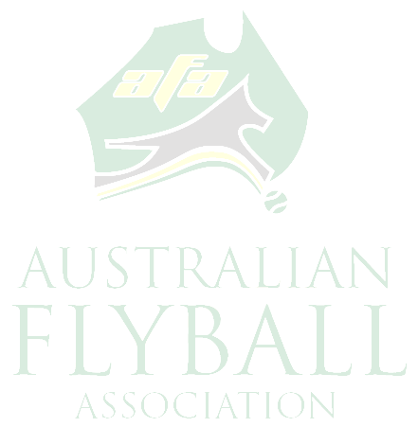
Name:

Address:

Telephone: Fax:

Mobile: Email:

Brief Description of Qualifications:

The above applicant has demonstrated his/her understanding of the Rules and Policies of the Australian Flyball Association Inc.

I/We recommend that the Australian Flyball Association Inc. approve the applicant for AFA judging assignments.

Provisional Judging Assignments:

Race Meeting Race Meeting Organiser Date_________________________ ____________________
________________________ ____________________ ________________________ ____________________

Comments:

AFA use only:
Approved by: Date: / /

