AFA Form C-14: Weekly Training Log (Ver: 08 March 2017)
AUSTRALIAN FLYBALL ASSOCIATION INC.
WEEKLY TRAINING LOG

DOG NAME: | CRN: | HANDLER’S NAME: | DATE:

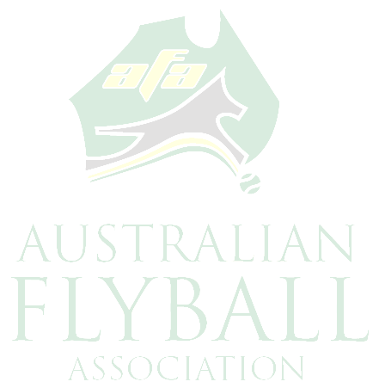
SPECIFIC PROBLEM: ______________________________________________________________

FLYBALL TRAINING PROGRAM

Frequency of Training: ____________ No. of hours: ____________ Total per week: ___________

Training Location: _________________________________________________________________

Training Supervisor 1 ________________________ Supervisor 2 ____________________________

Training Objectives: ________________________________________________________________

Procedures followed: _______________________________________________________________

Were distractions used? NO / YES if Yes, explain details _____________________________

Independent Observer: ____________________________________________________________

Experience: _____________________________________________________________________

Observations: ____________________________________________________________________

________________________________________________________________________________

Please complete all details and forward to:
Australian Flyball Association Inc. PO Box 4179, Pitt Town, NSW 2756

