AFA Form C-11: Judge’s Report Form (Ver: 07 March 2017)
AUSTRALIAN FLYBALL ASSOCIATION INC.
INCIDENT REPORT FORM
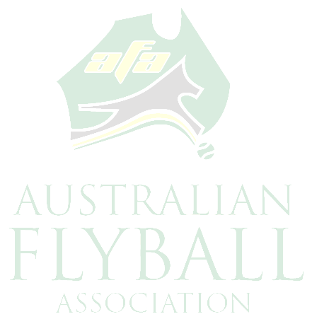

Race Meeting ………………………………………………………..………. Date ……..…………

Host Club …………………………………..………. Judge ……………..………………………..

Competitors Details:

Name ……………………………………………………………………………..

CRN …………………………. Dogs Name ………………………………….

Race Division ………….………. Race No. ………..…. Heat No………………….

Type of Incident
Interference Suspected Aggression Aggression

Other ……………………………………………………………………..

Action Taken ……………………………………………………………………………………..

Injury
Human Dog None
(If Human or Dog Injury please complete additional Injury Form)

AFA Rep. Advised Yes No Host Club advised Yes No

Description of Incident

……………………………………………………………………………………………………….

………………………………………………………………………………………………………

………………………………………………………………………………………………………

………………………………………………………………………………………………………

………………………………………………………………………………………………………

………………………………………………………………………………………………………

………………………………………………………………………………….…………………..

………………………………………………………………………………………………………

Judges Signature…………………………………….. Date …………………………………
(This report form must be forwarded to AFA Secretary within 48 hours of Incident or handed to the AFA Representative on the day of the Incident)
(One Incident form per dog per Race Meeting for Interference Only – either one, two or three offences)

Particulars of Human Injury

Name:
Age | Sex: | Mem#:
Nature of injury:
Sprains/Strains Contusion (Bruise) Concussion Abrasion/Open wound Amputation
Fracture Dislocations Burns/scold Exposure to elements
Psychological disorder/Stress Object in eye
Other………………………………………………………………….
Part/s of
body injured Side of Body Region Internal or External Injury

Head Left Right Back Front Internal External
Face Left Right Ear Nose Mouth Jaw Internal External
Eye Left Right Sight effected Yes No Internal External
Torso Left Right Upper Lower Internal External
Abdomen Left Right Upper Lower Internal External
Back Left Right Upper Lower Internal External
Arm Left Right Upper Lower Internal External
Hand Left Right Back Palm Finger/s Internal External
Leg Left Right Upper Lower Internal External
Buttocks Left Right Upper Lower Internal External

First Aid and Medical Treatment

Did you require any medical treatment?
First Aid Only General Practitioner Consulted Hospital Emergency/Out-patient
- Hospital In-Patient
Other, please specify:

First Aid treatment provided by,
Name:
Address:
Details of treatment:

Name of person making entry:
Signature: Date:

Particulars of Dog Injury (if more than 1 dog injured print this page again)

Dogs Name: | Breed:
Age | Sex: | Crn:
Nature of injury:
Sprains/Strains Contusion (Bruise) Concussion Abrasion/Open wound
Amputation Fracture Dislocations Object in eye Puncture
Other…………………………………………………………………………………………
Part/s of
body injured Side of Body Region Internal or External Injury

Head Left Right Ear Back Front Internal External
Muzzle Left Right Nose Mouth Jaw Internal External
Eye Left Right Internal External
Torso Left Right Upper Lower Internal External
Abdomen Left Right Upper Lower Internal External
Back Left Right Upper Lower Internal External
Rear Legs Left Right Upper Lower Internal External
Paws Left Right Pad Claw Internal External
Front Legs Left Right Upper Lower Internal External
Tail Internal External

First Aid and Veterinary Treatment

Did the dog require any veterinary treatment? Yes No
First Aid Only
Name of Veterinary Clinic/ Hospital & Veterinarian:

Other, please specify:

First Aid treatment provided by,
Name:
Address:
Details of treatment:

Name of person making entry:
Signature: Date:

Additional information has been attached NO YES, Number of pages attached:………….

Please attach any additional Information you have not already included:
Note: All documentation must be received by the AFA Secretary within 48 hours of the
completion of the Race Meeting or demonstration.

