AFA Form C-10: Title Redemption Form – ver. 8th march 2017

Australian Flyball Association Inc.

Title Redemption Form

- Dogs must have a current Financial CRN
- Please complete all details and forward with appropriate fee to:
Australian Flyball Association Inc.
PO Box 4179,
Pitt Town, NSW 2756
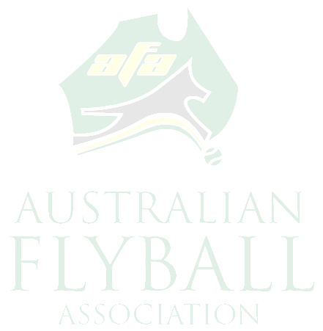
Name:

Address:

State: Postcode:

Membership #: Exp Date: CRN#:

Dog’s Name:

TITLE APPLIED FOR:

Certificate: $10.00 each. Please circle Certificate(s) required.

FD FDX FDCh AFCh FM FMX FMCh ONYX FDGCh Jeddah Award
Ezri Award

Title Pins: $15.00 each

FM FMX FMCh ONYX FDGCh Jeddah Award Ezri Award

Single Title Plaques $60.00 each – please circle the plaque required

ONYX FDGCh Jeddah Award Ezri Award

Multi Title Plaque: $60.00 each (including first Shield). All other Shields $5.00 each.
Please circle Shield(s) required.

FD FDX FDCh AFCh FM FMX FMCh ONYX FDGCh

Jeddah Award Ezri Award

Signature: Date:

AFA Use only:
Date Received: / / Amount Received: $ Receipt No:

www.flyball.org.au

