The Australian Flyball Association Inc.
(AFA)

The AFA was formed on the 13th October 1996 by a few loving dog owners. They adopted the rules of the North American Flyball Association (NAFA) to get them started.

Their main objective was to have as much fun as possible with their dogs and to promote responsible dog ownership through showing people how much fun the sport of flyball can be.

When you see the excited faces of the handlers and dogs that are racing together in teams it will definitely make you want to join in with Flyball at your local club.

Contacting the AFA is as easy as going to our website www.flyball.org.au or
Mail: PO Box 4179
Pitt Town, NSW 2756
Flyball Club Contacts
For more information about flyball in your area, please contact one of our Regional Representatives.

Australian Capital Territory
Carolyn Shrives
Email: act@flyball.org.au
New South Wales
Louise Stephen
Email: nsw@flyball.org.au
Queensland
Candice Leighton
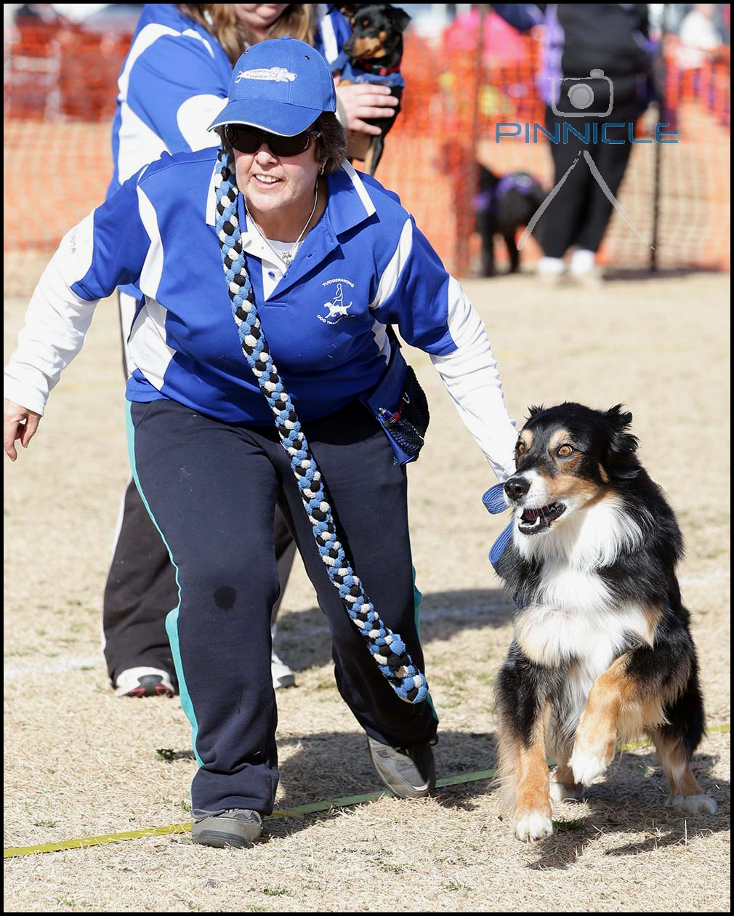
Email: qld@flyball.org.au
South Australia
Martin Watt
Email: sa@flyball.org.au
Victoria
Josh Ellen
Email: vic@flyball.org.au
Tasmania
Helen Strong
Email: tas@flyball.org.au

Clubs by State
A list of clubs by state is available on the AFA website:
http://www.flyball.org.au/find-a-club/

Selected Photos by Pinnicle Photography
www.pinnicle.com.au


The
Australian Flyball Association Inc.
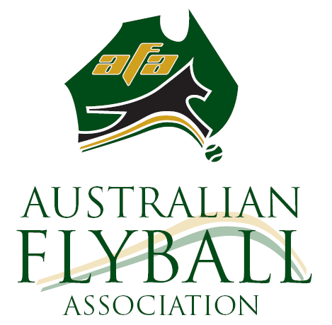
would like to introduce you to the
amazing sport of Flyball Racing.
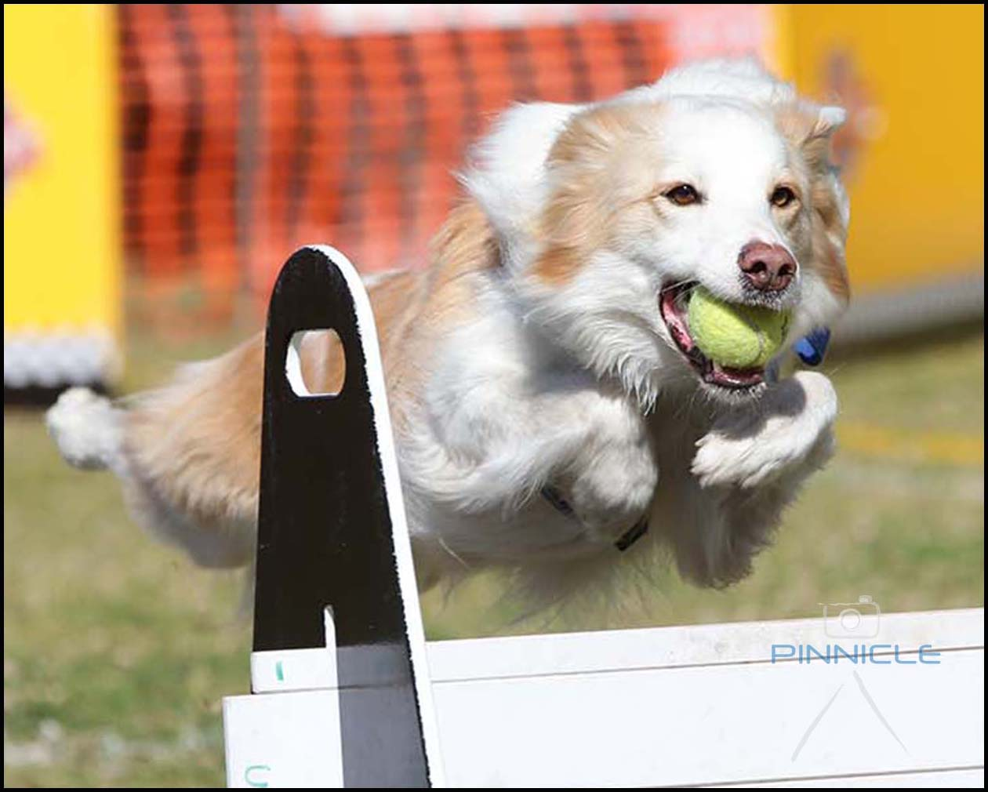

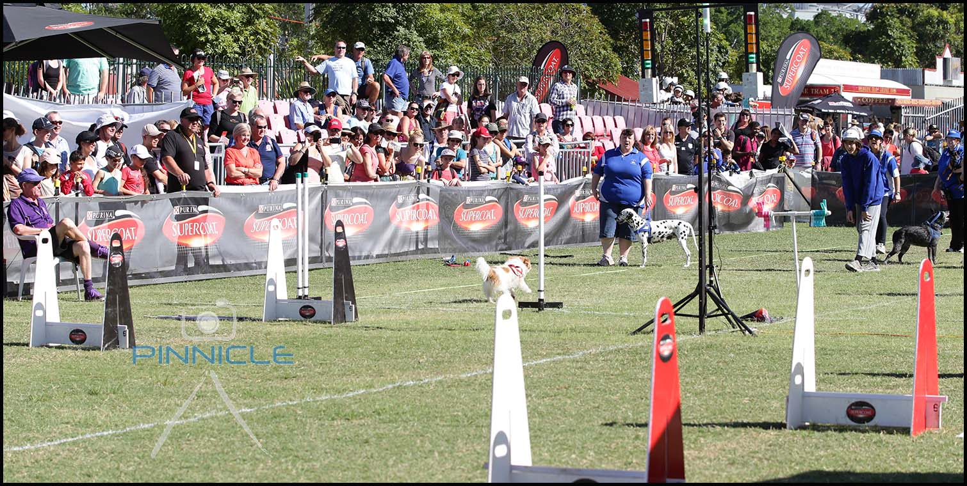
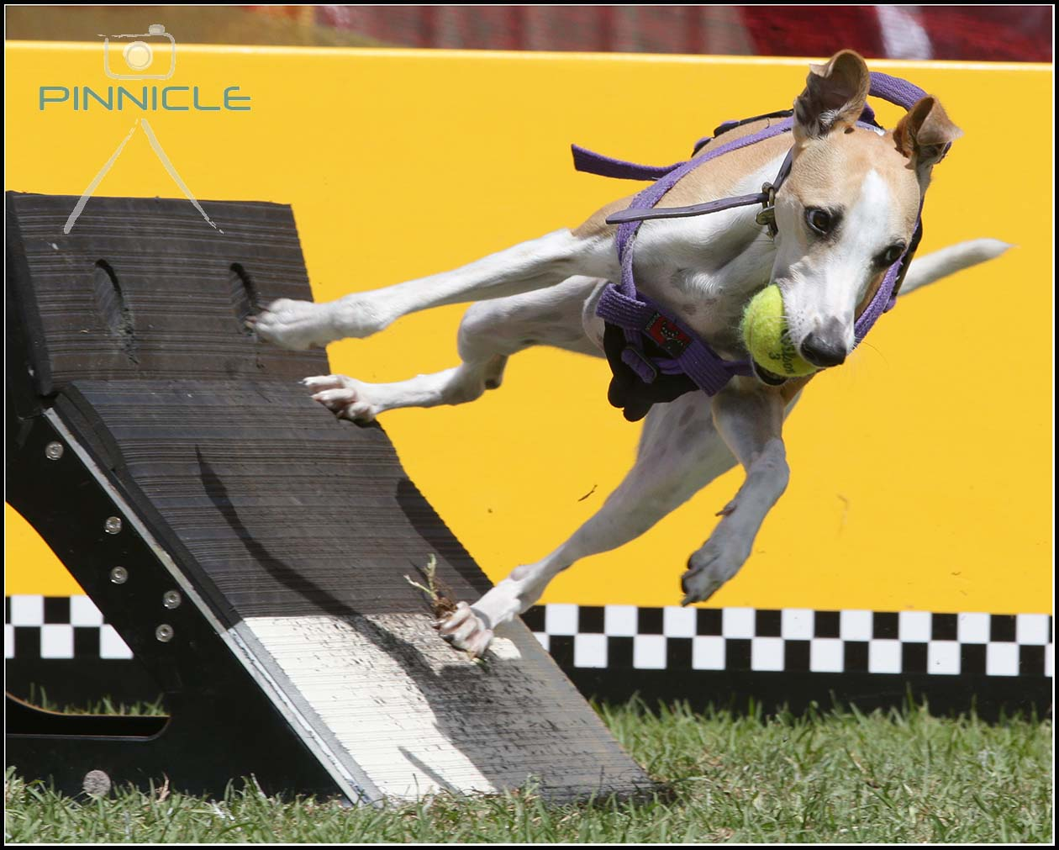

What is Flyball Racing?
Flyball racing is a relay race between two teams; each team has four dogs racing in a heat, with up to two reserve dogs eagerly awaiting their turn, ‘they could get their chance in the next heat’. There can be 3 or 5 heats to a race.
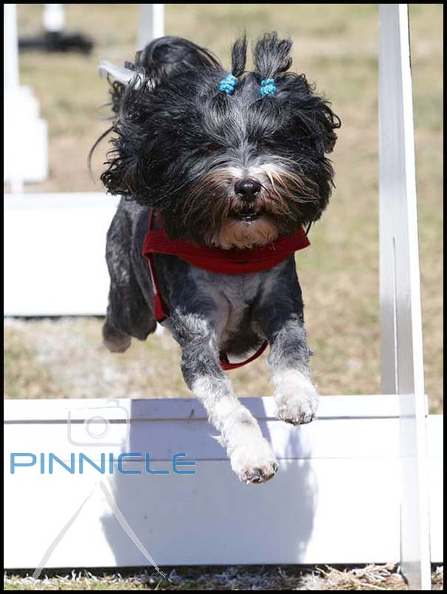
There are two racing lanes set up with as little as a 10 foot space between each lane. In the centre of the racing lanes there is a set of drag racing lights waiting to do the count down for the start of each heat. When the last light turns green the dogs are off and racing (they mustn’t cross the start/finish line until the light is green otherwise they receive a foul).

They must run as fast as their can for the first 51 feet of the course, they will have to jump four
hurdles one by one (hurdle height is set at 5 inches lower than the shoulder height of the smallest dog in the team, minimum of 7 inches and maximum of 14 inches) spaced 10 feet apart then 15 feet from the last hurdle is a flyball box with a tennis ball in it. The dogs leap onto the box to do fancy swimmers turn and at the same time the box releases the ball

which the dog has to catch on the run. The dog then races as fast as they can back over the 4 hurdles to its handler who is usually jumping up and down, waving arms above their head encouraging their dog all they way. As soon as the first dog crosses the start/finish line with its nose the next dog is off and racing.

The first team to have all four of their racing dogs complete their runs cleanly wins the heat.

Every dog can do Flyball. It can vary significantly on how long it takes to train your dog to be ready for its first competition based on the dog's previous training and breed.

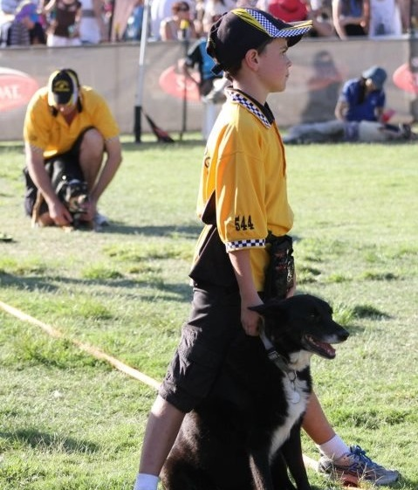

When did this sport begin?
Flyball had it beginnings in North America in the early 1970’s when Californian Herbert Wagner, developed a tennis ball launcher to keep his ball mad dog amused.

He then gave a demonstration of his tennis ball launcher on the Tonight show. Then with rules said to have come from scent hurdling he introduced his idea by giving demonstrations in Toronto and Detroit areas. The very first competition was held in 1983 in North America. The earliest known Flyball activity in Australia was in 1982 in Perth (WA).

Now flyball is played in North America, Britain, Belgium, Japan, Germany, South Africa, Poland, Netherlands, Italy, Canada and Australia, with more than 20,000 eager dogs and more than 4,000 teams actively competing in competitions.

Where is Flyball Today?

In Australia today we have over 600 dogs and handlers enjoying the sport. Flyball is a family friendly sport where every member of the family can participate. Not only do teams need dogs and handlers but they also need Ball Shaggers, Box Loaders, Statisticians, Team Managers and Stewards. The AFA supports juniors by offering a junior membership.



