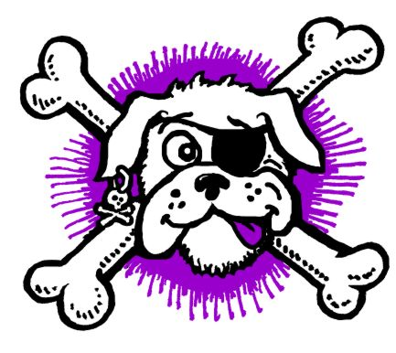

Sydney Scallywags Flyball Incorporated

SKULL AND CROSSBONE COMPETITION

Sun 23 Oct 2022

Location | Princes Park. Princes Road West Auburn
Check in | 7:30 a.m.
Judges briefing | 8.00 a.m
Racing commences | 8:30 a.m.

Judges | Frank Lux, Philip Lea, Shell Gurney
Timekeepers | Gavin Bland and Richard Mellon
AFA rep | Karen Bland
Competition Organiser | Jenni Redmond
Competition Secretary | Jenni Redmond
Helpers/Assistants | All of Sydney Scallywags

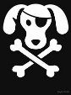 PARKING ON GRAVEL ONLY.
We suggest to bring a trolley
Big shout out to Cumberland City Council,
who have been supporters of
Sydney Scallywags for many years
Thank you

.

Nearest Vet
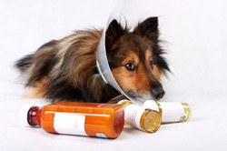

Auburn Veterinary hospital  107A Park Rd, Auburn 2144 ·  0296496333  Opening Hours  Saturday 9:00 AM - 1:00 PM Sunday 9:00 AM - 12:00 PM | Fairford Rd Animal Hospital  2 Short St, Bankstown 2200  02 9709 6844  Open Hours  Mon-Fri: 9am-7pm Sat-Sun: 9am-12noon | Animal Referral Hospital  250 Parramatta Road, Homebush West 2140 ·  0297588666  Open 24 hours

A special mention to Sydney Scallywags supporting vet clinic.
Address: 392 Woodstock Ave, Rooty Hill NSW 2766
Phone: (02) 9625 0981
Hours: Open ⋅ Closes 6:30PM

RAFFLE TICKETS
Please purchase our raffle tickets for a chance to win your share of $1000’s worth of prizes from many of the following sponsors
Tickets prices will be announced
A POS ‘square reader’ will be available for the raffle only if cash is not available

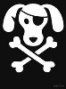 SPONSORS
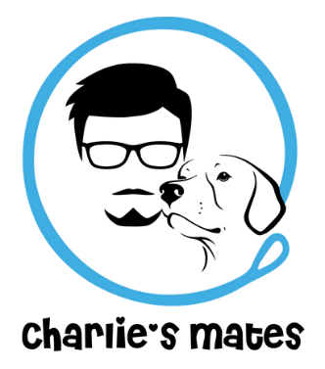  charliesmates.com.au  dog grooming, dog walking services etc | Holiday accommodation  dcsmadra.com.au
www.rainbowdogtugs.com.au | 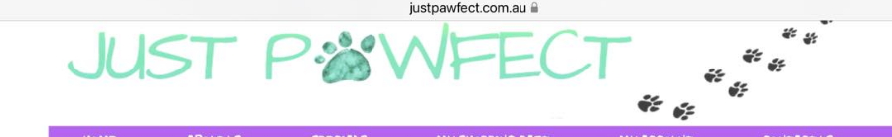  www.justpawfect.com.au
kongs.com.au | 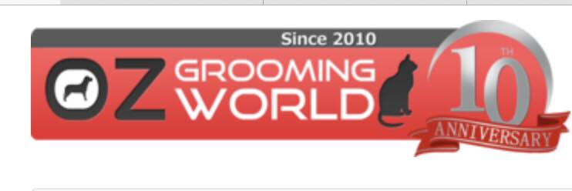  ozgroomingworld.com.au
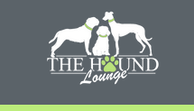  www.thehoundlounge.com.au | www.bendigodps.com.au
www.smartpettreats.com.au
ezydog.com.au | 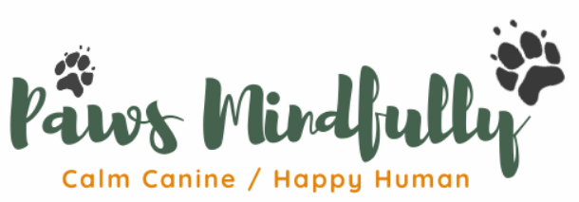  www.pawsmindfully.com.au
fitnflash.com.au | eacanimalcare.com
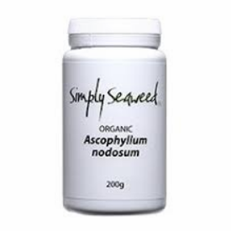  www.simplyseaweed.com.au | prime100.com.au
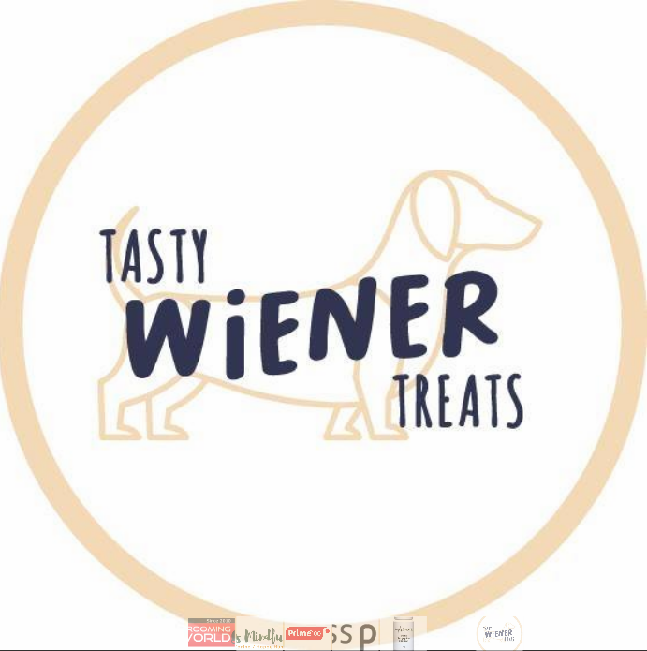  tastywienertreats.com.au | www.ruthlessphotos.com

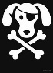 CATERING BY

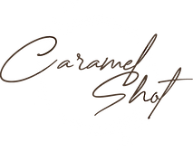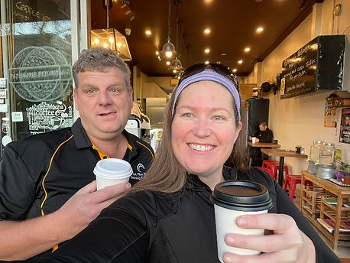
kick off from 7:30am!
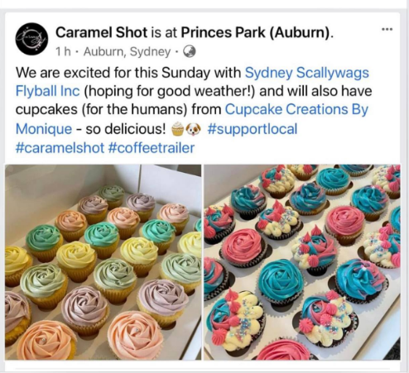

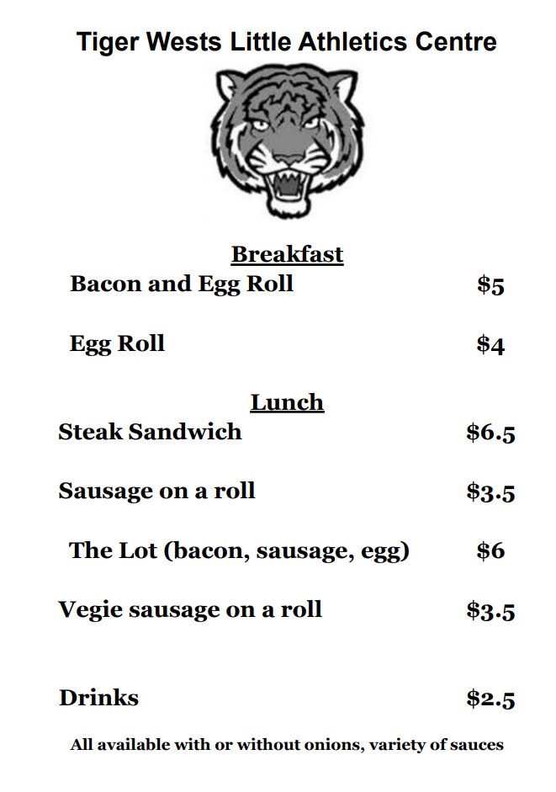

Thank you to all the teams who have attended and supported Sydney Scallywags first Sydney Competition.

LUNCH TIME TRAINING IN THE RING
Time will be available for training in the ring To be advised for each session on the day.

RULES AND REGULATIONS
• All racing will be conducted under the Rules and Regulations of the Australian Flyball Association.
• Count Back Rule will apply at the end of the day in the event of a tied placings as per the AFA Rules and Regulations.
• Stewarding - All teams are to help with stewarding throughout the day to ensure smooth running of the competition.
• Changeover Times - 90 seconds
• All competitors are required to pick up after their dogs and dispose of in the bins provided.
• All competitors are asked to help with the pack down of the ring at the end of the day.

DIVISION SPLITS AND RUNNING ORDER

Division | Team Name | Web Time | Dec Time | Seed Time | Breakout | Div Gap | Format | Races per team | Races per division
1 | Norwest Thunderdogs 1 | 16.198 |  | 16.198 | 15.698 | 1.874 | Handicapped | 6 | 9
1 | Norwest Thunderdogs 3 | 17.656 |  | 17.656 | 17.156 |  | Best of 5
1 | Norwest Thunderdogs 4 | 18.072 |  | 18.072 | 17.572 |  | Triple RR
2 | Primed Up Woofers | 18.230 |  | 18.230 | 17.730 | 1.047 | Regular | 6 | 9
2 | Unleashed Force |  | 18.500 | 18.500 | 18.000 |  | Best of 5
2 | Norwest Thunderdogs 5 | 19.277 |  | 19.277 | 17.730 |  | Triple RR
3 | Unleashed Speed |  | 19.900 | 19.900 | 19.400 | 1.597 | Handicapped | 6 | 12
3 | Wooftimus Prime | 20.074 |  | 20.074 | 19.574 |  | Best of 5
3 | Star Burst | 20.828 |  | 20.028 | 19.528 |  | Double RR
3 | Norwest Thunderdogs 6 | 21.497 |  | 21.497 | 20.997
4 | Norwest Thunderdogs 7 |  | 23.750 | 23.750 | 23.250 | 6.156 | Handicapped | 6 | 9
4 | Munchkins |  | 26.492 | 26.492 | 25.992 |  | Best of 5
4 | Primal Woofers | 29.906 |  | 29.906 | 29.406 |  | Triple RR
O1 | The Panzers |  | 19.2 | 19.2 | 18.70 | 7.8 | Handicapped | 6 | 12
O1 | Zoomies |  | 21.01 | 21.01 | 20.50 |  | Best of 5
O1 | MAD Flyers |  | 25.1 | 25.1 | 24.60 |  | Double RR
O1 | Flyball Friends |  | 27 | 27 | 26.50
 |  |  |  |  |  |  |  | Total races | 51

Race # | Div
1 | Open | Flyball Friends | MAD Flyers | Handicap
2 | Open | Zoomies | The Panzers | Handicap
3 | 3 | Star Burst | Wooftimus Prime | Handicap
4 | 3 | Unleashed Speed | Norwest Thunderdogs 6 | Handicap
5 | 1 | Norwest Thunderdogs 1 | Norwest Thunderdogs 4 | Handicap
6 | 2 | Unleashed Force | Primed Up Woofers | Regular
7 | 4 | Munchkins | Norwest Thunderdogs 7 | Handicap
8 | Open | The Panzers | Flyball Friends | Handicap
9 | 3 | Norwest Thunderdogs 6 | Star Burst | Handicap
10 | 1 | Norwest Thunderdogs 4 | Norwest Thunderdogs 3 | Handicap
11 | 2 | Norwest Thunderdogs 5 | Unleashed Force | Regular
12 | 4 | Norwest Thunderdogs 7 | Primal Woofers | Handicap
13 | Open | MAD Flyers | Zoomies | Handicap
14 | 3 | Unleashed Speed | Star Burst | Handicap
15 | 1 | Norwest Thunderdogs 3 | Norwest Thunderdogs 1 | Handicap
16 | 2 | Primed Up Woofers | Norwest Thunderdogs 5 | Regular
17 | 4 | Primal Woofers | Munchkins | Handicap
18 | Open | Zoomies | Flyball Friends | Handicap
19 | 3 | Norwest Thunderdogs 6 | Wooftimus Prime | Handicap
20 | 1 | Norwest Thunderdogs 4 | Norwest Thunderdogs 1 | Handicap
21 | 2 | Norwest Thunderdogs 5 | Unleashed Force | Regular
22 | 4 | Munchkins | Norwest Thunderdogs 7 | Handicap
23 | Open | MAD Flyers | The Panzers | Handicap
24 | 3 | Unleashed Speed | Wooftimus Prime | Handicap
25 | 1 | Norwest Thunderdogs 4 | Norwest Thunderdogs 3 | Handicap
26 | 2 | Primed Up Woofers | Norwest Thunderdogs 5 | Regular
27 | 4 | Munchkins | Primal Woofers | Handicap
28 | Open | MAD Flyers | Zoomies | Handicap
29 | 3 | Norwest Thunderdogs 6 | Unleashed Speed | Handicap
30 | 1 | Norwest Thunderdogs 3 | Norwest Thunderdogs 1 | Handicap
31 | 2 | Primed Up Woofers | Unleashed Force | Regular
32 | 4 | Norwest Thunderdogs 7 | Primal Woofers | Handicap
33 | Open | Flyball Friends | MAD Flyers | Handicap
34 | 3 | Star Burst | Norwest Thunderdogs 6 | Handicap
35 | 1 | Norwest Thunderdogs 1 | Norwest Thunderdogs 3 | Handicap
36 | 2 | Norwest Thunderdogs 5 | Primed Up Woofers | Regular
37 | 4 | Norwest Thunderdogs 7 | Munchkins | Handicap
38 | Open | The Panzers | Flyball Friends | Handicap
39 | 3 | Wooftimus Prime | Star Burst | Handicap
40 | 1 | Norwest Thunderdogs 3 | Norwest Thunderdogs 4 | Regular
41 | 2 | Unleashed Force | Primed Up Woofers | Regular
42 | 4 | Primal Woofers | Munchkins | Handicap
43 | Open | Zoomies | The Panzers | Handicap
44 | 3 | Wooftimus Prime | Unleashed Speed | Handicap
45 | 1 | Norwest Thunderdogs 1 | Norwest Thunderdogs 4 | Handicap
46 | 2 | Unleashed Force | Norwest Thunderdogs 5 | Regular
47 | 4 | Primal Woofers | Norwest Thunderdogs 7 | Handicap
48 | Open | Flyball Friends | Zoomies | Handicap
49 | Open | The Panzers | MAD Flyers | Handicap
50 | 3 | Star Burst | Unleashed Speed | Handicap
51 | 3 | Wooftimus Prime | Norwest Thunderdogs 6 | Handicap

