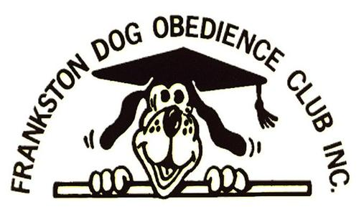
ON THE FLY - FLYBALL COMP
MENU 2018

HOT FOOD:
Roast Beef Roll w/ chips & gravy
Fish & Chips
Southern Fried Chicken w/ chips

CAKES:
Jaffa Cheesecake
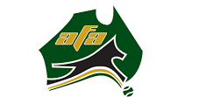
Key Lime Pie
$5.00
$6.00
$5.00

$2.50
$2.50
$2.00
$2.50
Wagon Wheel Slice
Salted Caramel Chocolate Tart

REGULAR FDOC MENU IS STILL AVAILABLE

ALL OFFICIALS ARE FREE OF CHARGE

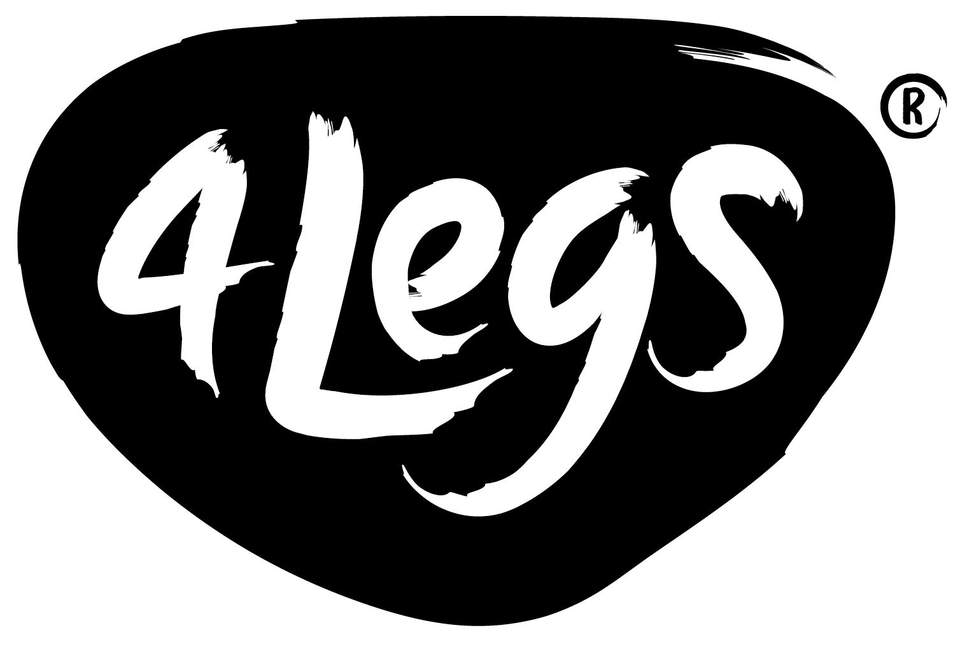
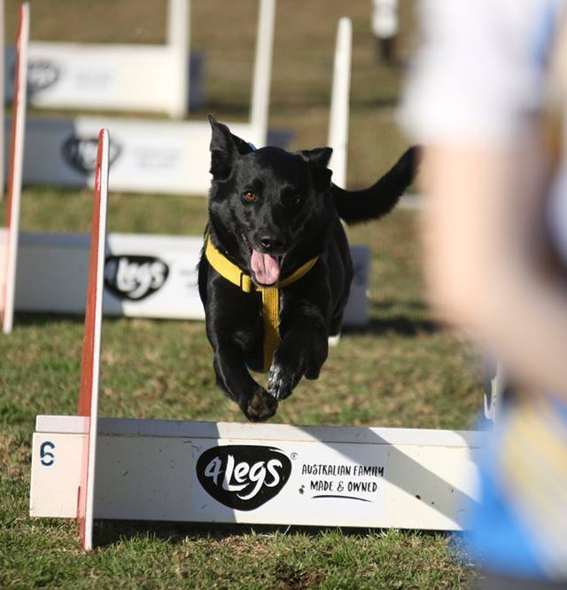
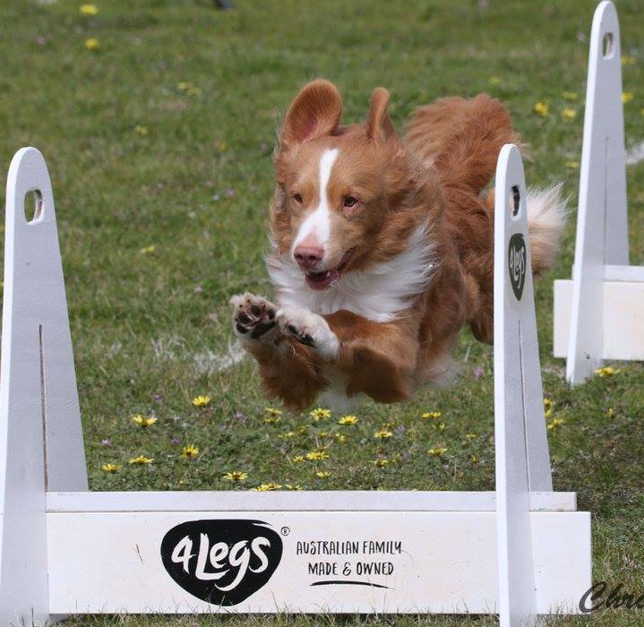
THANK YOU TO OUR SPONSORS, 4LEGS DOG FOOD

