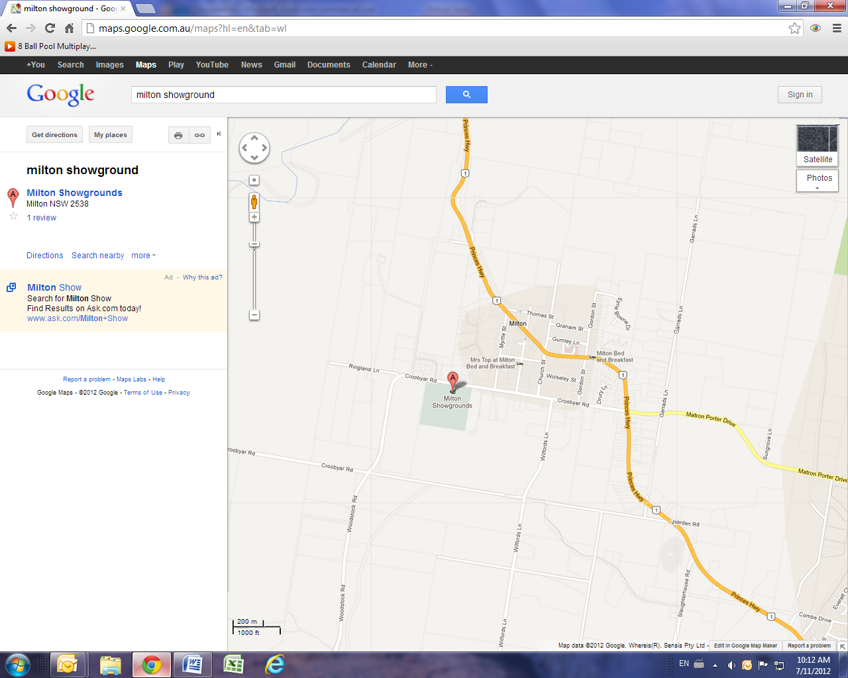
To Sydney
from Ulladulla

