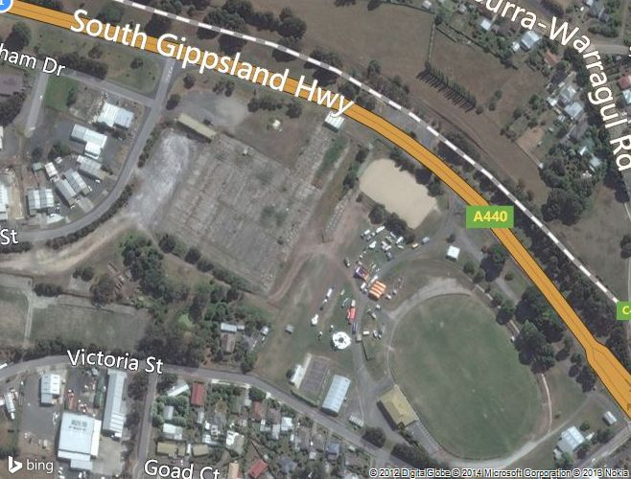

Parking

Sanders St

Gate Entry