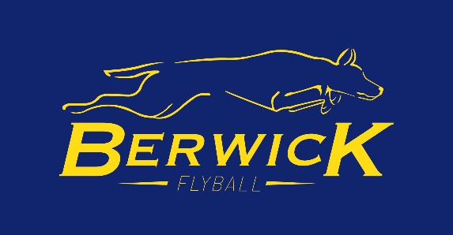

**Frankston Storm and Berwick Flyball Teams Welcome you to the Double Trouble Halloween Pairs Competition**

**Dress up in your Halloween gear or as yourself (whichever is scarier)**

**May be prizes up for grabs**

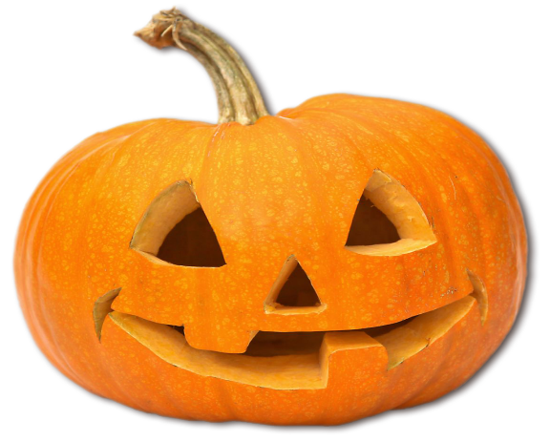

**Sunday 27th October 2024**

**Frankston Dog Obedience Club**

**117 McClelland Drive Frankston**

**The competition will be run in accordance with the rules of the Australian Flyball Association**

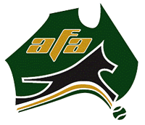

**Details**

**Check in Time 8.00am**

**Judges Briefing 8.30am**

**Racing Commences 9.00am**

**Judges Ula Lane and Josh Ellen**

**AFA Representative Drew Harrison**

**Timekeepers Carly Sorenson, Deb Moody and Taylor Deardon**

**The Canteen will be open on the day for the usual Frankston Menu**

**Toilets are in the Frankston Clubrooms**

**Competitors are asked to park in the carpark and only cars with trailers are allowed on to the ground along the northern fence line only**

**Competitors may need to bring a trolley to move their equipment from the carpark or place equipment in their team trailers to be transported**

**Trailor entry is via the old gravel carpark**

**Frankston Dog Obedience Club and Frankston City Council thanks you for being respectful in your interactions with its members, facilities and grounds**

**We would like to thank all the volunteers that have made this competition possible**

**There will be 70 races on the day and because of this the warm up will be for 60 seconds**

**Please be ready to enter the ring as soon as the flag goes up so that we can finish the day at a reasonable time**

Local vet

Frankston Animal Emergency Centre

39 McMahons Road, Frankston VIC 3199, Australia Emergency Contact: 03 9770 5555 Opening hours: Open 24 hours

**Teams**

|  |  |  |  |  |  |  |  |  |  |  |  |  |  |
| --- | --- | --- | --- | --- | --- | --- | --- | --- | --- | --- | --- | --- | --- |
| **ETC** |  | **Grinners** | | | | | | | | | | | |
| Ellie | Rhiannon Wood | Cobber | | | | | James Wood | | | | | | |
| Harry | Drew Harrison | Sami | | | | | Marguerite Beasley | | | | | | |
| Twigs | Marie Schellekens | **M&M's** | | | | | | | | | | | |
| **MFC** | | Milo | | | | | Jessica Thompson | | | | | | |
| Taffy | Maryanne Kovach | Monty | | | | | Taylor Dearden | | | | | | |
| Celeste | Simon Bates | **The 2 M’s** | | | | | | | | | | | |
| Rosie | Jordyn Naylor | Mocha | | | | | Diane Gnieslaw | | | | | | |
| **GTR** | | Molly | | | | | Eva Zubcic | | | | | | |
| Fung Cha | Simon Bates | **Consistently Inconsistent** | | | | | | | | | | | |
| Flick | Brad Storen | Millie | | | | | April Smith | | | | | | |
| Karma | Jess Mitchell | Forrest | | | | | April Smith | | | | | | |
| **JRJ** | | Uma | | | | | Sally Laity | | | | | | |
| Jessie | Drew Harrison | **Dreamers** | | | | | | | | | | | |
| Rocky | Bree Mitchell | Tubs | | | | | Lynne Louziotis | | | | | | |
| Jasper | Jordyn Naylor | Minx | | | | | Kate Dunkley | | | | | | |
| **Eureka Rush** | | Tilly | | | | | Kate Dunkley | | | | | | |
| Sammi | Jenny Vandromme | **Firehearts** | | | | | | | | | | | |
| Ruby | Catrice Grahame | Kona | | | | | Brian Marsh | | | | | | |
| Steele | Sally Laity | Star | | | | | Lauren Dolley | | | | | | |
| **Spooky Howlers** | | Willow | | | | | Rachael Nahmias | | | | | | |
| Sarasota Zak | Shirelle Lean | **Snippy** | | | | | | | | | | | |
| Harli | Emma Arthur | Poppy | | | | | Matt Haines | | | | | | |
| **Fluffed Up** | | Switch | | | | | Sally Laity | | | | | | |
| Kurbie | Tiarne Moody | Ned | | | | | Sam Hartnett | | | | | | |
| Rydor | Debra Moody | **Intense Gremlins** | | | | | | | | | | | |
| Red | Jenni Veitch | Midge | | | | | Sam Hartnett | | | | | | |
| **Accell** | | Bailey | | | | | Ula Lane | | | | | | |
| Dexter | Lachlan Adams | Rogue | | | | | Matt Haines | | | | | | |
| Ziggy | Jacqui Walsh | **Bonkers for Balls** | | | | | | | | | | | |
| Quest | Kim Murrie | Rozz | | | | | Sam Hartnett | | | | | | |
| **Selbilovery** | | Bob | | | | | Lilly Knorr | | | | | | |
| Layla | Christine Slatter | Bailey | | | | | Paul Percival | | | | | | |
| Selby | Christine Slatter | **Chocolate Tornadoes** | | | | | | | | | | | |
| Avery | Katrina Coulson | Coco | | | | | Tony Rowland | | | | | | |
| **Kwik K9 Kaos** | | Riley | | | | | Tony Rowland | | | | | | |
| Cookie | Olive O'Shea | Poppy | | | | | Tony Rowland | | | | | | |
| Jesus | Josh Ellen |  |  |  |  |  |  |  |  |  |  |  |  |
| Joey | Aylah Dolley |  |  |  |  |  |  |  |  |  |  |  |  |

**Divisions**

|  |  |  |  |
| --- | --- | --- | --- |
| **Division Split** | **Seed** | **Racing** | **Format** |
| **Division 1** |  | Regular | Double round robin x 3 heats |
| Consistently Inconsistent | 8.2 |  |  |
| Intense Gremlins | 8.3 |  |  |
| Kwik K9's Kaos | 8.5 |  |  |
| GTR | 8.5 |  |  |
| JRJ | 8.5 |  |  |
| **Division 2** |  | Regular | Double round robin x 3 heats |
| Fluffed Up | 8.7 |  |  |
| ETC | 8.9 |  |  |
| Firehearts | 9 |  |  |
| Eureka Rush | 9.1 |  |  |
| M&M's | 9.2 |  |  |
| **Division 3** |  | Regular | Double Round Robin Best of 5 |
| Spooky Howlers | 9.6 |  |  |
| MFC | 10 |  |  |
| Snippy | 10 |  |  |
| Chocolate Tornadoes | 10 |  |  |
| **Division 4** |  | Regular | Triple Round Robin Best of 5 |
| Accell | 10.3 |  |  |
| The 2 M's | 10.3 |  |  |
| Bonkers for Balls | 10.6 |  |  |
| **Division 5** |  | Regular | Triple Round Robin Best of 5 |
| Selbilovery | 11.7 |  |  |
| Dreamers | 12 |  |  |
| Grinners | 12 |  |  |

**Running Order**

|  |  |  |  |  |  |
| --- | --- | --- | --- | --- | --- |
| **Race** | **Div** | **Left lane** | **Right Lane** | **Heats** | **Judge** |
| Race 1 | 2 | Eureka Rush | Firehearts | 3 | Ula |
| Race 2 | 2 | ETC | M&M's | 3 | Ula |
| Race 3 | 1 | Kwik K9 Kaos | Consistently Inconsistent | 3 | Ula |
| Race 4 | 1 | GTR | Intense Gremlins | 3 | Josh |
| Race 5 | 5 | Grinners | Selbilovery | Best of 5 | Josh |
| Race 6 | 4 | The 2 M's | Bonkers for Balls | Best of 5 | Josh |
| Race 7 | 3 | Chocolate Tornadoes | MFC | Best of 5 | Josh |
| Race 8 | 3 | Snippy | Spooky Howlers | Best of 5 | Ula |
| Race 9 | 2 | M&M's | Eureka Rush | 3 | Ula |
| Race 10 | 2 | Firehearts | Fluffed Up | 3 | Ula |
| Race 11 | 1 | GTR | Kwik K9 Kaos | 3 | Ula |
| Race 12 | 1 | JRJ | Consistently Inconsistent | 3 | Josh |
| Race 13 | 5 | Dreamers | Grinners | Best of 5 | Josh |
| Race 14 | 4 | Bonkers for Balls | Accell | Best of 5 | Josh |
| Race 15 | 3 | Spooky Howlers | MFC | Best of 5 | Josh |
| Race 16 | 3 | Snippy | Chocolate Tornadoes | Best of 5 | Ula |
| Race 17 | 2 | Eureka Rush | ETC | 3 | Ula |
| Race 18 | 2 | M&M's | Fluffed Up | 3 | Ula |
| Race 19 | 1 | Kwik K9 Kaos | JRJ | 3 | Ula |
| Race 20 | 1 | Consistently Inconsistent | Intense Gremlins | 3 | Josh |
| Race 21 | 5 | Selbilovery | Dreamers | Best of 5 | Josh |
| Race 22 | 4 | Accell | The 2 M's | Best of 5 | Josh |
| **Break** ( Ballarat 10, Berwick 10) | | | | | |
| Race 23 | 2 | ETC | Firehearts | 3 | Josh |
| Race 24 | 2 | Fluffed Up | Eureka Rush | 3 | Josh |
| Race 25 | 1 | Intense Gremlins | Kwik K9 Kaos | 3 | Josh |
| Race 26 | 1 | JRJ | GTR | 3 | Josh |
| Race 27 | 5 | Selbilovery | Grinners | Best of 5 | Ula |
| Race 28 | 4 | Bonkers for Balls | The 2 M's | Best of 5 | Ula |
| Race 29 | 3 | Spooky Howlers | Chocolate Tornadoes | Best of 5 | Ula |
| Race 30 | 3 | MFC | Snippy | Best of 5 | Ula |
| Race 31 | 2 | Firehearts | M&M's | 3 | Ula |
| Race 32 | 2 | Fluffed Up | ETC | 3 | Ula |
| Race 33 | 1 | Consistently Inconsistent | GTR | 3 | Josh |
| Race 34 | 1 | Intense Gremlins | JRJ | 3 | Josh |
| Race 35 | 5 | Grinners | Dreamers | Best of 5 | Josh |
| Race 36 | 4 | Accell | Bonkers for Balls | Best of 5 | Josh |
| **Lunch** ( Keilor 25, 4 paws 15, Weiners 15) | | | | | |
| Race 37 | 2 | Firehearts | Eureka Rush | 3 | Ula |
| Race 38 | 2 | M&M's | ETC | 3 | Ula |
| Race 39 | 1 | Consistently Inconsistent | Kwik K9 Kaos | 3 | Ula |
| Race 40 | 1 | Intense Gremlins | GTR | 3 | Josh |
| Race 41 | 5 | Dreamers | Selbilovery | Best of 5 | Josh |
| Race 42 | 4 | The 2 M's | Accell | Best of 5 | Josh |
| Race 43 | 3 | Spooky Howlers | Snippy | Best of 5 | Josh |
| Race 44 | 3 | MFC | Chocolate Tornadoes | Best of 5 | Ula |
| Race 45 | 2 | Fluffed Up | Fireheartss | 3 | Ula |
| Race 46 | 2 | Eureka Rush | M&M's | 3 | Ula |
| Race 47 | 1 | Kwik K9 Kaos | GTR | 3 | Ula |
| Race 48 | 1 | Consistently Inconsistent | JRJ | 3 | Ula |
| Race 49 | 5 | Grinners | Selbilovery | Best of 5 | Ula |
| Race 50 | 4 | The 2 M's | Bonkers for Balls | Best of 5 | Ula |
| **Break** ( Hastings10, Frankston 15 minutes) | | | | | |
| Race 51 | 2 | ETC | Eureka Rush | 3 | Ula |
| Race 52 | 2 | Fluffed Up | M&M's | 3 | Ula |
| Race 53 | 1 | JRJ | Kwik K9 Kaos | 3 | Ula |
| Race 54 | 1 | Intense Gremlins | Consistently Inconsistent | 3 | Josh |
| Race 55 | 5 | Dreamers | Grinners | Best of 5 | Josh |
| Race 56 | 4 | Bonkers for Balls | Accell | Best of 5 | Josh |
| Race 57 | 3 | MFC | Spooky Howlers | Best of 5 | Josh |
| Race 58 | 3 | Chocolate Tornadoes | Snippy | Best of 5 | Josh |
| Race 59 | 2 | Firehearts | ETC | 3 | Ula |
| Race 60 | 2 | Eureka Rush | Fluffed Up | 3 | Ula |
| Race 61 | 1 | Kwik K9 Kaos | Intense Gremlins | 3 | Ula |
| Race 62 | 1 | GTR | JRJ | 3 | Ula |
| Race 63 | 5 | Selbilovery | Dreamers | Best of 5 | Ula |
| Race 64 | 4 | Accell | The 2 M's | Best of 5 | Josh |
| Race 65 | 3 | Snippy | MFC | Best of 5 | Josh |
| Race 66 | 3 | Chocolate Tornadoes | Spooky Howlers | Best of 5 | Josh |
| Race 67 | 2 | ETC | Fluffed Up | 3 | Josh |
| Race 68 | 2 | M&M's | Firehearts | 3 | Josh |
| Race 69 | 1 | GTR | Consistently Inconsistent | 3 | Josh |
| Race 70 | 1 | JRJ | Intense Gremlins | 3 | Josh |

Thank you all for coming

Have a Safe Drive Home!!