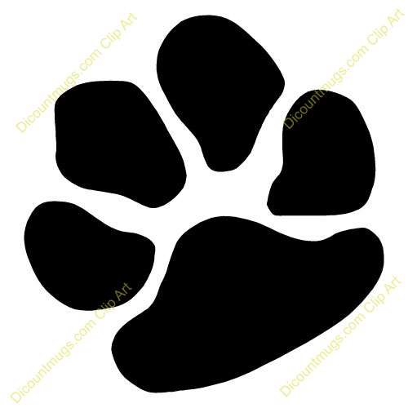
Paws N Claus
Hosted by Awesome Pawsome

We wish you all a Merry Christmas
and a very Happy New Year

AFA Rep: Kevin Crane

Judges: Sue Norton and Steve Pitt

Time Keepers: Mike McChesney and Paul Newman

Competition Organiser: Jenny Crane

Prizes: Dog treats for everyone

Itinerary:

Check in : 2:30pm

Judge’s Briefing: 3:00pm

Racing starts: 3;30pm

Competition Race Format:

Two Divisions – triple round robin – 6 races each team

All Divisions are best of 5 heats

Points for Round Robin will be allocated as follows:

2 points for winning the race,

1 point for a drawn race,

0 points for a loss.

In the event of a tied place teams will be ranked on “head to head” race results. Then best weighted average time. (No run offs)

In the event of a team forfeiting a race the team left to run by itself must complete a minimum of three heats to claim points for a win. If the team does not complete three heats, zero points will be awarded.

Stewarding

All teams are requested to participate in the stewarding throughout the competition to ensure the smooth running of the competition.

Breakouts

Break out time for division one is not applicable and all three teams in division two have lodged web times so the break out time will be one (1) second faster than the fastest seed time in that division. Penalty for first and second break out for the same team in a competition will result in forfeit of each heat in question. Should a team break out three (3) times in a single competition, the penalty will be exclusion from placing in the competition.
Changeover Times
Teams will have two minutes from the end of the proceeding race to have their box and jumps set up and be ready to race. The judge will indicate when there is thirty seconds remaining. The judge may forfeit a team if they are not ready on time.
If you have a clash of races, that is if you have dogs running in races straight after one another, please let the judge know at the end of one race, before the start of the next. The teams will be permitted to enter the ring and adjust their jump heights and secure their Flyball boxes. Teams will not commence warming up until given the ok by the judge. The captains are to inform the judge when their team members are all present and then the two minutes will commence count down.
Catering

Thanks to Pine Rivers Dog Training Club we will have a BBQ for dinner. Canteen will also be open with the usual homemade treats…..thanks ladies.

Drinks for sale and snacks provided for after racing presentations
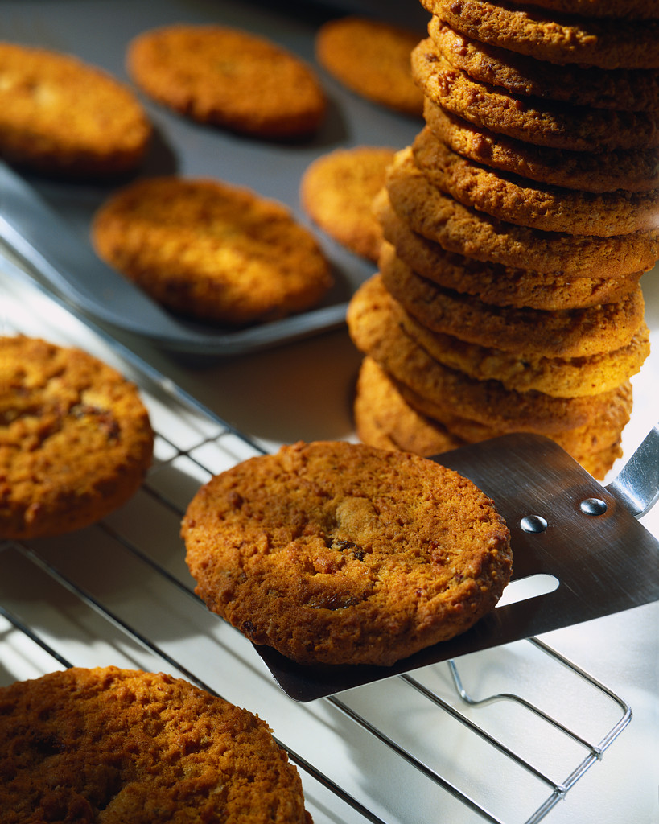
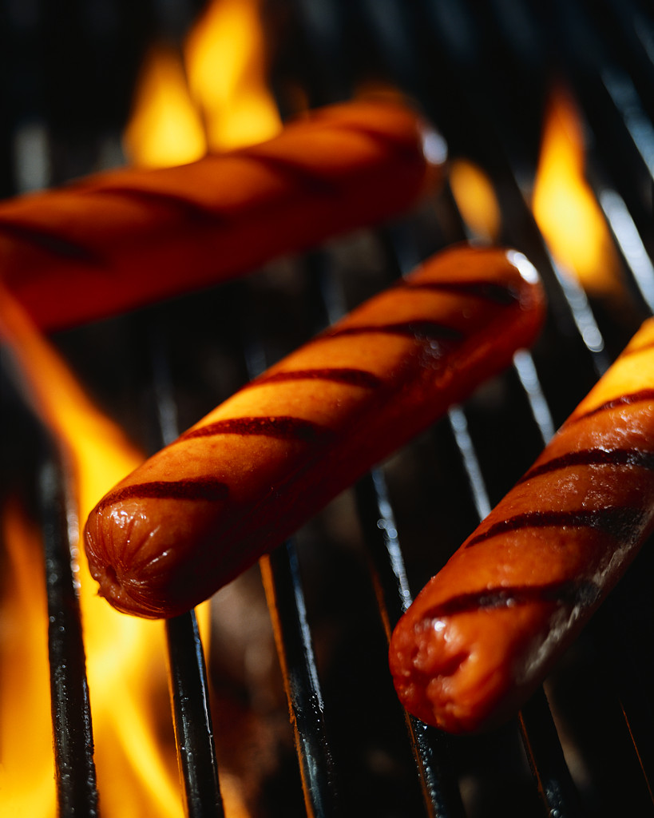

RAFFLE –

Please see any of the Awesome Pawsome people for tickets

Special Presentations

Racing will continue with only two 15 minute breaks for the beginners to work in the ring.

Sausage Sizzle will be after the completion of the racing and the ring pack up. This will then be followed by the usual competition presentation and raffle drawing.

Then it is time for the announcement of the winner of the Clean Run Award for the year and a very special surprise presentation. Soft drinks and snacks will be available and everyone is welcome to join us in a social get together for the end of the year.

Division One

Pine Rivers Devils 19.916

Awesome Pawsome One 23.600

Luvadog Regardless 1 23.670

Division Two

Pine Rivers Rebels 25.315

Flyball Fanatics 26.616

Backyard Buddies 27.648

