Para District Obedience
Dog Club Inc

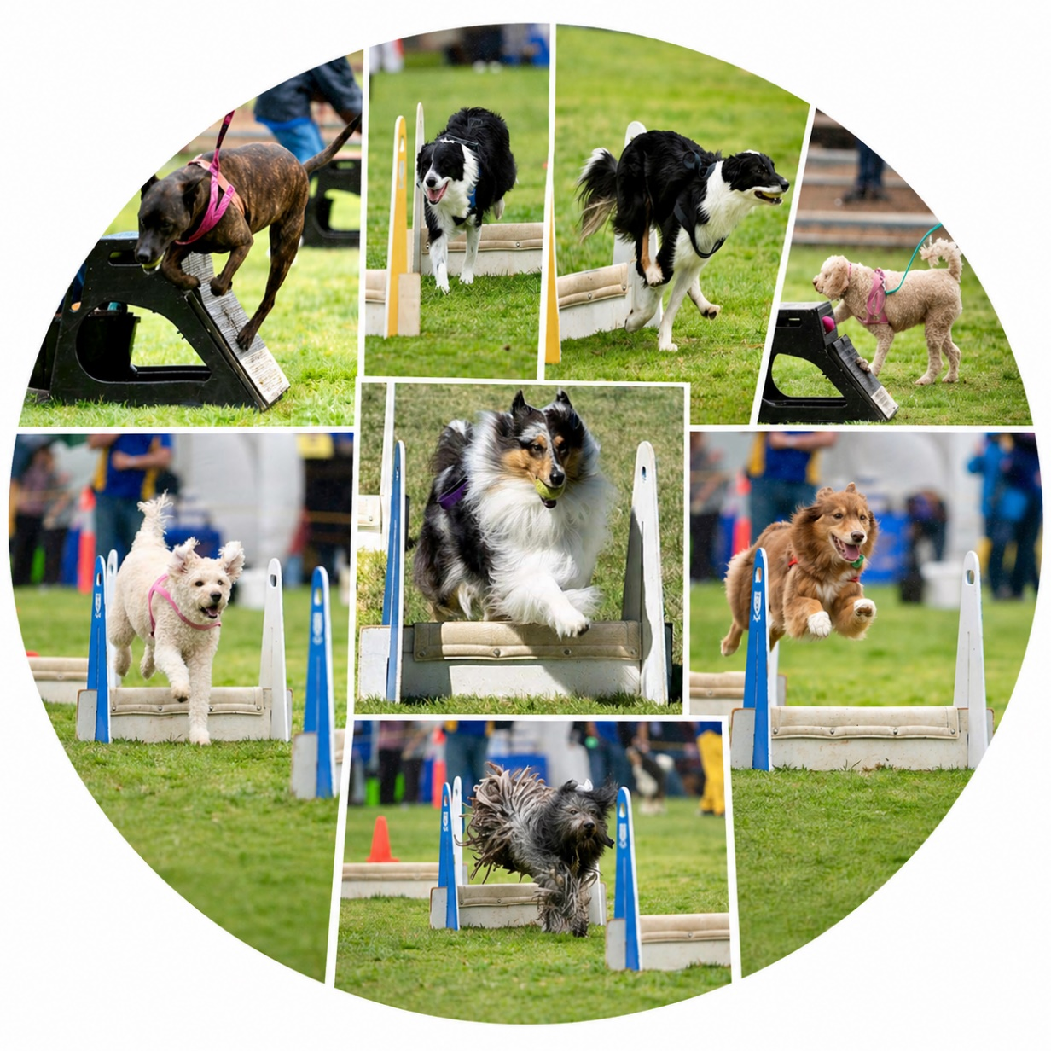

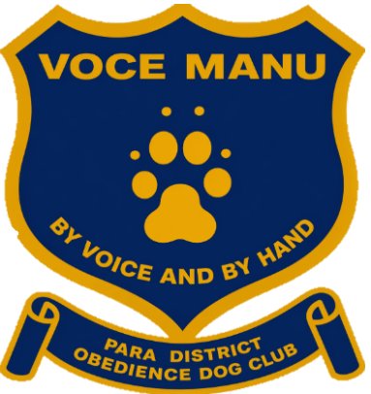

K9 Pro Lead Into The Show Flyball Competition
12th September 2026
Jenkins Reserve, Saints Rd, Salisbury
CAF #1313

WELCOME
Welcome to our Flyball Competition!
Para District Obedience Dog Club warmly welcomes you and thanks you for joining us for today’s competition.
We are excited to have such keen teams, dedicated handlers, and enthusiastic supporters here to share in the spirit of friendly competition and great sportsmanship. Flyball is all about teamwork, speed, and having fun with our amazing dogs, and we hope today is filled with exciting races, strong performances, and plenty of memorable moments.
Whether you are competing, supporting from the sidelines, or volunteering your time, your participation helps make this event a success. We truly appreciate everyone’s effort and commitment to the sport.
We wish you all safe, successful racing and hope you and your dogs have a fantastic day filled with fun, friendship, and plenty of wagging tails!

GENERAL INFORMATION
This event is sanctioned by the Australian Flyball Association Inc. As such, it will be run in accordance with the Rules and Policies of the AFA.
Check in is at 8.00am. Judges Briefing at 8.30am. Racing will commence at 9.00am.

Apart from the dogs involved in the current race, all dogs must be held effectively, either on lead or crated. No dog is to be tied to the ring.
Bitches in season are not permitted on the grounds. Any dog that is considered unfit for racing, either by a Veterinarian or Judge, will be excused from the competition. No dog related advertising other than that used by the competition organiser is permitted on display.

COMPETITION FORMAT
Open handicap Division 1 is x3 RR best 3 of 5, 6 races per team 18-30 heats Division 2 is x2 RR best 3 of 5 heat 6 races per team 18-30 heats

Points are awarded for each race (i.e. a team must win two out of three heats OR three out of five heats to win the race and hence the race points). The points will be tallied, and the team with the most race points will win the division.

COUNT BACK
In the case of competition points being equal, the tie will be resolved as follows:
Count back based first on head to head RACE wins during competition, where more than two teams are tied and count back for each team shall be the total RACE wins scored against all of the teams that are tied (the combined number of wins).
If two teams are still even the teams are compared on head to head heats.
If two teams are still even - then fastest heat time head to head decides the winner.

BREAK OUT RULE
The break out rule will apply. In case of a combined division round robin, the breakout that is relevant to the team’s division will apply.
The break out time for a declared seed time in handicap format racing will be 0.5 seconds faster than the team’s declared seed time. Where manual timing is used, the breakout time is 1.5 seconds faster than the relevant seed time.
A team will forfeit all subsequent heats and the right to place at the race meeting after breaking out twice or if its first breakout is by 0.5 seconds or more (major break out). A major breakout means that a team has finished a heat in a time 0.5 seconds or more faster than its breakout time.
All normal rules of racing apply to a breakout team except that:
- False starts do not apply to the breakout team, and before each heat, the EJS must be set up with a false start for the breakout team.
- A dog may not run again after a fault

A team scheduled to run in a race against a breakout team
- To earn race meeting points for a win in the race must run the required number of heats and finish at least one of those heats
- Is otherwise subject to all normal rules of racing.

CHANGE OVER TIME
The Change Over time is 3 minutes.

MEASURING
At the discretion of the team, dogs jumping less than 14 inches may be measured by the measuring Judge and a second official (Judge, AFA Representative or an experienced official appointed by the accredited AFA Representative) during times designated by the host club. A dog must be entered in the competition in order to have its height recorded on a Height Card Application (Form C.8).

The nearest veterinary services are:

Salisbury Park Vets4Pets
1914 Main North Rd, Salisbury Park SA 5109
Phone (08) 8258 0168
Open Sat 9am – 1pm

Golden Grove Vets4Pets
103 The Golden Way, Wynn Vale SA 5127
Phone (08) 8289 3722
Open Sat 7am – 9pm

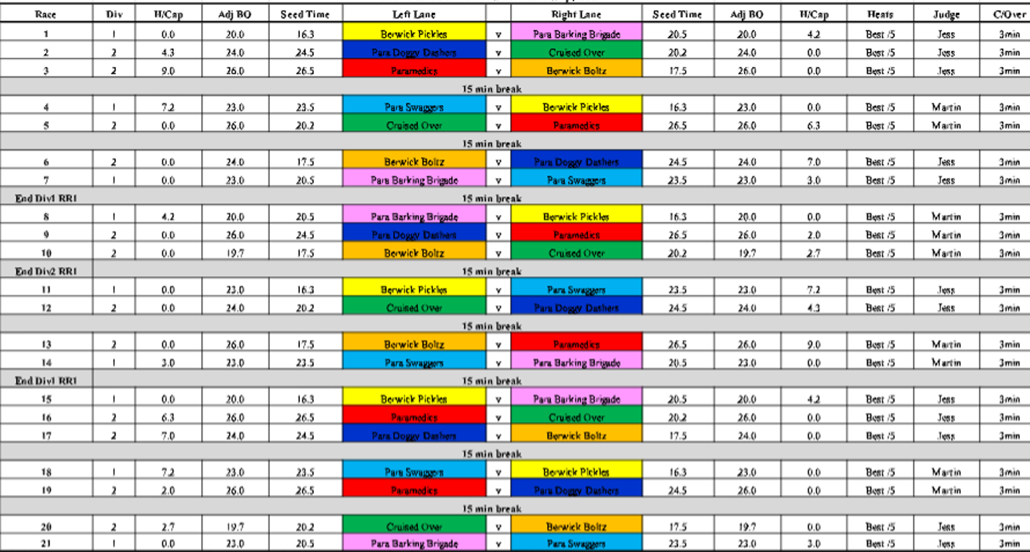
Run Order
Teams
Para Doggy Dashers
Captain: Julian Stokes
Dogs: Loki
Alegra
Sasha
Copper
Lily
Opal
Cruised Over
Captain: Melissa Jolley
Dogs: Arlo
Ben
Loki
Presto
Tona
Clay

Para Swaggers
Captain: Rebecca Knapp
Dogs: Rumble
Raven
Quill
Gracie
Winnie
Treble

Paramedics
Captain: Carmel Nottle
Dogs: Eddie
Mia
Zoe
Charli
Dusty
Sadie
Para Barking Brigade
Captain: Christina Dalla Valle
Dogs: Cea
Baci
Callie
Ollie
Tux

Berwick Boltz
Captain: Jenni Veitch
Dogs: Forrest
Ned
Switch
Drift
Stella
Hex

Berwick Pickles
Captain: Jenni Veitch
Dogs: Millie
Midge
Rozz
Uma
Etzio
Rydor

Thank you…….
A huge thank you to all of our wonderful sponsors for supporting the K9 Pro Lead Into the Show Flyball Competition. Your generosity and support help make this event possible and contribute to a fantastic day of racing, fun, and community for everyone involved.
A very special thank you to our major sponsor, K9 Pro, for your incredible support and commitment to our sport.
We would also like to sincerely thank our amazing sponsors:
Critter Cube,
Antinol Plus,
Fergusons Treatos,
Pet Deli Marion,
Zoe and Georgie’s Snack Shack Munchies.
Your support is truly appreciated, and we are so grateful to have you as part of our flyball community.

We would also like to thank
AFA Judge: Jess Baker
Time Keepers: Alli Dawson & Michelle Stokes
Cathy Hancock and Juian Stokes for the BBQ
Event Organisation support : Rebecca Knapp
Stewards, Box Loaders & Ball Shaggers








