FLYBALL AT THE DIAMOND
3 June 2023
Redlands Rays Baseball Club, 20 Duncan Rd Capalaba
Check in Time: 7:30am Judges Briefing: 8:15am Racing Starts: 8:30am
Bayside Flyball Racing would like to welcome all competitors to the Flyball at the Diamond competition, and we thank you for supporting our competition.

Our Officials for today are:
Judges: Paul Newman
Timekeepers: Mike McChesney Tony Gee
AFA Representative: Kathryn Royes
Comp Organiser: Craig Pearce
First Aid Officer: Alissa Mason
Raffle Coordinator: Pauline Oldman

Rays Baseball Club will have food and drink available this Saturday.

Bacon & Egg Rolls
Hamburgers
Chicken Burgers
Hot Chips
Pies
Coffee, tea and drinks

Please support the club that supports us.

Please note, there will be no cooking allowed on the grounds.
Housekeeping
Flyball at the Diamond, although it is not a public event, all care needs to be taken to ensure the safety of competitors and their dogs. Dogs need to be accompanied on lead by their handler, or restrained in a crate at all times when they are not in the Flyball ring.
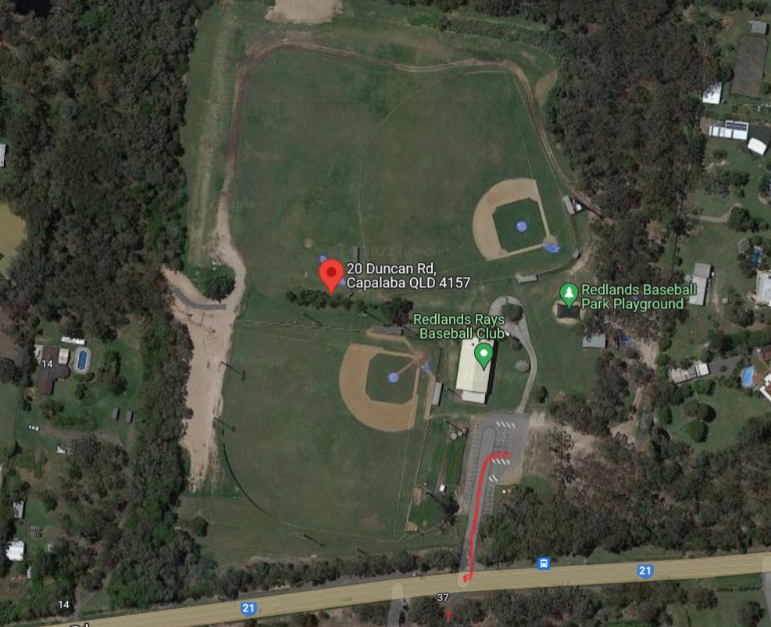
No dogs will be permitted in or near the Event food area.
Entry to our Flyball area is off Duncan Road. Please follow the road through to the parking area when entering the Baseball club. Setup will be located on Field one which is located to the left of the car park area.

Car Movements
As you enter the grounds the asphalt car park is where you park. Additional parking can be located to the right of the car park under the trees after entering the grounds. Gazebos can be set up around the outside of Ring 1. Please ensure you have a crate for your dog, as crating out of a vehicle will not be permitted.
Toileting dogs
Please pick up your dogs’ droppings from around the grounds on the day. Bins will be located close to the areas where you will set up your Gazebos.
Toilet location
Toilets are located under Rays Baseball Club building which is shown with a green icon the location map provided.
Canteen
The canteen is located on the first floor of the Baseball Club building. Dogs are not permitted to be taken to the canteen area.
Nearest vet After Hours (24 hrs)
Redlands Veterinary Clinic Super Vets
Ph: 3207 7325 Ph: 3893 0509
433 Boundary Road, 190 Radford Road,
Thornlands Manly West
Saturday: 7:00am to 3:00pm

Prizes
Bayside Flyball would like to thank our major sponsor Instincto for sponsoring today’s Flyball event. Each competitor will receive an Instincto bag on the day.
Raffle Sponsor Supporters
We have a raffle that would not have been possible without our raffle coordinator, Pauline Oldman. The generous donations come from Instincto, Art Creations Picture Framing, Canine Cubby, Brisbane Animal Chiro, T/A Belmont Chiro Centre, Canine Cubby & Maceys Toy Box, Capalaba Produce, Active Dog-Wear, IGA Mt Cotton, Desrae Grant – Emmett Therapy and Hogan’s Hotel.
Major Raffle Prize
The major raffle prize is valued over $200.00. We will provide the contact details and address of the businesses.
Raffle tickets are $2 each, 3 for $5, or 6 for $10. If you spend $10 or more on tickets, you automatically go into the draw for the major prize. Please see Pauline Oldman to purchase tickets.
The major raffle prize will be drawn at the conclusion of racing on Saturday.

Shop 1B, Oxenford Square, Old Pacific Highway, Oxenford
Phone. (07) 5573 7716

Phone: (07) 3207 2511 | SUPER IGA – MOUNT COTTON  Phone: 3206 6680
Email: info@activedog.com.au  Phone: 0401 169 379 | Phone: 0405 396 731
3247 Old Cleveland Rd, Chandler  Phone: (07) 3390 1433 | Phone: 0403 270 003  wetnoseproduction@yahoo.com  CANINE ENRICHMENT TOYS

Racing Format Racing Format
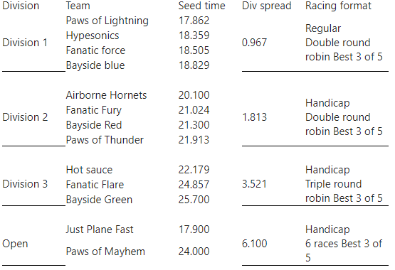
This is an AFA Sanctioned event and will be run in accordance with all the Rules and Policies of the Australian Flyball Association Inc.
Change over time will be 90 second.
AFA Approved Count Back Rules
Count back is based first on head to head RACE wins during competition (where more than two teams are tied, the count back for each team shall be the total RACE wins scored against all the teams that are tied (the combined number of wins); if two teams are still even, the teams are compared on head to head heats; if two teams are still even – then fastest heat time head to head decides the winner
Teams
Division 1
Paws of Lightning- Seed Time 17.862
 | Dog’s Name | CRN | Height | Handler Name | Breed
1 | Wilbur | 2893B | 10 | Nicholas Podmore | Border Collie
2 | Chief | 3383A |  | Emily Giezen | American Staffy X
3 | Nala | 2893A | 10 | Emma Podmore | Border Collie
4 | Kitana | 857D | 10 | Jenni Crane | Kelpie
5 | Brandy | 3385A | 9 | Amy Mrak | Border Collie

Hypersonics – Seed Time 18.359
 | Dog’s Name | CRN | Height | Handler Name | Breed
1 | Frankie | 3137A |  | Judy Gee | Kelpie x Border
2 | Sadie | 2970A | 10 | Kathryn Royes | Kelpie X Border
3 | Nixon | 2174C |  | Nealle Best | Cattle X
4 | Ruby | 2970B | 10 | Kathryn Royes | Kelpie X
5 | Dekota | 2174B | 10 | Nealle Best | Kelpie x Malinois
6 | Archer | 2970C |  | Kathryn Royes | Kelpie

Fanatic Force – Seed Time 18.505
 | Dog’s Name | CRN | Height | Handler Name | Breed
1 | Icon | 444C | 10 | Jane Trezise | Border Collie
2 | Soda | 2636B |  | Candice Leighton | Aust Cattle X
3 | Riptide | 2985B |  | Sarah Wieland | Aust Koolie
4 | Rusty | 2985A | 10 | Claire Peterken | Cattle X
5 | Mr Wilson | 2905A | 11 | Kym Gralton | Border Collie

Bayside Blue – Seed Time 18.829
 | Dog’s Name | CRN | Height | Handler Name | Breed
1 | Holo | 3142A | 9 | Emma Peters | Border Collie
2 | Ollie | 3219A | 10 | Danielle Healey | Border Collie Mix
3 | Honey | 2940A | 10 | Judith Sorbello | Kelpie x Cattledog
4 | Buddy | 3048A | 10 | Ayla Watt | Staffy x Kelpie
5 | Rocco | 2762A | 10 | Annette Wickings | Stumpy Tail Cattle
6 | Fay | 3466A | 11 | Jade McKeown | Border Collie

Division 2
Airborne Hornets – Seed Time 20.100
 | Dog’s Name | CRN | Height | Handler Name | Breed
1 | Daisy | 2779A | 7 | Dianne Penman | Cocker Spaniel
2 | Wednesday | 2952C | 9 | Jesse Tosch | Border Collie
3 | Benji | 2867A | 10 | Connie Blakemore | Staffy x Collie
4 | Scout | 2671A | 10 | Sally Elsom | Border Collie
5 | Marley | 1222C | 10 | Erin Cooke | BC X Smithfield
6 | Opal | 2812C |  | Nicola Dudley | Aust. Koolie

Fanatic Fury – Seed time 21.024
 | Dog’s Name | CRN | Height | Handler Name | Breed
1 | Twist | 2975B |  | Anne Hardacre | Flat Coated Retriever
2 | Boston | 2936A |  | Kim Kaim | Bull Arab X
3 | Fenway | 2905B | 10 | Kym Gralton | Aust. Shepherd
4 | Daxter | 3278B |  | Lana Kennedy | Golden Retriever X BC
5 | Cricket | 2636A | 11 | Candice Leighton | Aust. Cattle X
6 | Moe | 2676A |  | Yolanda Wong | Aust. Shepherd

Bayside Red – Seed Time 21.300
 | Dog’s Name | CRN | Height | Handler Name | Breed
1 | Rexington | 2915A | 10 | Nathalie Casalaina | Whippet x BC
2 | Virginia | 2915B | 10 | Nathalie Casalaina | Whippet
3 | Squeak | 3048B | 10 | Ayla Watt | BC X Belgium Shep
4 | Luna | 3393A | 10 | Casey Werder | Border Collie
5 | Koco | 3020A | 10 | Gillian du Plessis | Koolie
6 | Stormy | 3349B | 11 | Alissa Mason | Border Collie

Paws of Thunder – Seed Time 21.913
 | Dog’s Name | CRN | Height | Handler Name | Breed
1 | Peanut | 3415A | 10 | Peter Bauer | Kelpie
2 | Junya | 2758A | 10 | Graeme McGregor | Rotty x Sharpie
3 | Judge | 2758B | 10 | Graeme McGregor | Kelpie x Corgi
4 | Maggie | 3401A | 7 | Courtney Nicholas | Spoodle
5 | Pepe Le Pew | 2112B | 7 | Jenni Crane | King Charles Spaniel
6 | Georgie | 3384A | 8 | Genevieve Pyne | Terrier X

Division 3
Hot Sauce – Seed Time 22.179
 | Dog’s Name | CRN | Height | Handler Name | Breed
1 | Flick | 745B | 9 | Jo Slade | Border Whippet
2 | Shay | 371D | 9 | Jan McChesney | Border Collie
3 | Zam | 3141A | 11 | Robyn Williams | Border Collie
4 | Charlie | 3299A | 11 | Sally Morton | Border Collie
5 | Insane Bolt | 834A | 7 | Tim Slade | Whippahuahua
6 | Boof-Head | 2565A | 7 | Nikki Bultitude | Mini Poodle X

Fanatic Flare – Seed Time 24.857
 | Dog’s Name | CRN | Height | Handler Name | Breed
1 | Leala | 2975A |  | Anne Hardacre | Labrador
2 | Asher | 2650B | 7 | Paul Trezise | Terrie X
3 | Darcy | 845F | 9 | Kerry Wallison | ACD X
4 | Tilly | 3153A | 7 | Lesley Brumley | Kelpie Mix
5 | Yoshi | 2676B |  | Yolanda Wong | Aust. Shepherd
6 | Monty | 2596B |  | Sophie Calvert | Border Collie

Bayside Green – Seed Time 25.700
 | Dog’s Name | CRN | Height | Handler Name | Breed
1 | Tahni | 1359C | 9 | Edna Pearce | Aust. Koolie
2 | Kylo | 1359B | 10 | Craig Pearce | Aust. Koolie
3 | Charlie | 2726B | 7 | Pauline Oldman | Cocker Spaniel
4 | Pippa | 2873A | 7 | Donna Spencer | Cattle X
4 | Ted | 2800A | 7 | Mirella Taylor | Jack Russell
5 | Douglas | 2127F | 11 | Anne Newman | Whippet

Open
Just Plane Fast – Seed Time 17.900
 | Dog’s Name | CRN | Height | Handler Name | Breed
1 | Koda | 2867B | 10 | Connie Blakemore | Aust. Koolie
2 | Clancy | 2784A | 10 | Penny Parker | Border Collie
3 | Lincoln | 2952A | 12 | Jesse Tosch | Border Collie X
4 | Jem | 2671B | 10 | Sally Elsom | Border Collie
5 | Izzy | 1222D | 10 | Erin Cook | Border Collie

Paws of Mayhem – Declared Time 24.000
 | Dog’s Name | CRN | Height | Handler Name | Breed
1 | Stella | 3400A | 9 | Hayley Brooker | Border Collie
2 | Poppy | 382C | 8 | Eleanor Rivett | Schnauzer X JR
3 | Alvin | 857C | 7 | Jenni Crane | Papillon X
4 | Mildred | 3210A | 10 | Jacinta Smith | Cattle Dog
5 | Whisky | 3490A | 8 | Kim Daley | Labradoodle

