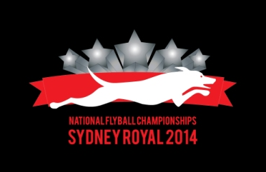
Nationals Merchandise

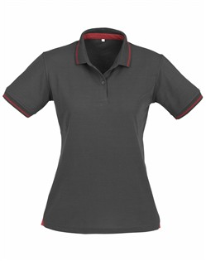
(all items include the 2014 Nationals logo)

Ladies Polo Shirt – Charcoal with Red piping - $35
50% Cotton inner, 50% BIZCOOL, Polyester pique outer, Contrast hem panel detail, New slim knitted stripe collar and cuff, 170 GSM, UPF rating - Good

Measurement (cm):
Size | 8 | 10 | 12 | 14 | 16 | 18 | 20 | 22 | 24
Half Chest | 46.5 | 49 | 51.5 | 54 | 56.5 | 59 | 62 | 65 | 68
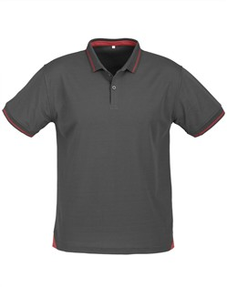
Mens Polo Shirt – Charcoal with Red piping - $35
50% Cotton inner, 50% BIZCOOL� Polyester pique outer, Contrast hem panel detail, New slim knitted stripe collar and cuff, Loose pocket included, 170 GSM, UPF rating – Good

Measurement (cm):
Size | S | M | L | XL | 2XL | 3XL | 5XL
Half Chest | 52 | 55 | 58 | 62 | 65 | 71 | 79

Hooded Jacket – Black with Charcoal lining - $70
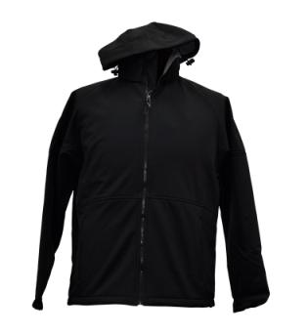
340gsm - Shell face 90% Polyester, 10% Elastane, Shell back 100% Polyester, Water/wind resistant, breathable, tough wearing, insulative, hi-tech 4 ways stretch (up - down & left - right).

Measurement (cm):
Size | S | M | L | XL | 2XL | 3XL | 4XL | 5XL
Half Chest | 57.5 | 60 | 62.5 | 65 | 67.5 | 70 | 72.5 | 75
Body Length | 71.5 | 73.5 | 75.5 | 77.5 | 79.5 | 81.5 | 83.5 | 85.5

Cap - Black with Red - $15
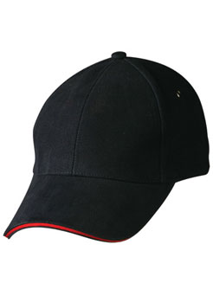
6 panel structured laid back front. Pre-curved peak with
contrasting sandwich. 4 metal eyelets on 4 panels & tuck in
fabric strap with gun metal buckle. One size fits all.

Bum bag - Black - $25

Front main zippered pocket, Mobile phone pocket with Velcro closure,
Document zippered pocket at back, 600 denier nylon,
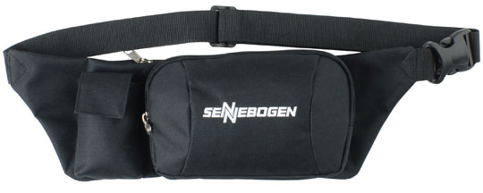
approximate size 30cm (W) x 13 cm (H)
Pre-ordering merchandise
If you want to collect your merchandise order at the Nationals you will need to get your order in by Wednesday 2/4/14. Any orders not received by then will need to be posted out or collected at the Howling in the Hawkesbury comp on 10/5/14 (for teams competing there only). If your order is not received by 2/4/14 an extra postage cost of $15 will apply – please include this in your order & payment.
The following Order Form should be completed & emailed, with the Direct Deposit receipt (see below), to Karen Bland at kazzi252@yahoo.com.au or Karen will accept orders with Cheque payment at the Hounds in the Hills comp on 30/3/14.
* Karen will have samples of these items at the Hounds in the Hills comp if you want to check them out
Payment
- For pre Nationals orders:
a) * Direct deposit to the Sydney Flyball Associates Bank a/c BSB: 012-357 A/c: 268864803 with your full name as the reference. The bank transfer receipt needs to be emailed to Karen Bland to confirm your order kazzi252@yahoo.com.au
  - Cheque payment at Hounds in the Hills – cheque to be made out to “Sydney Flyball Associates”.

- For those ordering at the Nationals: Cash or cheque on the day for later delivery. You must include postage costs ($15) if you can’t collect items at the next flyball comp. Please see Karen on the day

*** All queries re merchandise should be referred to Karen***
2014 Nationals Merchandise Order Form
Name: _______________________________________________________________________
Address:
_______________________________________________________________________
Phone number: _________________________________________________________________
Club: ___________________________________________________________________
Delivery method: Highlight or double click on Check box & select “Checked” for required option
Collect at Nationals Post order to above address
Collect at Howling in the Hawkesbury comp
Item | Price | Size | Qty | Total
Ladies Polo Shirt | $35
Ladies Polo Shirt | $35
Mens Polo Shirt | $35
Mens Polo Shirt | $35
Hooded Jacket (unisex) | $70
Hooded Jacket (unisex) | $70
Cap | $15
Bum bag | $25
Postage (if not collecting order at the Nationals or Hawkesbury comp) | $15
Order Total:
Please email completed Order Form & your Direct Deposit receipt to Karen Bland kazzi252@yahoo.com.au

