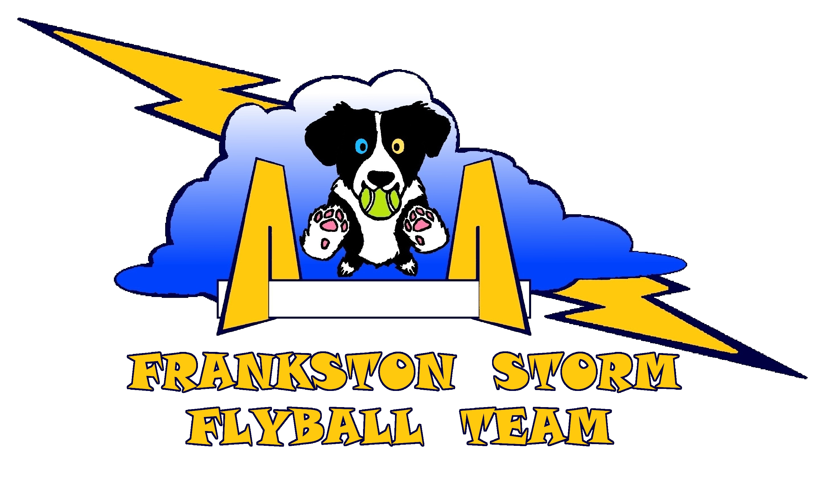

Kingston Pet Expo 2019

FLYBALL CAR

Phone: _______________________________________________________________



Kingston Pet Expo 2019

FLYBALL CAR

Phone: _______________________________________________________________