 HASTINGS & DISTRICT
OBEDIENCE DOG CLUB Inc.

HASTINGS FLYBALL COMPETITION
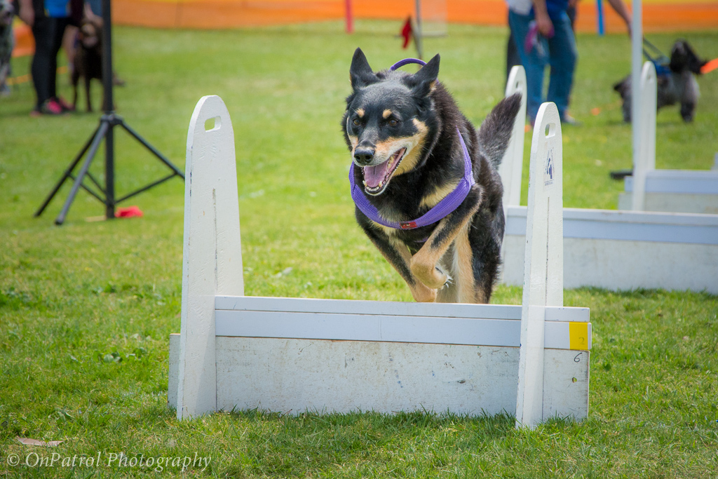
23 & 24 APRIL 2016
TCh Mullarway Gypsy Queen Onyx

Supported by

Petstock Braeside – Jem & Cam

Visit us at www.hastingsdogclub.org.au or find us on Facebook

Hastings & District Obedience Dog Club would like to welcome all competitors to our 2016 Hastings flyball competition.

Competing for the Russell McDonald Perpetual Shield

There are many people we wish to thank for making today’s competition possible – especially the following people for keeping everything running in an orderly fashion.

Competition Organiser: Jenny Millar

Judges: Josh Ellen Ian Gauntlett Ian Kendt

Timekeepers: Trevor Nicholls Helen Gauntlett Andrew Metha Bill Reynolds

AFA Representative: Anne Coleman

Without these people competitions like this would not be possible.

Also Thank you to Ian Kendt for use of PA speakers.

Lastly but by no means least, Thank You to all the competitors that make these competitions so enjoyable.

Veterinarians

Hastings Veterinary Clinic
2110 Frankston Flinders Road

Hastings

Phone: 59791214

Racing Format

Division 1 3 x 5 + 3 x 5 + 3 x 3 + 3 x 3 heats 12 races = 48 heats

Division 2 4 x 5 + 4 x 3 + 4 x 3 heats 12 races = 44 heats

Division 3 3 x 5 + 3 x 5 + 3 x 5 heats 9 races = 45 heats

Division 4 2 x 5 + 2 x 5 + 2 x 5 + 2 x 3 heats 8 races = 46 heats

Division 5 3 x 3 + 3 x 3 + 5 x 5 11 races = 43 heats

Division 6 1 x 5 + 1 x 5 + 1 x 3 + 5 x 5 heats 8 races = 43 heats

Rules

This is an AFA sanctioned event and will be run in accordance with the Rules and Policies of the Australian Flyball Association Inc.

The AFA approved Count Back Rule

Count back is based first on head to head RACE wins during competition (where more than two teams are tied the count back for each team shall be the total RACE wins scored against all of the teams that are tied (the combined number of wins); if two teams are still even the teams are compared on head to head heats; if two teams are still even - then fastest heat time head to head decides the winner.

Seed Times

Seed Time B/Out

Division One
Hot Dogs 18.074 web N/A
Berwick Bladerunners 18.522 web N/A
Ballarat Eureka Diggers 19.643 web N/A
Frankston Storm – Hurricanes 19.982 web N/A

Division Two
Berwick Breezers 20.000 dec 19.000
Frankston Storm – Cyclones 20.111 web 19.000
WonDogs Quicksilver’s 20.500 dec 19.500
Altona Arrows 20.817 web 19.000
Eastside Flyers Kites 20.865 web 19.000

Division Three
Chilli Dogs 21.032 web 20.032
WonDogs Cut Backs 21.438 web 20.032
Devils Cut 21.700 dec 20.700
Hastings Howlers Hit & Hum 21.921 web 20.032

Division Four
Corn Dogs 24.000 dec 23.000
Frankston Storm – Twisters 24.000 dec 23.000
Berwick Blaze 24.066 web 23.000

Division Five
WonDogs Pointbreak 25.000 dec 24.000
Croydon Rocket NQR 25.550 web 24.000
Hastings Howlers Hit & Run 25.580 web 24.000
Frankston Storm – Chasers 25.800 web 24.000

Division Six
Toppers 26.047 web 25.047
Ballarat Eureka Rebels 26.100 web 25.047

Teams

Division One

Western Weiner Hot Dogs Seed time – 18.074 web
Captain – Sally Laity Box Loader – Kylie Ellen
1 | Flite | 823B |  | Sally Laity | Border Collie
2 | Fly | 1007E |  | Josh Ellen | Border Collie
3 | Switch | 772D | 7 | Mike Perry | JRT X
4 | Flea | 1007A |  | Josh Ellen | Border Collie
5 | Steele | 772E |  | Sally Laity | Border Collie

Berwick Bladerunners Seed time – 18.522 web
Captain – Gordon Chalmers Box Loader – Chris Moore
1 | Frankie | 1273C | 9 | Belinda O’Shea | Staffordshire Bull Terrier
2 | Zane | 1174B | 14 | April Smith | Kelpie
3 | Flint | 2217B | 14 | Pauline Sampson | Staffy X
4 | Penny | 2523A | 13 | Matt Haines | Border X
5 | Shaddow | 1256B | 14 | Janet Fry | Border X Lab

Ballarat Eureka Diggers Seed time – 19.643 web
Captain – Jane House/Karen Bishop Box Loader – Des House
1 | Abbie | 877C | 12 | Wendy McKechnie | Kelpie X
2 | Copper | 995D | 12 | Sharon Dwyer | N.S.D.T.R.
3 | Max | 2179B | 14 | Jane House | Koolie
4 | Zee | 1013B | 14 | Jen Van Dromme | Border Collie
5 | Jacqui | 1159C | 14 | Karen Bishop | Kelpie
6 | Beau | 1159B | 14 | Karen Bishop | Kelpie

Frankston Storm- Lightning Bolts Seed time – 19.536 web Captain – Paul Louziotis Box Loader – Matt Sharp
1 | Monty | 2408D | 7 | Taylor Dearden | Staffy X
2 | Kenny | 2315B | 14 | David Sharp | Border Collie
3 | Brody | 2822A | 14 | Denise Male | Border Collie
4 | Colby | 2675A | 14 | Juanita Spinelli | Border Collie X
5 | Willow | 1312B | 13 | James Wood | Border Collie

Division Two

Berwick Breezers Seed time – 20.00 dec Captain – Craig Chalmers Box Loader – Chris Moore
1 | Pimms | 2594A | 14 | Nic Hobbs | Labrador
2 | Astro | 2447A | 7 | Janice Turriff | Schnoodle
3 | Murray | 462C | 14 | Gordon Chalmers | Border Collie
4 | Lucy | 2571A | 14 | Elysha Neylan | Groodle
5 | River | 26678A | 14 | Sunshine Day | Labrador
6 | Lou Lou | 1134C | 13 | Ula Lane | Kelpie X

Frankston Storm – Cyclones Seed time – 20.111 web Captain – Louise Hamilton Box Loader – Matt Sharp
1 | Jovi | 1076C | 11 | Natasha Sleep | N.S.D.T.R.
2 | Dakota | 2408B | 14 | Taylor Dearden | Border Collie X
3 | Coco | 2342A | 14 | Louise Hamilton | Kelpie
4 | Chad | 2524B | 14 | Paul Louziotis | Border Collie
5 | Ruby | 2649A | 14 | Jacinta Saloman | Border Collie

WonDogs Quicksilver’s Seed time – 20.500 dec Captain – Danielle Basile Box Loader – Sandra Jerger
1 | Skip | 244F | 14 | Danielle Basile | Border Collie
2 | Splash | 2575A | 12 | Penny Lloyd | Border Collie
3 | Sparkie | 1096C | 14 | Lorraine Heyward | Border Collie
4 | Declan | 2529B | 12 | Carole King | Shetland Sheepdog
5 | Brash | 2529C | 10 | Carole King | Shetland Sheepdog
6 | Radar | 2530B | 14 | Sandra Jerger | Kelpie

Altona Arrows Seed time – 20.817 web Captain – Samantha Brown Box Loader – Chloe Brown
1 | Lewie | 2626C | 10 | Samantha Brown | Working Cocker Spaniel
2 | Stitch | 2626A | 14 | Chris Brown | Border Collie
3 | Indy | 2508A | 14 | Tracey Rose | Border Collie
4 | Jack | 2819A | 8 | Rebecca Paul | JRT X
5 | Jazz | 2723A | 14 | Simon Bates | Kelpie X
6 | Ollie | 2626D | 14 | Chris Brown | Border Collie

Eastside Flyers Kites Seed time – 20.865 web Captain – Anne Coleman Box Loader – Anne Coleman
1 | Shae | 2121A | 14 | Bronni Metha | Border Collie
2 | Spark | 2121B | 14 | Andrew Metha | Border Collie
3 | Maddi | 296D | 13 | Ross Wilkinson | Border Collie
4 | Gracie | 296F | 13 | Pam Atkinson | Borer Collie

Division Three

Chilli Dogs Seed time – 21.032 web Captain – Kylie Ellen Box Loader – Hayley Ellen
1 | Cupee | 705E | 8 | Gayle Ellen | JRT X
2 | Belle | 772B |  | Sally Laity | Border Collie
3 | Romi | 823C | 13 | Mike Perry | Border Collie
4 | Sylvie | 2237C |  | Garry Woollard | Border Collie
5 | Ricky | 1100A | 7 | Kylie Ellen | Papillon
6 | Mollie | 1203B |  | Ray Ellen | Border Collie

WonDogs Cut Backs Seed time – 21.438 web Captain – Danielle Basile Box Loader – Debbie Murray
1 | Phoenix | 244D | 14 | Tracie Ainsworth | Border Collie
2 | Tilly | 2175A | 14 | Alison Smith | Border Collie
3 | Merlin | 244E | 14 | Penny Lloyd | Border Collie
4 | Cindy | 92E | 14 | Eric Van Zuyden | Border Collie
5 | Echo | 1320A | 8 | Helen O’Brian | Border Collie X JRT
6 | Buzz | 1320B | 9 | Helen O’Brian | Heeler X JRT

Devils Cut Seed time – 21.700 dec
Captain – Kim Murrie Box Loader – Narelle Foulkes
1 | Samson | 2610A |  | Kelly Hall | Groodle
2 | Jack | 2314A | 9 | Ann Gorton | Mini Schnauzer
3 | Sam | 1213A | 14 | Kim Murrie | Kelpie X
4 | Doza | 1213B | 14 | Kim Murrie | Kelpie
5 | Wombat | 2441B | 14 | Robert Foulkes | Border Collie

Hastings Howlers Hit & Hum Seed time – 21.921 web Captain – Jessica Townsend Box Loader – Rob Millar
1 | Ajay | 190D | 14 | Jenny Millar | Border Collie
2 | Foxie | 2550A | 14 | Jessica Townsend | Border Collie
3 | Remy | 2313A | 13 | Geordie Male | Aust Shepherd
4 | Diesel | 2506A | 14 | John Partyka | Border Collie / Kelpie
5 | Koby | 2197A | 14 | Damian Townsend | Border Collie

Division Four

Corn Dogs Seed time – 24.000 dec Captain – Josh Ellen Box Loader – Garry Woollard
1 | Jazz | 689B |  | Gayle Ellen | Aust Shepherd
2 | Spock | 659C |  | Kylie Ellen | Kelpie X
3 | Leroy | 823D | 7 | Hayley Ellen | JRT X
4 | Ryker | 767D |  | Gayle Ellen | Border Collie
5 | Maggie | 2237B | 8 | Linda Hutchinson | Tenterfield Terrier
6 | Bundy | 772C |  | Sally Laity | Mastiff X

Frankston Storm – Twisters Seed time – 24.000 dec Captain – Louise Hamilton Box Loader –
1 | Ash | 1266B | 7 | Anne Harlond | Poodle X Shih Tzu
2 | Jodie | 2338A | 14 | Diane Gnieslaw | Labrador
3 | Stevie G | 2315A | 14 | David Sharp | Border Collie
4 | Stryker | 2673A | 14 | Charles Mouton | Border Collie /Aust Shepherd
5 | Ella | 2199A | 14 | Lauren Dolley | Maremma X
6 | Skater | 2339A | 14 | Tazzie Eggins | Aust Cattle Dog

Berwick Blaze Seed time – 24.066 web Captain – Box Loader –
1 | Ahsoka | 2214B | 12 | Nik Boyd | Finnish Lapphund
2 | Grady | 1134B | 14 | Ula Lane | Kelpie X
3 | Pepe | 1134A | 7 | Ula Lane | Maltese X Poodle
4 | Ana | 2541A | 7 | Monique Smith | Staffordshire Bull Terrier
5 | Toby | 2773A | 14 | Vivien Wilson | Labrador
6 | Jackie | 1174A | 11 | April Smith | Kelpie X

Division Five

WonDogs Pointbreak Seed time – 25.000 dec Captain – Danielle Basile Box Loader –
1 | Cozmo | 577E | 14 | Danielle Basile | Border Collie
2 | Jango | 1140D | 14 | Jeanette Sleebs | Pointer
3 | Zack | 1140C | 10 | Jeanette Sleebs | Border Collie X
4 | Charlie | 2532A | 10 | Debbie Murray | Jack Russell X
5 | Caspa | 2530A | 7 | Sandra Jerger | Toy Poodle
6 | Scruffy | 92F | 7 | Eric Van Zuyden | Maltese X

Croydon Rocket NQR Seed time – 25.550 web Captain – Frances Campbell Box Loader –
1 | Tigger | 1116D | 14 | Frances Campbell | Staffy X Whippet
2 | Tess | 2714A | 14 | Jolien van der Knoop | Border Collie
3 | Buddy | 2692A | 14 | Stephen Bullas | ACD X
4 | Sasha | 2670A | 14 | Debra Moody | Border Collie
5 | Candy | 1116B | 7 | Rachael Campbell | JRT X
6 | Selkie | 2703A | 14 | Melissa Ryan | Border Collie

Hastings Howlers Hit & Run Seed time – 25.580 web
Captain - Kate Dunkley Box Loader – Rob Millar
1 | Gypsy | 190C | 14 | Jenny Millar | Kelpie
2 | Millie | 915A | 14 | John Partyka | Kelpie
3 | Buster | 2724A | 14 | Bob Wilson | Cattle Dog
4 | Ruby | 2581A | 14 | Pauline Dodd | Border Collie
5 | Grace | 2509A | 9 | Denise Halliwell | Cocker Spaniel
6 | Minx | 690D | 9 | Kate Dunkley | Spoodle

Frankston Storm – Chasers Seed time – 25.800 web
Captain – Lauren Dolley Box Loader – Jacinta Saloman
1 | Rufus | 1157B | 7 | Romayne Berenger | Tenterfield Terrier
2 | Lily | 2342B | 7 | Louise Hamilton | Daschund X
3 | Pip | 2524A | 14 | Lynne Louziotis | Border Collie
4 | Regina | 2408A | 14 | Taylor Dearden | Labrador
5 | Bowie | 1312A | 14 | James Wood | Border Collie
6 | Kali | 2199B | 13 | Lauren Dolley | Border Collie

Division Six

Toppers Seed time – 26.047 web
Captain – Narelle Foulkes Box Loader – Narelle Foulkes
1 | Bodie | 1298C | 8 | Robert Foulkes | JRT
2 | Sam | 2314B | 14 | Ann Gorton | PWD
3 | Gus | 1398A | 7 | Narelle Foulkes | JRT
4 | Maisie | 2610B |  | Kelly Hall | Groodle
5 | Dash | 2441A | 14 | Kim Murrie | Border Collie
6 | Seven | 58E | 7 | Kim Murrie | JRT

Ballarat Eureka Rebels Seed time – 26.100 dec
Captain – Bill Reynolds Box Loader -
1 | Nellie | 516D | 8 | Bill Reynolds | C.K.C.S.
2 | Harriet | 2606A | 7 | Jen Van Dromme | Papillon
3 | Womey | 2334A | 14 | David Pollard | Border Collie
4 | Possum | 2179A | 14 | Jane House | Kelpie
5 | Bodie | 1013A | 14 | Jen Van Dromme | Border Collie
6 | Nate | 877D | 14 | Wendy McKechnie | Kelpie



