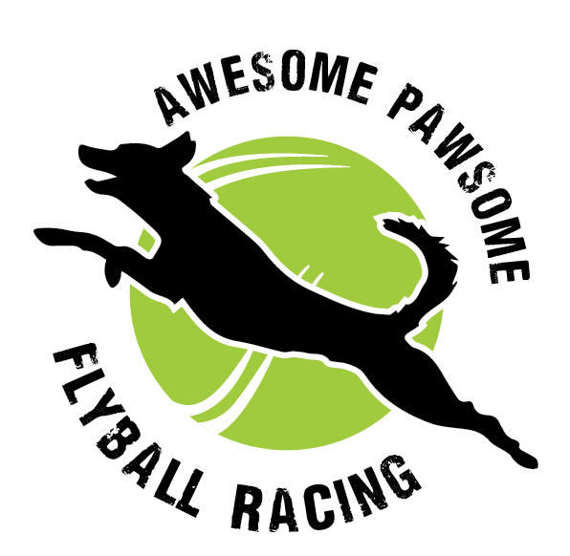
Northern Rivers Flyball Rookies
ENTRIES CLOSE SATURDAY 25TH JULY

21st AUGUST 2026
ALSTONVILLE SHOWGROUNDS
6 SOUTH ST ALSTONVILLE
CHECK IN 9:30AM
10AM START (ring set up prior)
AFA REP: CANDICE LEIGHTON
ORGANISER: EMMA PODMORE

Vets
- 24hr ANIMAL EMERGENCY SERVICE Unit 1 Bangalow Business Centre Dudgeons Lane, Bangalow 02 72554095
- BALLINA COAST VETS 25a Racecourse Rd, Ballina 02 66869333. Fri 7am-7pm Sat 8am-12pm
- ALSTONVILLE VET 4 Daley St, Alstonville 02 66285262. Fri 8:30am-5:30pm Sat 8:30am-12:30pm

Club coordinators please make sure that your members are aware of the following:
- Dogs are to remain on lead and in control at all times, when outside the ring.
- Dogs are not to enter the toilet/shower or the kitchen block
- Please pick up after your dog and dispose in the bins provided
- Participants will not have access to the onsite kitchen, please plan your meals accordingly
- As per AFA rules, all participants must have a valid CRN
- Dogs under 12mo are not permitted to use flyball equipment

Information regarding the venue i.e entry/exit and parking will be shared as soon as possible.

