

Bunyip Show
Sunday 22nd March 2026
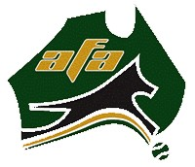

This is an AFA sanctioned event and will be run in accordance with the rules and policies of the Australian Flyball Association Inc.


Thank you to Advance for donating prizes for this event!

COMPETITION INFORMATION
Berwick Flyball would like to thank the following officials for their help on the day:

AFA Rep
Drew Harrison

Judges
Gordon Chalmers
Ula Lane

Time Keepers
Carly
Andrew

Vetting/Measuring: 8.00am
Captains briefing: 8.30am
Racing starts: 9.00am

Location: 80 Nar Nar Goon- Longwarry Road Bunyip

Food/Toilets will be available at the Show.

VET
Gippsland Pet Emergency
1 Bona Vista Road
Warragul
Ph: (03) 5623 4822

MAP

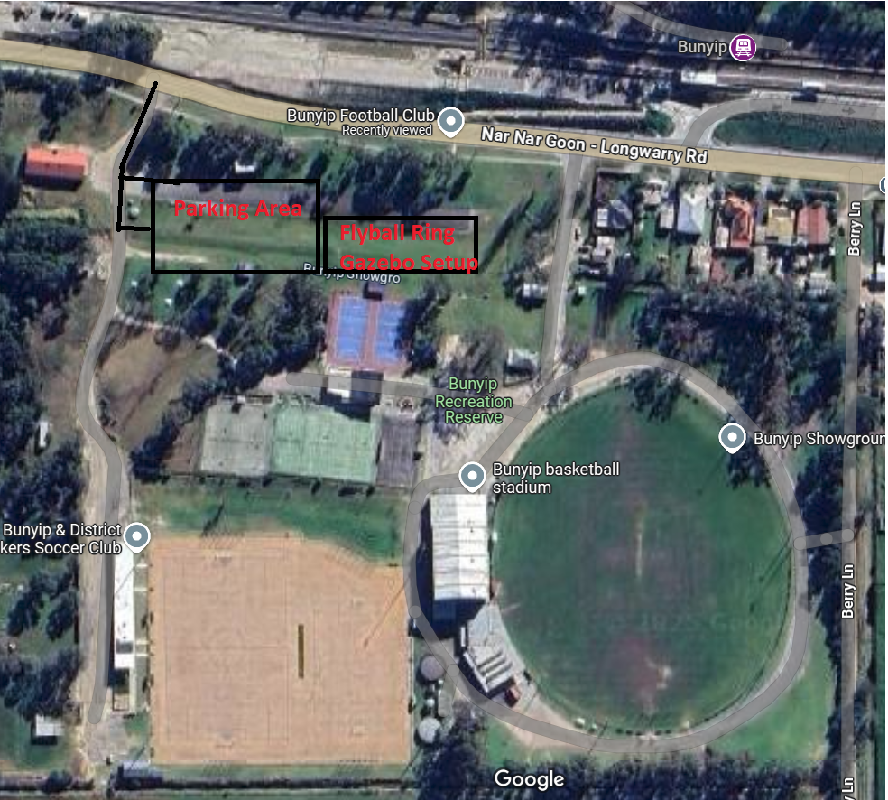

DIVISION SPLIT

Division | Team | Seed Time | W/D | B/O
Open | Berwick Pickles | 16.600 | D | 16.100 | Double Round Robin
 | T'Keilor Mystic Marvel | 20.500 | D | 20.000 | Best 3 of 5
 | Eastside Balls of Fluff | 23.500 | D | 23.000 | 18-30 Heats
 | Super Storm | 27.800 | D | 27.300 | 6 Races
Division 1 | T'Keilor Gold | 16.355 | Web | 15.855 | Double Round Robin
 | Berwick Blaze | 18.552 | Web | 18.052 | Best 3 of 5
 | VW Silly Sausages | 19.985 | Web | 19.485 | 18-30 Heats
 | Glen Iris Sit Happens | 21.600 | D | 21.100 | 6 Races

RUNNING ORDER
Time | Race | Division | Left Lane | Right Lane | Format | Judge
9.00 | 1 | Div 1 | Glen Iris Sit Happens | T'Keilor Gold | Best 3 of 5 | Ula
9.09 | 2 | Div 1 | VW Silly Sausages | Berwick Blaze | Best 3 of 5 | Ula
9.18 | 3 | Open | Super Storm | Berwick Pickles | Best 3 of 5 | Gordon
9.27 | 4 | Open | T'Keilor Mystic Marvel | Eastside Balls of Fluff | Best 3 of 5 | Gordon
9.36 |  |  | Break 20M. Training Frankston 10M/Eastside 10M
9.56 | 5 | Div 1 | T'Keilor Gold | VW Silly Sausages | Best 3 of 5 | Ula
10.05 | 6 | Div 1 | Berwick Blaze | Glen Iris Sit Happens | Best 3 of 5 | Ula
10.14 | 7 | Open | Berwick Pickles | Eastside Balls of Fluff | Best 3 of 5 | Gordon
10.23 | 8 | Open | Super Storm | T'Keilor Mystic Marvel | Best 3 of 5 | Gordon
10.32 |  |  | Break 20M. Training Glen Iris 10M
10.52 | 9 | Div 1 | VW Silly Sausages | Glen Iris Sit Happens | Best 3 of 5 | Ula
11.01 | 10 | Div 1 | T'Keilor Gold | Berwick Blaze | Best 3 of 5 | Ula
11.10 | 11 | Open | Eastside Balls of Fluff | Super Storm | Best 3 of 5 | Gordon
11.19 | 12 | Open | Berwick Pickles | T'Keilor Mystic Marvel | Best 3 of 5 | Gordon
11.28 |  |  | Lunch 1H. F'ston 15M/E'side 15M/B'wick 15M/K'lor 15M
12.28 | 13 | Div 1 | T'Keilor Gold | Glen Iris Sit Happens | Best 3 of 5 | Ula
12.37 | 14 | Div 1 | Berwick Blaze | VW Silly Sausages | Best 3 of 5 | Ula
12.46 | 15 | Open | Berwick Pickles | Super Storm | Best 3 of 5 | Gordon
12.55 | 16 | Open | Eastside Balls of Fluff | T'Keilor Mystic Marvel | Best 3 of 5 | Gordon
1.04 |  |  | Break 20M. Training Glen Iris 10M
1.24 | 17 | Div 1 | VW Silly Sausages | T'Keilor Gold | Best 3 of 5 | Ula
1.33 | 18 | Div 1 | Glen Iris Sit Happens | Berwick Blaze | Best 3 of 5 | Ula
1.42 | 19 | Open | Eastside Balls of Fluff | Berwick Pickles | Best 3 of 5 | Gordon
1.51 | 20 | Open | T'Keilor Mystic Marvel | Super Storm | Best 3 of 5 | Gordon
2.00 |  |  | Break 20M. Training Berwick 10M/Keilor 10M
2.20 | 21 | Div 1 | Glen Iris Sit Happens | VW Silly Sausages | Best 3 of 5 | Ula
2.29 | 22 | Div 1 | Berwick Blaze | T'Keilor Gold | Best 3 of 5 | Ula
2.38 | 23 | Open | Super Storm | Eastside Balls of Fluff | Best 3 of 5 | Gordon
2.47 | 24 | Open | T'Keilor Mystic Marvel | Berwick Pickles | Best 3 of 5 | Gordon

TEAMS
Division 1
T-Keilor Gold
Captain: Drew Harrison
Dogs Name | CRN | Jump Height | Handler Name | Breed
Jessie | 2830C | 9 | Drew Harrison | Border Collie
Bellatrix | 2830G | 10 | Rhiannon Wood | Border Collie
Lottie | 3160D | 10 | Bree Mitchell | Border Collie
Harry | 2830E | 11 | Drew Harrison | Border Collie X Koolie

Berwick Blaze
Captain: Paul Percival |  |  |  | Box Loader: Chris Moore
Dogs Name | CRN | Jump Height | Handler Name |  | Breed
Forrest | 1174E | 12 | April Smith |  | Whippet
Switch | 772D | 7 | Michael Perry |  | Jack Russel x Foxie
Luna | 462E | 8 | Heath Chalmers |  | Border Collie
Ned | 3110C | 13 | Sam Hartnett |  | Kelpie
Xander | 462D | 10 | Lachlan Chalmers |  | Border Collie
Kurbie | 2938A | 9 | Tiarne Moody |  | Border Collie

VW Silly Sausages
Captain: Josh Ellen |  |  |  | Box Loader: Belinda Fry
Dogs Name | CRN | Jump Height | Handler Name |  | Breed
Jesus | 1007F | 12 | Josh Ellen |  | Whippet
Juno | 3107B | 7 | Lainie Hocart |  | Tenterfield Terrier
Avery | 2801C | 7 | Katrina Coulson |  | Staffordshire Bull Terrier
Selby | 3128B | 7 | Christine Slatter |  | Staffordshire Bull Terrier
Layla | 3128A | 7 | Christine Slatter |  | Staffordshire Bull Terrier
Evie | 2960B | 12 | Carly Sorensen |  | Whippet

 | Glen Iris Sit Happens
 | Captain: Florence Chiu |  |  |  |  |  |  |  |  |  |  |  |  |  |  |  | Box Loader: Lucy Garner
 | Dogs Name |  |  |  |  | CRN |  |  | Jump Height |  |  | Handler Name |  |  |  |  |  |  |  |  | Breed
 | Ruby |  |  |  |  | 3694A |  |  | 11 |  |  | Madeleine Smith |  |  |  |  |  |  |  |  | Border collie
 | Riley |  |  |  |  | 725C |  |  | 11 |  |  | Tony Rowland |  |  |  |  |  |  |  |  | Border Collie
 | Poppy |  |  |  |  | 725E |  |  | 11 |  |  | Tony Rowland |  |  |  |  |  |  |  |  | Border Collie
 | Goldie |  |  |  |  | 3761A |  |  | 15 |  |  | Chava Rodriguez |  |  |  |  |  |  |  |  | Kelpie x Labrador
 | Snowy |  |  |  |  | 1200B |  |  | 11 |  |  | Florence Chiu |  |  |  |  |  |  |  |  | Border Collie x

Open

 | Berwick Pickles
 | PicklesCaptain: Kate Dunkley |  |  |  |  |  |  |  |  |  |  |  |  |  |  |  | Boxloader: Charles Mouton
 | Dogs Name |  |  |  |  | CRN |  |  | Jump Height |  |  | Handler Name |  |  |  |  |  |  |  |  | Breed
 | Millie |  |  |  |  | 1174C |  |  | 12 |  |  | April Smith |  |  |  |  |  |  |  |  | Kelpie x whippet
 | Midge |  |  |  |  | 3110A |  |  | 9 |  |  | Sam Hartnett |  |  |  |  |  |  |  |  | Kelpie
 | Uma |  |  |  |  | 823E |  |  | 12 |  |  | Michael Perry |  |  |  |  |  |  |  |  | Border collie
 | Stella |  |  |  |  | 2237F |  |  | 10 |  |  | Garry Woollard |  |  |  |  |  |  |  |  | Kelpie x
 | Rozz |  |  |  |  | 3110B |  |  | 10 |  |  | Sam Hartnett |  |  |  |  |  |  |  |  | Kelpie
 | Bailey |  |  |  |  | 1353C |  |  | 12 |  |  | Paul Percival |  |  |  |  |  |  |  |  | Kelpie X Border Collie

 | T’Keilor Mystic Marvel
 | Captain: Bree Mitchell
 | Dogs Name |  |  |  |  | CRN |  |  | Jump Height |  |  | Handler Name |  |  |  |  |  |  |  | Breed
 | Fung Cha |  |  |  |  | 2723C |  |  | 12 |  |  | Simon Bates |  |  |  |  |  |  |  | Kelpie
 | Twigs |  |  |  |  | 1052G |  |  | 10 |  |  | Marie Schellekens |  |  |  |  |  |  |  | Kelpie
 | Birdie |  |  |  |  | 1052H |  |  | 10 |  |  | Max Schellekens |  |  |  |  |  |  |  | Border Collie
 | Gus |  |  |  |  | 552F |  |  | 7 |  |  | Rohan Richardson |  |  |  |  |  |  |  | Terrier Cross
 | Bailey |  |  |  |  | 1134D |  |  | 10 |  |  | Ula Lane |  |  |  |  |  |  |  | Kelpie

 | Eastside Ball of Fluff
 | Captain: Bronwyn Ruigrok
 | Dogs Name |  |  |  |  | CRN |  |  | Jump Height |  |  | Handler Name |  |  |  |  |  |  |  |  | Breed
 | Luci |  |  |  |  | 2714C |  |  | 10 |  |  | Jolien Van der knoop |  |  |  |  |  |  |  |  | Kelpie x bc
 | Chase |  |  |  |  | 2714B |  |  | 11 |  |  | Bronwyn Ruigrok |  |  |  |  |  |  |  |  | Kelpie x BC
 | Mac |  |  |  |  | 3211A |  |  | 9 |  |  | Gaby Smith |  |  |  |  |  |  |  |  | Staffordshire bull terrier
 | Ruby |  |  |  |  | 3732A |  |  | 10 |  |  | Michael D’Angelo |  |  |  |  |  |  |  |  | Kelpie
 | Oslo |  |  |  |  | 3640B |  |  | 7 |  |  | Bella Butterworth |  |  |  |  |  |  |  |  | Japanese Spitz
 | Mila |  |  |  |  | 3640A |  |  | 10 |  |  | Bella Butterworth |  |  |  |  |  |  |  |  | Bordercollie Koolie Mix

 | Super Storm
 | Captain: Jessica Thompson |  |  |  |  |  |  |  |  |  |  |  |  |  |  | Boxloader: Charles Mouton
 | Dogs Name |  |  |  |  | CRN |  |  | Jump Height |  |  | Handler Name |  |  |  |  |  |  |  |  | Breed
 | Milo |  |  |  |  | 3375A |  |  | 11 |  |  | Jessica Thompson |  |  |  |  |  |  |  |  | Border Collie
 | Mocha |  |  |  |  | 2338D |  |  | 12 |  |  | Diane Gnieslaw |  |  |  |  |  |  |  |  | Labrador retriever
 | Bozz |  |  |  |  | 690G |  |  | 7 |  |  | Barbara OBrien |  |  |  |  |  |  |  |  | Yorkshire Terrier
 | Minx |  |  |  |  | 690D |  |  | 7 |  |  | Barbara OBrien |  |  |  |  |  |  |  |  | Spoodle
 | Tilly |  |  |  |  | 690F |  |  | 7 |  |  | Kate Dunkley |  |  |  |  |  |  |  |  | Spoodle
 | Zeke |  |  |  |  | 690E |  |  | 7 |  |  | Kate Dunkley |  |  |  |  |  |  |  |  | Spoodle

