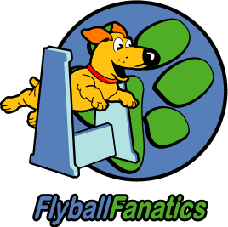

presents

Flyball on the Field 2026

Sunday 3rd May 2026
Croatian Club Brisbane, Rocklea

Thank you to our sponsors
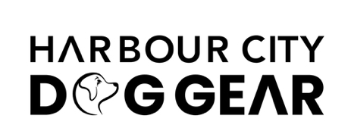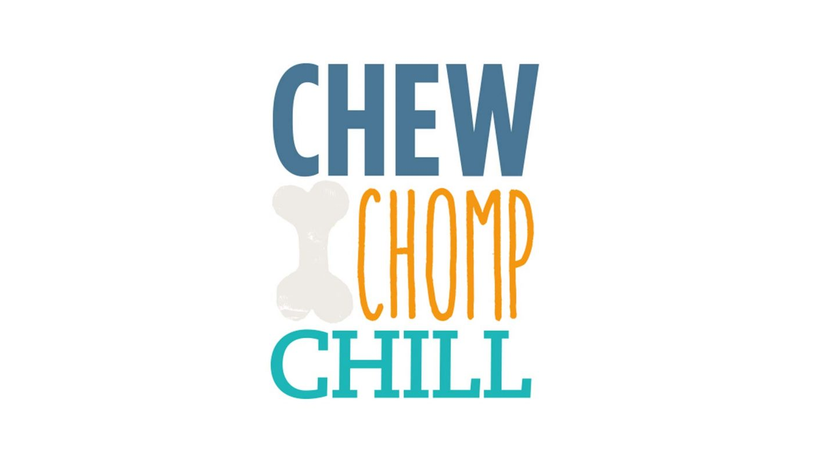

Flyball Fanatics would like to welcome you to the competition and thank you for your support. Good luck to all teams for some safe and fun racing!

Officials

Judge s Steve Pitt Ben Royes Jason Tyrer

Timekeepers Mike McChesney Kim Kaim Holly Gormley

AFA Representative Jesse Tosch

Nearest Emergency Vet

Animal Referral Hospital Animal Emergency Service
532 Seventeen Mile Rocks Road 34 Goggs Road
Sinnamon Park Q 4073 Jindalee Q 4074
Ph: 07 3172 0593 Ph: 07 3062 7686

Rules and Racing Format

This is an AFA Sanctioned event and will be run in accordance with all the Rules and Policies of the Australian Flyball Association Inc.

Div | Races | Format | Maximum Heats per Team
1 | Round Robin – 6 races per team - handicap | Best 3 of 5 heats | 30
2 | Round Robin – 6 races per team – handicap | Best 3 of 5 heats | 30
3 | Round Robin – 6 races per team – handicap | Best 3 of 5 heats | 30
Open | Round Robin – 8 races per team – no handicap | Best of 3 of 5 heats, then 3 heats | 32

Division Splits - Flyball on the Field 2026
Division 1
Paws of Lightning | 17.501 | Handicap, 6 races best 3 of 5 heats
Fanatic Force | 18.519 | Handicap, 6 races best 3 of 5 heats
First Krush | 18.787 | Handicap, 6 races best 3 of 5 heats
Chasing Tail-spin | 19.080 | Handicap, 6 races best 3 of 5 heats
Division 2
Paws of Fire | 20.451 | Handicap, 6 races best 3 of 5 heats
Luvadog Regardless | 22.200 (D) | Handicap, 6 races best 3 of 5 heats
Paws of Thunder | 24.051 | Handicap, 6 races best 3 of 5 heats
Fanatic Fury | 24.161 (D) | Handicap, 6 races best 3 of 5 heats
Division 3
Paws of Chaos | 27.071 | Scratch, 6 races best 3 of 5 heats
Backyard Buddies | 27.513 | Scratch, 6 races best 3 of 5 heats
Fanatic Flare | 28.000 (D) | Scratch, 6 races best 3 of 5 heats
Open Division
Just Plane Fast | 18.500 | Handicap, 8 races best 3 of 5 heats then 3 heats
Skidmarks | 20.700 | Handicap, 8 races best 3 of 5 heats then 3 heats
Fanatic Krushers | 22.500 | Handicap, 8 races best 3 of 5 heats then 3 heats
Fur Fun | 25.500 | Handicap, 8 races best 3 of 5 heats then 3 heats
Ruff and Ready | 27.000 | Handicap, 8 races best 3 of 5 heats then 3 heats

