CANBERRA ROYAL FLYBALL RACING EVENT
SAT CAF 1143
SUN CAF 1142

FRI/SAT/SUN FEBRUARY 24-26TH 2024
CANBERRA ROYAL SHOW
EXHIBITION PARK
ACT
Entry via Gate 4
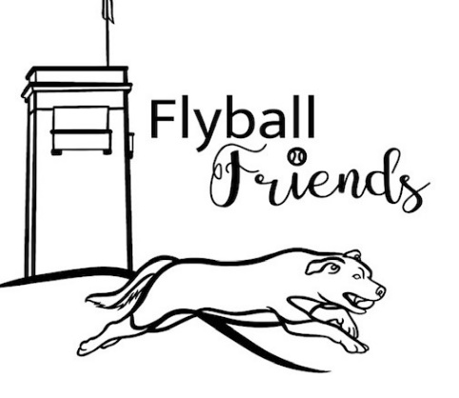

Welcome to the 2024 Canberra Royal Flyball Racing Event
Our sincere thanks go to the AFA Rep, Judges, Timekeepers, Stewards, and all who have helped to make this event a success.

Comp Organiser: Fiona Bulman

Comp Secretary: Tony Blaxland

Judges: Robyn Addie, Christine Bates, Paul Newman,
Ben Royes

Timekeepers: Gavin Bland, Richard Mellon, Christa Mellon
Kathryn Royes

AFA Rep: Verdelle Townsend

Nearest Vet:
Canberra Veterinary Emergency Service
21 Crinigan Circuit
Gungahlin
Ph: 6225 7257
Open 24hrs

Itinerary:
Check in, Measuring & Vetting 7.30am
Judge’s Briefing: 8:15 am
Racing starts 8.45 am
Raffle & Presentations Sat end of day. Sun: After ring pack up

Thank you for supporting our comp we hope you have a great day & please drive home safely
Competition Race Format:

In the event of tied places at the end of the competition, the AFA countback rule will apply.

Rules & Regulations
- All Competitors must ensure dogs are on lead when not racing and all dog faeces are disposed of in the appropriate manner.
- All dogs to remain in the Dedicated Flyball arena unless walking to & from parking.

All racing will be conducted under the rules and regulations of the Australian Flyball Association.

Break Outs
The AFA Break Out rule will be applied for all breakout occurrences.

Changeover Times
Teams will have 90 sec from the end of the proceeding race to have their box and jumps set up and be ready to race.

Stewarding
All teams are requested to participate in the stewarding throughout the day to ensure the smooth running of the competition.

Beginner training
Dedicated beginner ring available for clubs to use throughout the day. Please ensure dogs have been registered with competition organisers, follow all AFA rules & regulations and a nominated supervisor is present.

THANK YOU TO OUR SPONSORS SUPPORTERS & STALL HOLDERS

Black Hawk

SATURDAY Regular Teams Entered
DIVISION | TEAM NAME | Seed Time | Web/Dec | B/0 | Format
Div 1 | CANBERRA X FACTOR | 17.157 | WEB | 16.6 | Handicapp
Div 1 | TIDAL WAVE | 18.719 | WEB | 18.2 | Triple Round Robin
Div 1 | FANATIC FORCE | 17.9 | DEC | 18.4 | Best of 5 heats
Div 2 | UNLEASHED FURY | 20 | DEC | 19.5 | Scratch
Div 2 | PAWTATOES | 20.2 | DEC | 19.7 | Triple Round Robin
Div 2 | SCALLYWAG SCOUNDRELS | 20.493 | WEB | 19.5 | Best of 5 Heats
Div 3 | WOOFERS 1 | 21 | DEC | 20.5 | Scratch
Div 3 | BELCONNEN DODGA BULLETS | 21.006 | WEB | 20.5 | Triple Round Robin
Div 3 | FANATIC FURY | 21.44 | WEB | 20.5 | Best of 5 Heats
Div 4 | SYDNEYSIDERS | 22.4 | DEC | 21.9 | Handicapp
Div 4 | VIPERS | 23.1 | DEC | 22.6 | Triple Round Robin
Div 4 | WIDDLE WOOFERS | 29 | DEC | 28.5 | Best of 5 heats

SATURDAY Open Teams Entered

DIVISION | TEAM NAME | Seed Time | Web/Dec | B/0 | Format
Open 1 | Unleash the MADness | 17.3 | DEC | n/a | Scratch
Open 1 | Power Pups | 17.8 | DEC | n/a | Triple Round Robin
Open 1 | Bay Racers | 18 | DEC | n/a | Best of 5 Heats
Open 2 | We love this | 21.5 | DEC | 21.0 | Handicapped
Open 2 | Flyball Friends | 21.5 | DEC | 21.0 | Double Round Robin
Open 2 | MAD Flyers | 22 | DEC | 21.5 | Best of 5 heats
Open 2 | Scallywag Terrors | 24.973 | DEC | 24.4

Saturday Running Order

Race | Div | Left Lane | Right Lane
1 | 1 | Fanatic Force | Canberra X Factor
2 | 2 | Scallywag Scoundrels | Unleashed Fury
3 | 4 | Widdle Woofers | Sydneysiders
4 | O1 | Bay Racers | Unleash the MADness
5 | 3 | Fanatic Fury | Woofers 1
6 | O2 | Scallywag Terrors | We Love This
7 | O2 | Flyball Friends | MAD Flyers
8 | 1 | Tidal Wave | Fanatic Force
9 | 2 | Pawtatoes | Scallywag Scoundrels
10 | 4 | Vipers | Widdle Woofers
11 | O1 | Power Pups | Bay Racers
12 | 3 | Belconnen Dodgeda Bullets | Fanatic Fury
13 | O2 | We Love This | MAD Flyers
14 | 1 | Canberra X Factor | Tidal Wave
15 | 2 | Unleashed Fury | Pawtatoes
16 | 4 | Sydneysiders | Vipers
17 | O1 | Unleash the MADness | Power Pups
18 | 3 | Woofers 1 | Belconnen Dodgeda Bullets
19 | O2 | Scallywag Terrors | Flyball Friends
20 | 1 | Canberra X Factor | Fanatic Force
21 | 2 | Unleashed Fury | Scallywag Scoundrels
22 | 4 | Sydneysiders | Widdle Woofers
23 | O1 | Unleash the MADness | Bay Racers
24 | 3 | Woofers 1 | Fanatic Fury
25 | O2 | We Love This | Flyball Friends
26 | O2 | MAD Flyers | Scallywag Terrors
27 | 1 | Fanatic Force | Tidal Wave
28 | 4 | Widdle Woofers | Vipers
29 | 2 | Scallywag Scoundrels | Pawtatoes
30 | O1 | Bay Racers | Power Pups
31 | 3 | Fanatic Fury | Belconnen Dodgeda Bullets
32 | O2 | MAD Flyers | Flyball Friends
33 | 1 | Tidal Wave | Canberra X Factor
34 | 2 | Pawtatoes | Unleashed Fury
35 | 4 | Vipers | Sydneysiders
36 | O1 | Power Pups | Unleash the MADness
37 | 3 | Belconnen Dodgeda Bullets | Woofers 1
38 | O2 | We Love This | Scallywag Terrors
39 | 1 | Fanatic Force | Canberra X Factor
40 | 2 | Scallywag Scoundrels | Unleashed Fury
41 | 4 | Widdle Woofers | Sydneysiders
42 | O1 | Bay Racers | Unleash the MADness
43 | 3 | Fanatic Fury | Woofers 1
44 | O2 | Flyball Friends | Scallywag Terrors
45 | O2 | MAD Flyers | We Love This
46 | 1 | Tidal Wave | Fanatic Force
47 | 2 | Pawtatoes | Scallywag Scoundrels
48 | 4 | Vipers | Widdle Woofers
49 | O1 | Power Pups | Bay Racers
50 | 3 | Belconnen Dodgeda Bullets | Fanatic Fury
51 | O2 | Scallywag Terrors | MAD Flyers
52 | 1 | Canberra X Factor | Tidal Wave
53 | 2 | Unleashed Fury | Pawtatoes
54 | 4 | Sydneysiders | Vipers
55 | O1 | Unleash the MADness | Power Pups
56 | 3 | Woofers 1 | Belconnen Dodgeda Bullets
57 | O2 | Flyball Friends | We Love This

SUNDAY Regular Teams Entered
DIVISION | TEAM NAME | Seed Time | Web/Dec | B/0 | Format
Div 1 | CANBERRA X FACTOR | 17.157 | WEB | 16.6 | Handicapp
Div 1 | TIDAL WAVE | 18.719 | WEB | 18.2 | Triple Round Robin
Div 1 | FANATIC FORCE | 17.9 | DEC | 18.4 | Best of 5 heats
Div 2 | UNLEASHED FURY | 20 | DEC | 19.5 | Scratch
Div 2 | PAWTATOES | 20.2 | DEC | 19.7 | Triple Round Robin
Div 2 | SCALLYWAG SCOUNDRELS | 20.493 | WEB | 19.5 | Best of 5 Heats
Div 3 | WOOFERS 1 | 21 | DEC | 20.5 | Scratch
Div 3 | BELCONNEN DODGA BULLETS | 21.006 | WEB | 20.5 | Triple Round Robin
Div 3 | FANATIC FURY | 21.44 | WEB | 20.5 | Best of 5 Heats
Div 4 | ROCKY HILL RACERS | 22.316 | WEB | 21.8
Div 4 | SYDNEYSIDERS | 22.4 | DEC | 21.9 | Handicapp
Div 4 | TUGGERANONG SCREAMING TORPEDOES | 22.5 | DEC | 22.0 | Double Round Robin
Div 4 | WIDDLE WOOFERS | 29 | DEC | 28.5 | Best of 5 heats

SUNDAY Open Teams Entered

DIVISION | TEAM NAME | Seed Time | Web/Dec | B/0 | Format
Open 1 | Unleash the MADness | 17.3 | DEC | n/a | Scratch
Open 1 | Power Pups | 17.8 | DEC | n/a | Triple Round Robin
Open 1 | Bay Racers | 18 | DEC | n/a | Best of 5 Heats
Open 2 | We love This | 21.5 | DEC | 21.0 | Handicapped
Open 2 | High Flyers | 21.5 | DEC | 21.0 | Double Round Robin
Open 2 | MAD Flyers | 22 | DEC | 21.5 | 3 heats
Open 2 | Scallywag Terrors | 24.973 | DEC | 24.4
Open 2 | Flyball Besties | 28 | DEC | 27.5

Sunday Running Order

Race | Div | RIGHT LANE | LEFT LANE
1 | O2 | Scallywag Terrors | We Love This
2 | O2 | Flyball Besties | High Flyers
3 | 1 | Fanatic Force | Canberra X Factor
4 | 2 | Scallywag Scoundrels | Unleashed Fury
5 | 4 | Widdle Woofers | Rocky Hill Racers
6 | O1` | Bay Racers | Unleash the MADness
7 | 4 | Sydneysiders | Tuggeranong Screaming Torpedoes
8 | 3 | Fanatic Fury | Woofers 1
9 | O2 | MAD Flyers | Flyball Besties
10 | 02 | High Flyers | Scallywag Terrors
11 | 1 | Tidal Wave | Fanatic Force
12 | 4 | Rocky Hill Racers | Tuggeranong Screaming Torpedoes
13 | 2 | Pawtatoes | Scallywag Scoundrels
14 | O1 | Power Pups | Bay Racers
15 | 3 | Belconnen Dodgeda Bullets | Fanatic Fury
16 | O2 | Scallywag Terrors | Flyball Besties
17 | 02 | We Love This | MAD Flyers
18 | 1 | Canberra X Factor | Tidal Wave
19 | 2 | Unleashed Fury | Pawtatoes
20 | 4 | Widdle Woofers | Sydneysiders
21 | O1 | Unleash the MADness | Power Pups
22 | 3 | Woofers 1 | Belconnen Dodgeda Bullets
23 | O2 | Flyball Besties | We Love This
24 | O2 | High Flyers | MAD Flyers
25 | 1 | Canberra X Factor | Fanatic Force
26 | 2 | Unleashed Fury | Scallywag Scoundrels
27 | 4 | Tuggeranong Screaming Torpedoes | Widdle Woofers
28 | O1 | Unleash the MADness | Bay Racers
29 | 4 | Rocky Hill Racers | Sydneysiders
30 | 3 | Woofers 1 | Fanatic Fury
31 | 02 | MAD Flyers | Scallywag Terrors
32 | O2 | We Love This | High Flyers
33 | 1 | Fanatic Force | Tidal Wave
34 | 2 | Scallywag Scoundrels | Pawtatoes
35 | 4 | Rocky Hill Racers | Widdle Woofers
36 | O1 | Bay Racers | Power Pups
37 | 3 | Fanatic Fury | Belconnen Dodgeda Bullets
38 | O2 | High Flyers | Flyball Besties
39 | O2 | We Love This | Scallywag Terrors
40 | 1 | Tidal Wave | Canberra X Factor
41 | 2 | Pawtatoes | Unleashed Fury
42 | 4 | Tuggeranong Screaming Torpedoes | Sydneysiders
43 | O1 | Power Pups | Unleash the MADness
44 | 3 | Belconnen Dodgeda Bullets | Woofers 1
45 | O2 | Scallywag Terrors | High Flyers
46 | O2 | Flyball Besties | MAD Flyers
47 | 1 | Fanatic Force | Canberra X Factor
48 | 2 | Scallywag Scoundrels | Unleashed Fury
49 | 4 | Sydneysiders | Widdle Woofers
50 | 4 | Tuggeranong Screaming Torpedoes | Rocky Hill Racers
51 | O1 | Bay Racers | Unleash the MADness
52 | 3 | Fanatic Fury | Woofers 1
53 | O2 | Flyball Besties | Scallywag Terrors
54 | O2 | MAD Flyers | We Love This
55 | 1 | Tidal Wave | Fanatic Force
56 | 2 | Pawtatoes | Scallywag Scoundrels
57 | 4 | Widdle Woofers | Tuggeranong Screaming Torpedoes
58 | O1 | Power Pups | Bay Racers
59 | 3 | Belconnen Dodgeda Bullets | Fanatic Fury
60 | O2 | High Flyers | We Love This
61 | 02 | Scallywag Terrors | MAD Flyers
62 | 1 | Canberra X Factor | Tidal Wave
63 | 2 | Unleashed Fury | Pawtatoes
64 | 4 | Sydneysiders | Rocky Hill Racers
65 | O1 | Unleash the MADness | Power Pups
66 | 3 | Woofers 1 | Belconnen Dodgeda Bullets
67 | O2 | We Love This | Flyball Besties
68 | O2 | MAD Flyers | High Flyers

TEAM SET UP MAP
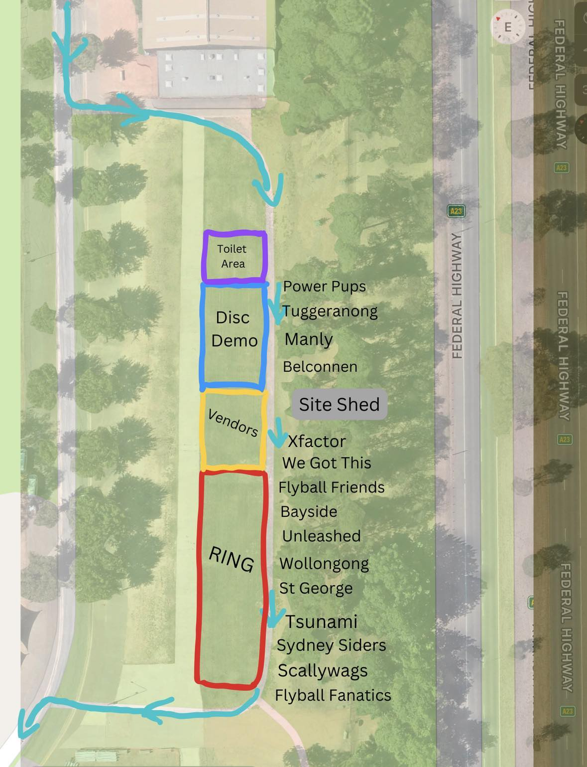
MONSTER RAFFLE
TICKETS
1 TICKET $2.00
3 TICKETS $5.00
7 TICKETS $10.00

Cash or Card available
Raffle drawn following Sunday’s racing

