BASS COAST SHOW 2015

FLYBALL COMPETITION

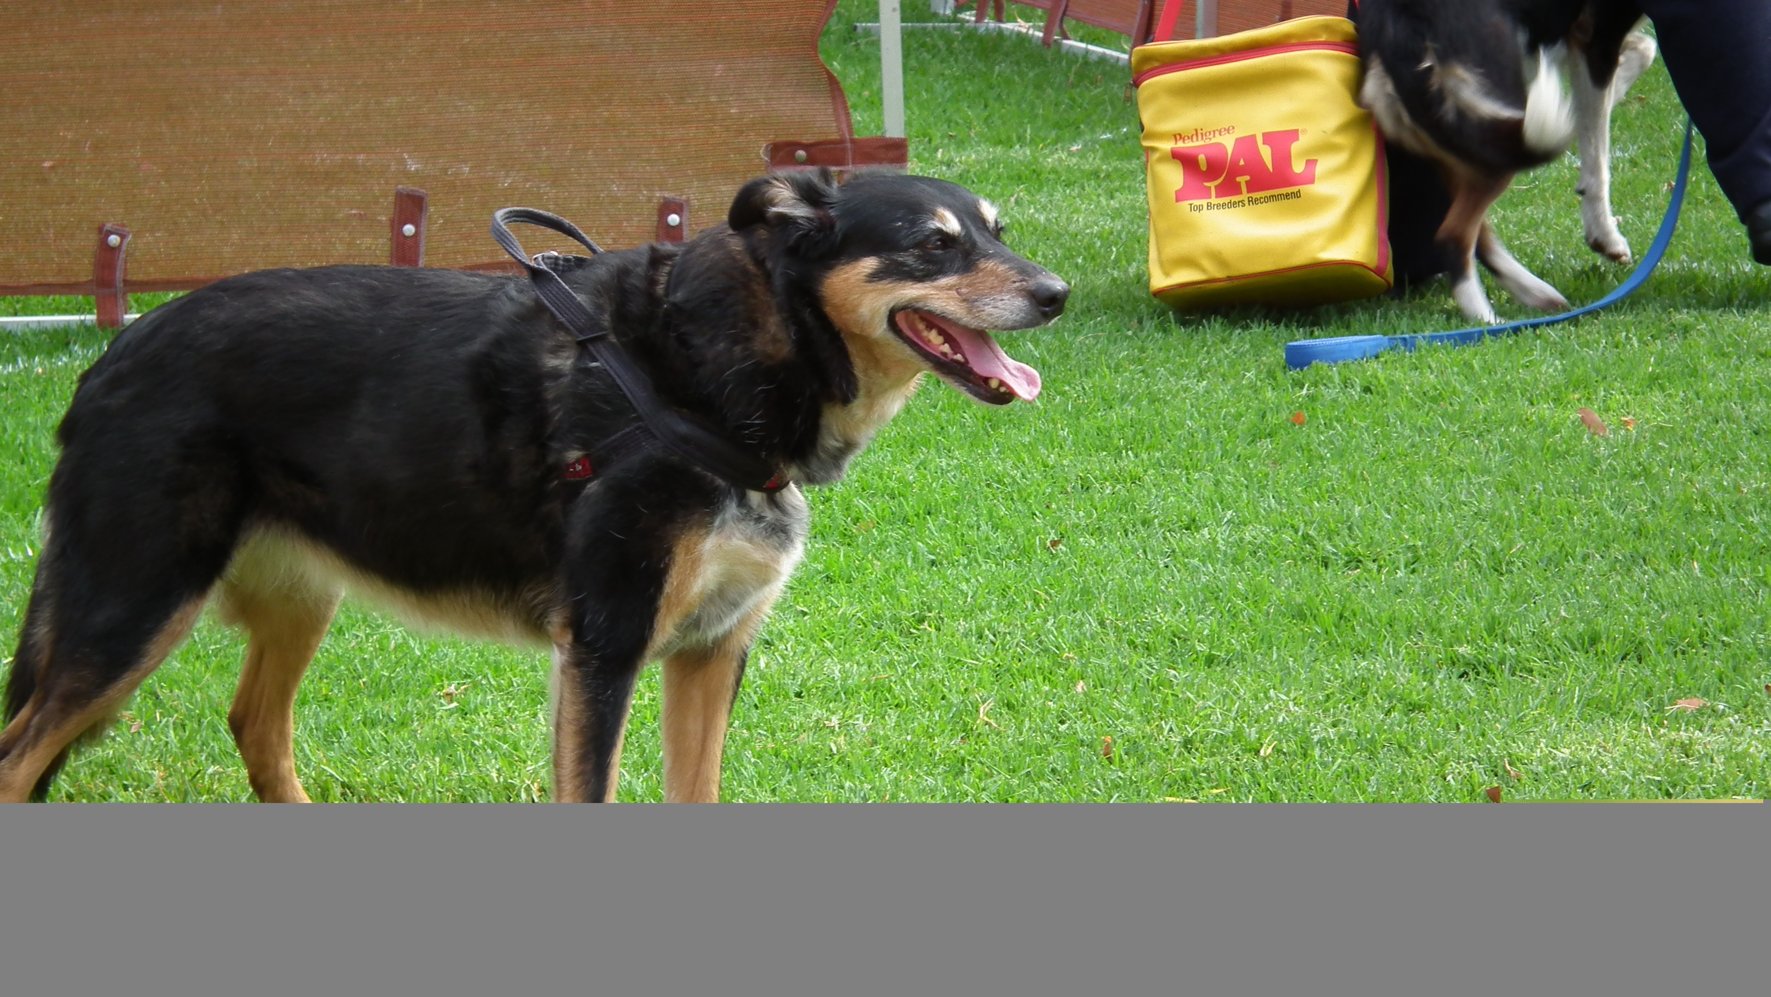

Hosted by Hastings & District Obedience Dog Club Inc

Hastings & District Obedience Dog Club would like to welcome all competitors to our 2015 Bass Coast Show flyball competition.

There are many people we wish to thank for making today’s competition possible – especially the following people for keeping everything running in an orderly fashion.

Comp Organizer: Jenny Millar

Judges: Emma Le Cras Ian Gauntlett David Strang

Timekeepers: Trevor Nicholls Helen Gauntlett

AFA Representative: Anne Coleman

Without these people competitions like this would not be possible.

Also Thank you to Berwick for the use of the start/run back tapes.

Lastly but by no means least, Thank You to all the competitors that make these competitions so enjoyable.

Veterinarians

Wonthaggi Vet Clinic
Opposite TAFE on Bass Hwy
Phone: 56721044

Emergency 24 hour no: 0418512058

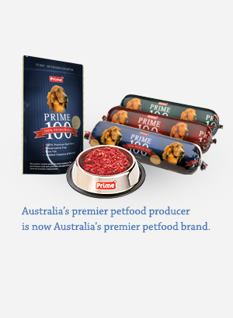

Racing Format

Division 1 4 races x 3 hts + 4 races x 3 hts = 24 heats

Division 2 2 races x 5 hts + 2 races x 3 hts + 2 races x 3 heats = 22 heats

Division 3 2 races x 5 hts + 2 races x 3 hts + 2 races x 3 hts = 22 heats

Division 4 2 races x 5 hts + 2 races x 3 hts + 2 races x 3 hts = 22 heats

Division 5 2 races x 5 ht + 2 races x 3 heats + 2 races x 3 hts = 22 heats

Division 6 3 races x 5 hts + 3 races X 3 hts = 24 heats

Rules

This is an AFA sanctioned event and will be run in accordance with the Rules and Policies of the Australian Flyball Association Inc.

The AFA approved Count Back Rule
Count back is based first on head to head RACE wins during competition (where more than two teams are tied the count back for each team shall be the total RACE wins scored against all the teams that are tied (the combined number of wins)); if two teams are still even the teams are compared on head to head heats; if two teams are still even – then fastest heat time head to head decides the winner.

Seed Times

Seed Time B/Out
Division One
Berwick Bladerunners 18.845 web N/A
Hot Dogs 18.931 web N/A
WonDogs Quicksilver’s 19.427 web N/A
Frankston Storm- Lightning Bolts 19.750 web N/A
Eastside Flyers Phoenix 19.968 web N/A

Division Two
Frankston Storm – Blizzards 21.143 web 20.143
WonDogs Surfs Up 21.260 web 20.143 Chilli Dogs 21.489 web 20.143

Division Three
T-Keilor Gold 22.000 dec 21.000
Hastings Howlers Hit & Run 22.298 web 21.000
Green Peppers 22.408 web 21.000

Division Four
WonDogs Cut Backs 23.000 dec 22.000
Hastings Howlers Hit & Rush 23.480 web 22.000
Ballarat Eureka Stockaders 23.610 dec 22.610

Division Five
Croydon Rocket Allsorts 24.257 web 23.257
Frankston Storm- Hurricanes 24.460 web 23.257
T-Keilor Slammers 24.900 web 23.257

Division Six
Frankston Storm – Chasers 26.000 dec 25.000
Surf Side Six 26.300 dec 25.300
Berwick Blaze 26.799 web 25.000
Berwick Bits & Pieces 27.270 web 25.000

Teams

Division One

Berwick Bladerunners Seed time: 18.845 web Captain - Belinda O’Shea Box Loader – Chris Moore
1 | Astro | Schnoodle | 7 | 2447A | Janice Turriff
2 | Penny | Border X | 13 | 2523A | Matt Hanies
3 | Frankie | Staffordshire Bull Terrier | 9 | 1273C | Belinda O’Shea
4 | Shaddow | Border X Lab | 14 | 1256B | Janet Fry
5 | Ebon | Lab X GRT | 14 | 1353A | Paul Percival
6 | Zane | Kelpie | 14 | 1174B | April Smith

Hot Dogs Seed time: 18.931 web Captain – Sally Laity Box Loader – Emma Le Cras
1 | Flite | Border Collie |  | 823D | Mike Perry
2 | Belle | Border Collie |  | 772B | Sally Laity
3 | Flea | Border Collie |  | 1007A | Mechelle Ellen
4 | Switch | JRT X | 8 | 772D | Mike Perry
5 | Lewie | Working Cocker Spaniel |  | 2626C | Sammy Brown

WonDogs Quicksilver’s Seed time: 19.427 web Captain – Cathy Trudinger Box Loader – Debbie Murray
1 | Hamish | Border Collie | 14 | 1096B | Laurie Heyward
2 | Phoenix | Border Collie | 14 | 244D | Mark Cheshire
3 | Skip | Border Collie | 14 | 244F | Penny Lloyd
4 | Sparkie | Border Collie | 14 | 1096C | Lorraine Heyward
5 | Declan | Shetland Sheepdog | 11 | 2529B | Carole King

Frankston Storm – Lightning Bolts Seed time: 19.750 web Captain – Louise Hamilton Box Loader –
1 | Ash | Poodle X Shitzu | 7 | 1266B | Ann Harlond
2 | Willow | Border Collie | 13 | 1312B | James Wood
3 | Dakota | Border Collie X | 14 | 2408B | Taylor Dearden
4 | Chad | Border Collie | 14 | 2524B | Paul Louziutis
5 | Coco | Kelpie | 14 | 2342A | Louise Hamilton
6 | Kenny | Border Collie | 14 | 2315B | David Sharp

Eastside Flyers Phoenix Seed time: 19.968 web Captain – Anne Coleman Box Loader – Jacinta
1 | Shae | Border Collie | 14 | 2121A | Bronni Metha
2 | Spark | Border Collie | 14 | 2121B | Andrew Metha
3 | Maddi | Border Collie | 13 | 296D | Pam Atkinson
4 | Max | Labrador x Border Collie | 14 | 2319A | Ursula Tems
5 | Daisy | Border Collie | 14 | 2319B | Ursula Tems
6 | Shah | Border Collie | 14 | 858B | Anne Coleman

Division Two

Frankston Storm - Blizzards Seed time: 21.143 web Captain – Lauren Dolley Box Loader -
1 | Jovi | NSDTR | 11 | 1076C | Natasha Sleep
2 | Bowie | Border Collie | 14 | 1312A | James Wood
3 | Ella | Maremma X | 14 | 2199A | Lauren Dolley
4 | Jodie | Labrador | 14 | 2338A | Dianne Gnieslaw
5 | Ruby | Border Collie | 14 | 2649A | Jacinta Wellsted
6 | Colby | Border Collie X | 14 | 2675A | Juanita Spinelli

WonDogs Surfs Up Seed time: 21.260 web Captain – Sandra Jerger Box Loader – Debbie Murray
1 | Molley | Border Collie | 14 | 1203B | Jennifer Phillips
2 | Zac | Kelpie | 14 | 1203A | Jennifer Phillips
3 | Merlin | Border Collie | 14 | 244E | Penny Lloyd
4 | Bailey | Border Collie | 14 | 178C | Cathy Trudinger
5 | Cindy | Border Collie | 14 | 92E | Eric Van Zuyden
6 | Echo | Border Collie / JRT | 8 | 1320A | Helen O’Brien

Chilli Dogs Seed time: 21.489 web Captain – Sammy Brown Box Loader – Emma Le Cras
1 | Romi | Border Collie |  | 823C | Mike Perry
2 | Bundy | Mastiff x |  | 772C | Sally Laity
3 | Stitch | Border Collie |  | 2626A | Chris Brown
4 | Leroy | JRT | 7 | 823D | Hayley Ellen
5 | Maggie-Mae | Bearded Collie X |  | 2626B | Sammy Brown

Division Three

T-Keilor Gold Seed time: 22.000 dec Captain – Garry Woollard Box Loader – Linda Hutchinson
1 | Lenny | Kelpie | 14 | 1052D | Max Schellekens
2 | Pinotage | Rough Collie | 14 | 88D | Sandra Crowley
3 | Miss Sylvie | Border Collie | 12 | 2237C | Garry Woollard
4 | Dexter | Staffy X | 8 | 552C | Julie Merryfull
5 | Syrah | Rough Collie | 14 | 88C | Bryan Crowley
6 | Abbey | Jack Russell | 7 | 1044C | Carol Di Teodoro

Hastings Howlers Hit & Run Seed time: 22.298 web Captain – Leah Rawlings Box Loader – Rob Millar
1 | Phineas | Poodle / Coolie | 10 | 234C | Carole Denehey
2 | Polly | Papillon | 7 | 234E | Carole Denehey
3 | Ajay | Border Collie | 14 | 190D | Jenny Millar
4 | Diesel | Border Collie / Kelpie | 14 | 2506A | Leah Rawlings
5 | Foxie | Border Collie | 14 | 2550A | Jessica Townsend
6 | Koby | Border Collie | 14 | 2197A | David Strang

Green Peppers Seed time: 22.408 web Captain – Lyn Cutajar Box Loader –
1 | Zack | Border / Jack Russell | 10 | 1140C | Jeanette Sleebs
2 | Jack | Schnauzer | 9 | 2314A | Ann Gorton
3 | Sam | Portuguese Water Dog | 14 | 2314B | Ann Gorton
4 | Roxy | Jack Russell | 7 | 688C | Lyn Cutajar
5 | Chester | Border Collie | 14 | 2657A | Pauline Williams
6 | Jango | German S/hair Poniter | 14 | 1140D | Jeanette Sleebs

Division Four

WonDogs Cut Backs Seed time: 23.000 dec Captain – Danielle Basile Box Loader – Penny Lloyd
1 | Sally | Border Collie | 14 | 1203C | Jennifer Phillips
2 | Charli | Jack Russell | 7 | 1203G | Jennifer Phillips
3 | Indigo | Border Collie | 12 | 577C | Tracie Ainsworth
4 | Cozmo | Border Collie | 14 | 577E | Danielle Basile
5 | Caspa | Toy Poodle | 7 | 2530A | Sandra Jerger
6 | Spinner | Kelpie | 14 | 1203H | Jennifer Phillips

Hastings Howlers Hit & Rush Seed time: 23.480 web Captain – Kate Dunkley Box Loader – Rob Millar
1 | Millie | Kelpie | 14 | 915A | John Partyka
2 | Remy | Aust Shepherd | 13 | 2313A | Leah Rawlings
3 | Ruby | Border Collie | 14 | 2581A | Pauline Dodd
4 | Minx | Spoodle | 9 | 690D | Kate Dunkley
5 | Grace | Cocker Spaniel | 9 | 2509A | Denise Halliwell
6 | D’artagnan | Toy Poodle | 7 | 234D | Carole Denehey

Ballarat Eureka Stockaders Seed time: 23.610 dec Captain – Jane House/Karen Bishop Box Loader – Des House
1 | Charlie | Cairn Terrier | 7 | 516B | Bill Reynolds
2 | Max | Kelpie Koolie X | 14 | 2179B | Jane House
3 | Zee | Border Collie | 14 | 1013B | Jenny Van Dromme
4 | Wombey | Border Collie | 14 | 2334A | David Pollard
5 | Archie | Border Collie | 14 | 2502A | Rachael Feeley
6 | Jacqui | Kelpie | 14 | 1159C | Karen Bishop

Division Five

Croydon Rocket Allsorts Seed time: 24.257 web Captain – Fran Campbell Box Loader –
1 | Candy | JRT X | 7 | 1116B | Rachael Campbell
2 | Samson | Border Collie | 14 | 2520A | Lynn Brown
3 | Pebbles | JRT X | 7 | 1065A | Caz Floyd
4 | Davy | Groodle | 14 | 2583A | Fiona Buterworth
5 | Tigger | Whippet X Staffy | 14 | 1116D | Fran Campbell
6 | Marlo | Schnoodle | 7 | 2377A | Thaes White

Frankston Storm - Hurricanes Seed time: 24.460 web Captain – Megan Underwood Box Loader –
1 | Wesley | Daschound X | 8 | 2516A | Megan Underwood
2 | Lily | Daschound X | 7 | 2342B | Louise Hamilton
3 | Ruby | Labrador | 14 | 2499A | Christine Netterfield
4 | Darcy | NSDTR | 14 | 1076B | Natasha Sleep
5 | Pip | Border Collie | 14 | 2524A | Lynne Louziotis
6 | Skater | ACD | 14 | 2339A | Tazzie Eggins

T-Keilor Slammers Seed time: 24.900 web Captain – Kerryn Martin Box Loader – Sandra Crowley
1 | Kyla | NSDTR | 12 | 782B | Joy Allen
2 | Honey | Jack Russell | 7 | 1044B | Carol Di Teodoro
3 | Doug | Golden Retriever | 14 | 786B | Leslie Loveday
4 | Bailey | Spoodle | 11 | 1268A | Kerryn Martin
5 | Ollie | Border Collie | 14 | 2227A | Gerard Lynch
6 | Choccy | Staffy X | 8 | 552D | Julie Merryfull

Division Six

Frankston Storm - Chasers Seed time: 26.000 dec Captain – Taylor Dearden Box Loader –
1 | Rufus | Tenterfield Terrier | 7 | 1157B | Romayne Berenger
2 | Morgan | Chinese Crested | 9 | 1266C | Ann Harlond
3 | Renee | Poodle | 14 | 2445A | Joyce Millson
4 | Stryker | Border Collie / Australian Shepherd | 14 | 2673A | Charles Mourton
5 | Gilbert | Beagle / Cocker Spaniel | 12 | 2648A | Christine Balesis
6 | Regina | Labrador | 14 | 2408A | Taylor Dearden

Surf Side Six Seed time: 26.300 dec Captain – Narelle Foulkes Box Loader – Kim Murrie
1 | Gus | JRT | 7 | 1298A | Narelle & Robert Foulkes
2 | Peabody | JRT | 7 | 58C | Rodney Gooch
3 | Dash | Border Collie | 14 | 2441A | Hope Cameron
4 | Zappa | PWS | 14 | 421C | Christine Taylor
5 | Wombat | Border Collie | 14 | 2441B | Anton Vigenser
6 | Mrs Mac | Gordon Setter | 14 | 60E | Linda Beer

Berwick Blaze Seed time: 26.799 web Captain – Belinda O’Shea Box Loader – Chris Moore
1 | Ana | Staffordshire Bull Terrier | 7 | 2541A | Monique Smith
2 | Molly | Staffordshire Bull Terrier | 10 | 1273A | Belinda O’Shea
3 | Stuart Little | Lancashire Terrier | 7 | 97B | Frances Cox
4 | Coco | Labrador X | 14 | 2217A | John Sampson
5 | Barny | Jack Russell | 7 | 1256C | Janet Fry
6 | Princess | Labrador | 14 | 1353B | Paul Percival

Berwick Bits & Pieces Seed time: 27.270 web Captain – Belinda O’Shea Box Loader – Chris Moore
1 | Grady | Kelpie X | 14 | 1134B | Ula Lane
2 | Becky | Labrador | 14 | 1316A | Dave Chalmers
3 | Pepe | Maltese X Poodle | 7 | 1134A | Ula Lane
4 | Pimms | Labrador | 14 | 2594A | Nic Hobbs
5 | River | Labrador | 14 | 2678A | Sunshine Day
6 | Jackie | Kelpie X | 11 | 1174A | April Smith



