CANBERRA ROYAL FLYBALL RACING EVENT
SAT CAF
SUN CAF

FRI/SAT/SUN FEBRUARY 20TH – 22ND 2026
CANBERRA ROYAL SHOW
EXHIBITION PARK
ACT
Entry via Gate 4
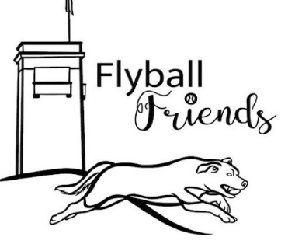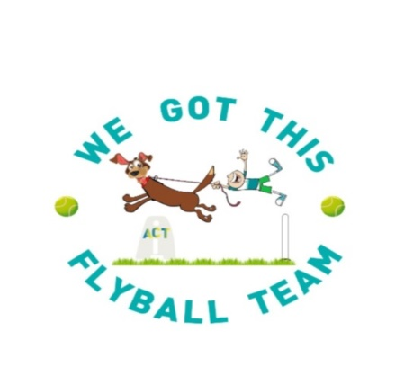

Welcome to the 2026 Canberra Royal Racing Event
Our sincere thanks go to the AFA Rep, Judges, Timekeepers, Stewards, and all who have helped to make this event a success.

Comp Organiser: Fiona Bulman

Entry Reciever: Kylie White

Judges: Christine Bates, Verdelle Townsend, Paul Newman
Assisting: Nick Baker

Supervisory Timekeepers: Gavin Bland, Richard Mellon,

AFA Rep: Friday: Verdelle Townsend
Sat & Sun: Sally Ashton

Nearest Vet:

On site vet available as required please contact Comp Organiser

Canberra Veterinary Emergency Service
21 Crinigan Circuit
Gungahlin
Ph: 6225 7257
Open 24hrs

Itinerary:
Check in, Measuring & Vetting 7.30am
Judge’s Briefing: 8:15 am
Racing starts 8.45 am
Presentations Sat end of day. Sun: After ring pack up

Competition Race Format:
In the event of tied places at the end of the competition, the AFA countback rule will apply.

Rules & Regulations
- All Competitors must ensure dogs are on lead when not racing and all dog faeces are disposed of in the appropriate manner.
- All dogs to remain in the Dedicated Flyball arena unless walking to & from parking.

All racing will be conducted under the rules and regulations of the Australian Flyball Association.

Break Outs
The AFA Break Out rule will be applied for all breakout occurrences.

Changeover Times
Teams will have 90 sec from the end of the proceeding race to have their box and jumps set up and be ready to race.

Stewarding
All teams are requested to participate in the stewarding throughout the day to ensure the smooth running of the competition.

Beginner training:
Lunch time training as per roster if time permits
THANK YOU TO OUR SPONSORS SUPPORTERS & STALL HOLDERS






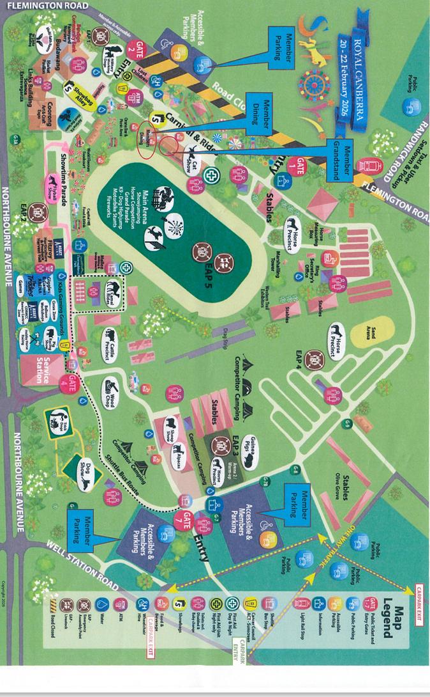Running Order for Friday 9am start

ROUND 1
BEGINNERS

CLUB | NUMBER OF DOGS | TIME ALLOCATED
SCALLYWAGS | 5 | 7MIN
FLYBALL FRIENDS | 5 | 7 MIN
SCDTC | 4 | 6 MIM
MANLY | 1 | 2 MIN
ST GEORGE | 3 | 4 MIN
CDC | 1 | 2 MIN
WGTF | 1 | 2 MIN

SINGLES
LENNY 5.0 SEC V BENNY 5.1 SEC
TIGER 7 SEC V GYPSY 10 SEC
CHARLIE 5.9 SEC V REMY 5 SEC
BRUNO 6 SEC V VIXEN 4.75 SEC

PAIRS
HOPEFULLY NO MISCHIEF 10.4 SEC V CROSS BORDERS 9.5 SEC

HOT SAUCE 10 SEC V COLLIE CHAOS 10 SEC

ROUGE WAVE 11 SEC V SMOOTH N CURLY 18 SEC

ROUND 2
BEGINNERS

CLUB | NUMBER OF DOGS | TIME ALLOCATED
SCALLYWAGS | 5 | 8MIN
FLYBALL FRIENDS | 5 | 8 MIN
SCDTC | 4 | 6 MIM
MANLY | 1 | 2 MIN
ST GEORGE | 3 | 4 MIN
CDC | 1 | 2 MIN
WGTF | 1 | 2 MIN

SINGLES

BENNY 5.1 SEC V TIGER 7 SEC
GYPSY 8.5 SEC V LENNY 5 SEC
CHARLIE 5.9 SEC V VIXEN 4.75 SEC
REMY 5 SEC V BRUNO 6 SEC

PAIRS

CROSS BORDERS 9.5 SEC V SMOOTH N CURLY 18 SEC

COLLIE CHAOS 10 SEC V HOPEFULLY NO MISCHIEF 10.4 SEC

HOT SAUCE10 SEC V ROUGE WAVE 11 SEC

ROUND 3

BEGINNERS

CLUB | NUMBER OF DOGS | TIME ALLOCATED
SCALLYWAGS | 5 | 8MIN
FLYBALL FRIENDS | 5 | 8 MIN
SCDTC | 4 | 6 MIM
MANLY | 1 | 2 MIN
ST GEORGE | 3 | 4 MIN
CDC | 1 | 2 MIN
WGTF | 2 | 2 MIN

SINGLES

BRUNO 6 SEC V CHARLIE 5.9 SEC
VIXEN 4.75 SEC V BENNY 5.1 SEC
LENNY 5 SEC V TIGER 7 SEC
GYPSY 8.5 SEC V REMY 5 SEC

PAIRS

HOT SAUCE 10 SEC V HOPEFULLY NO MISCHIEF 10.4 SEC
CROSS BORDERS 9.5 SEC V ROUGE WAVE 11 SEC
COLLIE CHAOS 10 SEC V SMOOTH N CURLY 18 SEC

BACK TO ROUND 1

SATURDAY TEAMS ENTERED

Div 1 |  |  | B/O
CDC X Factor | Canberra X-traterestrials | 17.14 | 16.6
South Coast Tsunami Flyball | Tsunami Wave Riders | 18.322 | 17.8
Sydney Scallywags Flyball INC | Scallywag Scoundrels | 19.348 | 18.8
Flyball Friends | Rocky Spuds | 22.5 | 22
Div 2
Wollongong Wonder Woofs Flyball Inc | Wrascally Woofers | 22.75 | 22.2
Belconnen Bullets | Belconnen Bullet Train | 24.1 | 23.6
Sydneysiders Flyball Club | Munchkins | 27.845 | 27.3
Wollongong Wonder Woofs Flyball Inc | Widdle Woofers | 29 | 28.5
OPEN
OPEN | Canberra X-traordinary | 19.5 | 19
OPEN | We Love This | 21 | 20.5
OPEN | Scallywag Terrors | 21.3 | 20.8
OPEN | MAD Flyers | 22.5 | 22
OPEN | Belconnen Random Bullets | 23.154 | 22.6
OPEN | Open Ocean | 23.4 | 22.9

DIV 1 2 X ROUND ROBIN BEST 3 OF 5 HEATS HANDICAPPED

DIV 2 2 X ROUND ROBIN BEST 3 OF 5 HEATS HANDICAPPED

OPEN 1 X ROUND ROBIN 5 HEAT RACING HANDICAPPED

SATURDAY RUNNING ORDER

Race | Div | Left | B/O | Right | B/0
1 | Open | Open Ocean | 22.9 | Canberra X-traordinary | 19
2 | Open | We Love This | 20.5 | Scallywag Terrors | 20.8
3 | 1 | Rocky Spuds | 22 | Canberra X-traterestrials | 16.6
4 | 1 | Tsunami Wave Riders | 17.8 | Scallywag Scoundrels | 18.8
5 | 2 | Belconnen Bullet Train | 23.6 | Munchkins | 27.3
6 | 2 | Widdle Woofers | 28.5 | Wrascally Woofers | 22.2
7 | Open | MAD Flyers | 22 | Belconnen Random Bullets | 22.6
8 | 1 | Canberra X-traterestrials | 16.6 | Scallywag Scoundrels | 18.8
9 | 1 | Rocky Spuds | 22 | Tsunami Wave Riders | 17.8
10 | 2 | Wrascally Woofers | 22.2 | Munchkins | 27.3
11 | Open | Scallywag Terrors | 20.8 | Open Ocean | 22.9
12 | 2 | Widdle Woofers | 28.5 | Belconnen Bullet Train | 23.6
13 | Open | MAD Flyers | 22 | We Love This | 20.5
14 | 1 | Canberra X-traterestrials | 1.6 | Tsunami Wave Riders | 17.8
15 | 1 | Scallywag Scoundrels | 18.8 | Rocky Spuds | 22
16 | Open | Belconnen Random Bullets | 23.1 | Canberra X-traordinary | 19
17 | 2 | Munchkins | 27.3 | Widdle Woofers | 28.5
18 | 2 | Belconnen Bullet Train | 23.6 | Wrascally Woofers | 23.6
19 | Open | We Love This | 20.5 | Open Ocean | 22.9
20 | 1 | Canberra X-traterestrials | 16.6 | Rocky Spuds | 22
 |  | LUNCH TIME
21 | 1 | Scallywag Scoundrels | 18.8 | Tsunami Wave Riders | 17.8
22 | Open | Canberra X-traordinary | 19 | MAD Flyers | 22
23 | 2 | Wrascally Woofers | 22.2 | Widdle Woofers | 28.5
24 | 2 | Munchkins | 27.3 | Belconnen Bullet Train | 23.6
25 | 1 | Scallywag Scoundrels | 18.8 | Canberra X-traterestrials | 16.6
26 | 1 | Tsunami Wave Riders | 17.8 | Rocky Spuds | 22
27 | Open | Belconnen Random Bullets | 22.6 | Scallywag Terrors | 20.8
28 | 2 | Munchkins | 27.3 | Wrascally Woofers | 22.2
29 | Open | Open Ocean | 22.9 | MAD Flyers | 22
30 | 2 | Belconnen Bullet Train | 23.6 | Widdle Woofers | 28.5
31 | Open | Scallywag Terrors | 20.8 | Canberra X-traordinary | 19
32 | Open | We Love This | 20.5 | Belconnen Random Bullets | 22.6
33 | 1 | Rocky Spuds | 22 | Scallywag Scoundrels | 18.8
34 | 1 | Tsunami Wave Riders | 17.8 | Canberra X-traterestrials | 16.6
35 | 2 | Widdle Woofers | 28.5 | Munchkins | 27.3
36 | Open | Belconnen Random Bullets | 22.6 | Open Ocean | 22.9
37 | Open | MAD Flyers | 22 | Scallywag Terrors | 20.8
38 | Open | Canberra X-traordinary | 19 | We Love This | 20.5
39 | 2 | Wrascally Woofers | 22.2 | Belconnen Bullet Train | 22.2

SUNDAY TEAMS ENTERED

DIV 1
CDC X Factor | Canberra X-traterestrials | 17.14 | 16.6
South Coast Tsunami Flyball | Tsunami Wave Riders | 18.32 | 17.8
Sydney Scallywags Flyball INC | Scallywag Scoundrels | 19.34 | 18.8
Div 2
Wollongong Wonder Woofs Flyball Inc | Wrascally Woofers | 22.75 | 22.2
Tuggeranong Dog Training Club | Tuggeranong Screaming Torpedoes | 23.03 | 22.5
Sydneysiders Flyball Club | Munchkins | 27.84 | 27.3
Wollongong Wonder Woofs Flyball Inc | Widdle Woofers | 29 | 28.5
OPEN
OPEN | Canberra X-traordinary | 19.5 | 19
OPEN | We Love This | 21 | 20.5
OPEN | Scallywag Terrors | 21.3 | 20.8
OPEN | MAD Flyers | 22.5 | 22
OPEN | Belconnen Random Bullets | 23.15 | 22.6
OPEN | Open Ocean | 23.4 | 22.9

DIV 1 3 X ROUND ROBIN BEST 3 OF 5 HEATS HANDICAP

DIV 2 2 X ROUND ROBIN BEST 3 OF 5 HEATS HANDICAP

DIV 3 1 X ROUND ROBIN 5 HEATS RACING HANDICAP

SUNDAY RUNNING ORDER

Race | Div | Left | B/O | Right | B/0
1 | 1 | Scallywag Scoundrels | 18.8 | Canberra X-traterestrials | 16.6
2 | 2 | Tuggeranong Screaming Torpedoes | 22.5 | Munchkins | 27.3
3 | Open | We Love This | 20.5 | Scallywag Terrors | 20.8
4 | 2 | Widdle Woofers | 28.5 | Wrascally Woofers | 22.2
5 | Open | Open Ocean | 22.9 | Canberra X-traordinary | 19
6 | Open | MAD Flyers | 22 | Belconnen Random Bullets | 22.6
7 | 1 | Tsunami Wave Riders | 17.8 | Scallywag Scoundrels | 18.8
8 | 2 | Wrascally Woofers | 22.2 | Munchkins | 27.3
9 | Open | Scallywag Terrors | 20.8 | Open Ocean | 22.9
10 | 2 | Widdle Woofers | 28.5 | Tuggeranong Screaming Torpedoes | 22.5
11 | Open | MAD Flyers | 22 | We Love This | 20.5
12 | 1 | Tsunami Wave Riders | 17.8 | Canberra X-traterestrials | 17.8
13 | Open | Belconnen Random Bullets | 22.6 | Canberra X-traordinary | 19
14 | 2 | Munchkins | 27.3 | Widdle Woofers | 28.5
15 | Open | We Love This | 20.5 | Open Ocean | 22.9
16 | 2 | Wrascally Woofers | 22.2 | Tuggeranong Screaming Torpedoes | 22.5
17 | 1 | Canberra X-traterestrials | 16.6 | Scallywag Scoundrels | 18.8
 |  | LUNCH TIME
18 | 1 | Scallywag Scoundrels | 18.8 | Tsunami Wave Riders | 17.8
19 | 2 | Wrascally Woofers | 22.2 | Widdle Woofers | 28.5
20 | 2 | Munchkins | 27.3 | Tuggeranong Screaming Torpedoes | 22.5
21 | Open | Canberra X-traordinary | 19 | MAD Flyers | 22
22 | Open | Belconnen Random Bullets | 22.6 | Scallywag Terrors | 20.8
23 | 1 | Canberra X-traterestrials | 16.6 | Tsunami Wave Riders | 16.6
24 | 2 | Munchkins | 27.3 | Wrascally Woofers | 22.2
25 | Open | Open Ocean | 22.9 | MAD Flyers | 22
26 | Open | Scallywag Terrors | 20.8 | Canberra X-traordinary | 19
27 | 2 | Tuggeranong Screaming Torpedoes | 22.5 | Widdle Woofers | 28.5
28 | 1 | Scallywag Scoundrels | 18.8 | Canberra X-traterestrials | 16.6
29 | Open | We Love This | 20.5 | Belconnen Random Bullets | 22.6
30 | Open | MAD Flyers | 22 | Scallywag Terrors | 20.8
31 | 2 | Tuggeranong Screaming Torpedoes | 22.5 | Wrascally Woofers | 22.2
32 | 1 | Tsunami Wave Riders | 17.8 | Scallywag Scoundrels | 18.8
33 | Open | Canberra X-traordinary | 19 | We Love This | 20.5
34 | Open | Belconnen Random Bullets | 22.6 | Open Ocean | 22.9
35 | 2 | Widdle Woofers | 28.5 | Munchkins | 27.3
36 | 1 | Canberra X-traterestrials | 16.6 | Tsunami Wave Riders | 17.8

