“LET’S RACE AT WALTERS PLACE”
2023

27 August 2023
RSPCA Wacol, 139 Station Road, Wacol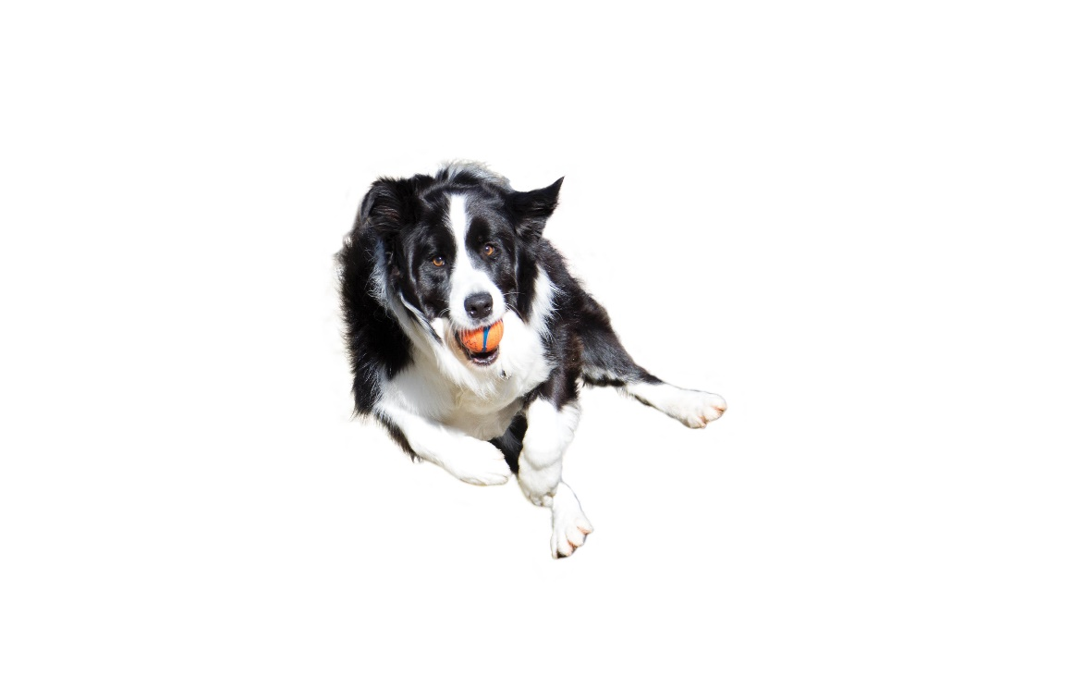
Check in Time: 8:00am
Judges Briefing: 8:30am
Racing Starts: 8:45am
Bayside Flyball Racing would like to welcome all competitors to the Let’s Race at Walters Place competition and we thank you for supporting our competition.

Our Officials for today are:
Judges: Paul Newman Ben Royes
Timekeepers: Mike McChesney Tony Gee
AFA Representative: Kathryn Royes
Comp Organiser: Craig Pearce
First Aid Officer: Alissa Mason
Raffle Coordinator: Pauline Oldman

Housekeeping
Let’s Race at Walters Place, although it is not a public event, all care needs to be taken to ensure the safety of competitors and their dogs. Dogs need to be accompanied on lead by their handler, or restrained in a crate at all times when they are not in the Flyball ring.
No dogs will be permitted in or near the Event food area.
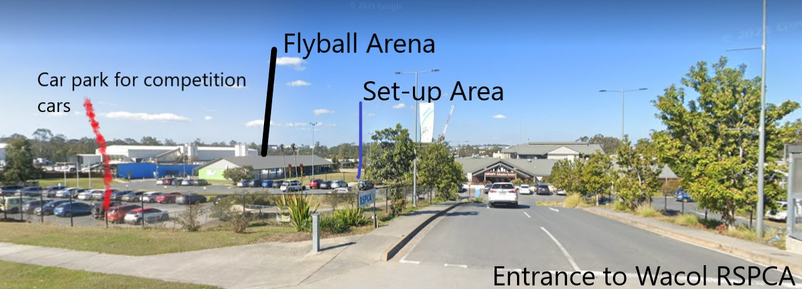

Entry to our Flyball area is off Wacol Station Road. Please follow the entry through to the parking area on the left when entering the RSPCA grounds. Set-up will be located in the fenced area as indicated in the picture above.

Car Movements
As you enter the grounds the temporary car park is located in front of the grassed area beside the flyball arena. After unloading your cars, it is mandatory cars then be moved to the gravel car park (see map). Gazebos can be set up near the outside of the flyball arena. Please ensure you have a crate for your dog.
Toilet location
Toilets are located in the Flyball arena area, at the back of the kitchen area.
Procedures for the day
Teams should avoid setting up gazebo/team areas along the fence line between Field 1 and the shelter building as dogs are walked on the other side of the fence.
• Field 2 is not available for Flyballers unless this has been specifically requested and approved.
• Handlers must pick up after their dogs and dispose of waste in the rubbish bins provided.
• To the North-East of the Flyball Arena next to the Sensory Walk is the Military and Service Working Dog National Monument which recognises the continuing contribution of Military and Law Enforcement dog teams to Australia’s internal and external security. Dogs MUST NOT be toileted in this area. Members observed toileting dogs in this area will face disciplinary action from the AFA.
• Dogs are not permitted off lead anywhere on the premises other than in the racing rings.
• Smoking is NOT permitted anywhere on the campus including the fields and carparking areas.

Canteen
The Black Cat canteen is located in the RSPCA building. Dogs are not permitted to be taken to the canteen area.
The cafe will open at 7.30am for hot drinks and bacon and egg muffins.
To avoid lengthy waits, a pre order system is available for lunches. Order and pay for your lunch when you get your morning coffee and the lunches will be available direct from the cafe servery window at the lunch break. This plan is to avoid lengthy queues and wait times for food.
The lunch menu will contain several varieties of toasties, sandwiches and other “grab and go” items.
Please support the RSPCA through the Black Cat Cafe as they are making a special effort to open two hours earlier than normal and provide an improved service to flyballers.
Please note: Clubs and teams ARE NOT PERMITTED to Cook or use gas on the premises.
Kitchen
The kitchen will have tea, coffee and hot chocolate available during the day.
A very special thankyou to Shireen from Supersonics for kindly donating these items for the day. We would also like to thank Shireen and Anne for manning the kitchen.

Nearest vet (24 hour Emergency Service)
Animal Emergency Service (approx. 9 min drive)
34 Goggs Rd, Jindalee
Ph: 07 3715 9999
Prizes
Bayside Flyball would like to thank our major sponsor Black Hawk for sponsoring today’s Flyball event. Each competitor will receive a gift pack on the day.

Raffle Sponsor Supporters
We have a raffle that would not have been possible without our raffle coordinator, Pauline Oldman. The generous donations come from Wet Nose Production, Antinol, Belmont Chiro, Paw Prints Animal Therapies, Furmilial, Koala Tavern, Animals Love Bowen and Chemist Warehouse Mt Cotton.
Major Raffle Prize
The major raffle prize is Pawsnap Pet Photography the value of $300. We will provide the contact details and address of the businesses.
Raffle tickets are $2 each, 3 for $5, or 6 for $10. If you spend $10 or more on tickets you automatically go into the draw for the major prize. Please see Pauline Oldman to purchase tickets.
The major raffle prize will be drawn at the conclusion of racing on Sunday.

Racing Format
Div | Races | Format | Maximum Heats per Team
1 | Double Round Robin – 8 races per team  First RR Best 3 of 5  Second RR 3 Heat Races | Scratch | 32
2 | Triple Round Robin – 6 races per team  Three RR Best 3 of 5 | Scratch | 30
3 | Triple Round Robin – 6 races per team  Three RR Best 3 of 5 | Handicap | 30
Open | Double Round Robin – 6 Races per Team  Double RR Best 3 of 5 | Handicap | 30

Racing Format
This is an AFA Sanctioned event and will be run in accordance with all the Rules and Policies of the Australian Flyball Association Inc.
AFA Approved Count Back Rules
Count back is based first on head to head RACE wins during competition (where more than two teams are tied, the count back for each team shall be the total RACE wins scored against all the teams that are tied (the combined number of wins); if two teams are still even, the teams are compared on head to head heats; if two teams are still even – then fastest heat time head to head decides the winner.
Seed Times
Division 1 - Scratch
Team | Seed Time
Bayside Blue | 17.462
Paws of Lightning | 17.564
Airborne Growlers | 18.00
Fanatic Force | 18.026
Hypersonics | 18.365

Division 2 - Scratch
Team | Seed Time
Airborne Hornets | 20.078
Paws of Thunder | 20.228
Fanatic Fury | 21.127

Division 3 – Handicap
Team | Seed Time
Bayside Green | 21.60
Fanatic Flare | 24.787
Bayside Yellow | 25.600

Open - Handicap
Team | Seed Time
Bay Racers | 18.00
Backyard Riff Ruff | 22.00
Paws of Mayhem | 24.00
Cross Border Runners | 24.80

Teams
Division 1
Bayside Blue – Seed Time 17.462
 | Dog’s Name | CRN | Jump Height | Handler Name | Breed
1 | Holo | 3142A | 9 | Emma Peters | Border Collie
2 | Ollie | 3219A | 10 | Danielle Healey | Border Collie Mix
3 | Honey | 2940A | 10 | Judy Sorbello | Kelpie x Cattledog
4 | Archie | 3124A | 9 | Sandra Koch | English x American Staffy
6 | Rocco | 2762A | 10 | Annette Wickings | Stumpy Tail Cattledog

Paws of Lighting – Seed Time 17.564
 | Dog’s Name | CRN | Jump Height | Handler Name | Breed
1 | Brandy | 3385A | 9 | Amy Mrak | Border Collie
2 | Wilbur | 2893B | 10 | Nicholas Podmore | Border Collie
3 | Stella | 3400A | 9 | Hayley Brooker | Border collie
4 | Nala | 2893A | 10 | Emma Podmore | Border Collie
5 | Kitana | 857D | 10 | Jenni Crane | Kelpie

Airborne Growlers – Seed Time 18.00
 | Dog’s Name | CRN | Jump Height | Handler Name | Breed
1 | Koda | 2867B | 10 | Connie Blakemore | Australian Kelpie
2 | Izzy | 1222D | 10 | Erin Cooke | Border Collie
3 | Clancy | 2784A | 10 | Penny Parker | Border Collie
4 | Lincoln | 2952A | 12 | Jesse Tosch | Border Collie x
5 | Jem | 2671B | 10 | Sally Elsom | Border Collie
6 | Wednesday | 2952C | 9 | Jesse Tosch | Border Collie

Fanatic Force – Seed Time 18.026
 | Dog’s Name | CRN | Jump Height | Handler Name | Breed
1 | Icon | 444C | 10 | Jane Trezise | Border Collie
2 | Mr Wilson | 2905A | 11 | Kym Gralton | Border Collie
3 | Rusty | 2985A | 10 | Claire Peterken | Cattle cross
4 | Riptide | 2985B |  | Sarah Wieland | Australian Koolie
5 | Soda | 2636B |  | Candice Leighton | Australian Cattle Dog cross

Hypersonics – Seed Time 18.365
 | Dog’s Name | CRN | Jump Height | Handler Name | Breed
1 | Ruby | 2970B | 10 | Ashleigh Royes | Kelpie x
2 | Frankie | 3137A |  | Judy Gee | Kelpie Cross Border Collie
3 | Sadie | 2970A |  | Kathryn Royes | Kelpie x Border Collie
4 | Nixon | 2174C |  | Nealle Best | Cattle Dog Mix
5 | Dekota | 2174B | 10 | Nealle Best | Kelpie X Malinois
6 | Archer | 2970C |  | Kathryn Royes | Kelpie

Division 2
Airborne Hornets – Seed Time 20.078
 | Dog’s Name | CRN | Jump Height | Handler Name | Breed
1 | Benji | 2867A | 10 | Connie Blakemore | Staffy x Collie
2 | Marley | 1222C | 10 | Erin Cooke | Border Collie X Smithfield
3 | Opal | 2812C | 10 | Nicola Dudley | Australian Koolie
4 | Billy | 2952B | 11 | Jesse Tosch | Australian koolie
5 | Scout | 2671A | 10 | Sally Elsom | Border Collie
6 | Daisy | 2779A | 7 | Dianne Penman | Cocker Spaniel

Paws of Thunder – Seed time 20.228
 | Dog’s Name | CRN | Jump Height | Handler Name | Breed
1 | Primrose | 2549B | 10 | Emily Symonds | Border collie
2 | Georgie | 3384A | 8 | Genevieve Pyne | Jack Russell Terrier x Kelpie
3 | Junya | 2758A | 10 | Graeme McGregor | RottyxSharpei
4 | Peanut | 3415A | 10 | Peter Bauer | Kelpie
5 | Judge | 2758B | 10 | Graeme McGregor | Kelpie x Corgi
6 | Maggie | 3401A | 7 | Courtney Nicholas | Spoodle

Fanatic Fury – Seed Time 21.127
 | Dog’s Name | CRN | Jump Height | Handler Name | Breed
1 | Cricket | 2636A | 11 | Candice Leighton | Australian Cattle Dog cross
2 | Fenway | 2905B | 10 | Kym Gralton | Australian Shepherd
3 | Yoshi | 2676B | 10 | Yolanda (May Lan) Wong | Australian Shepherd
4 | Daxter | 3278B |  | Lana Kennedy | Golden retriever cross border collie
5 | Twist | 2975B |  | Anne Hardacre | Flat Coated Retriever
6 | Image | 444D | 10 | Jane Trezise | Border Collie
Division 3
Bayside Green – Seed Time 21.60
 | Dog’s Name | CRN | Jump Height | Handler Name | Breed
1 | Tahni | 1359C | 9 | Craig Pearce | Australian Koolie
2 | Virginia | 2915B | 10 | Nathalie Casalaina | Whippet
3 | Luna | 3393A | 10 | Casey Werder | Border Collie
4 | Missy | 3510A | 9 | Fiona Etherington | Border collie
5 | Koco | 3020A | 10 | Gillian du Plessis | Koolie

Fanatic Flare – Seed Time 24.787
 | Dog’s Name | CRN | Jump Height | Handler Name | Breed
1 | Monty | 2596B | 11 | Sophie Calvert | BORDER Collie
2 | Zest | 3396A | 9 | Natalie Armstrong | Australian Koolie
3 | Leala | 2975A |  | Anne Hardacre | Labrador
4 | Darcy | 845F | 9 | Kerry Wallison | ACD x
5 | Asher | 2650B | 7 | Paul Trezise | Terrier cross
6 | Tilly | 3153A | 7 | Lesley Brumley | Kelpie mix

Bayside Yellow – Seed Time 25.60
 | Dog’s Name | CRN | Jump Height | Handler Name | Breed
1 | Kylo | 1359B | 10 | Craig Pearce | Aust. Koolie
2 | Rexington | 2915A | 10 | Nathalie Casalaina | Whippet x border collie
3 | Charlie | 2726B | 7 | Pauline Oldman | Cocker Spaniel
4 | Pippa | 2873A | 7 | Donna Spencer | Cattle X
5 | Douglas | 2127F | 10 | Anne Newman | Whippet
6 | Yahoo | 3048D |  | Ayla Watt | Koolie x whippet

OPEN
Bay Racers – Seed Time 18.00
 | Dog’s Name | CRN | Jump Height | Handler Name | Breed
1 | Fay | 3466A | 10 | Jade McKeown | Border Collie
2 | Stormy | 3349B | 11 | Alissa Mason | Border Collie
3 | Kaydee | 3034A | 11 | Debbie Stephens | Kelpie x
4 | Cody | 374C | 10 | Keith Fidler | KelpieX
5 | Rocco | 2762A | 10 | Annette Wickings | Stumpy Tail Cattledog
6 | Buddy | 3048A | 10 | Ayla Watt | Staffy x kelpie

Backyard Riff Ruff – Seed Time 22.00
 | Dog’s Name | CRN | Jump Height | Handler Name | Breed
1 | Jerry | 366E | 14 | Hannah Buckley | English Springer Spaniel
2 | Bosco | 3284A | 11 | Maranda Wegrzyniak | Border Collie
3 | Lunar | 3387A |  | Holly Gormley | Kelpie X
4 | Willow | 2460C | 7 | Meredith Pokarier | English Cocker Spaniel
5 | Ivy | 2639B | 7 | Sybil Stoltz | Cocker Spaniel
6 | Tuxedo | 2639C | 7 | Sybil Stoltz | Cocker Spaniel

Paws of Mayhem – Seed Time 24.00
 | Dog’s Name | CRN | Jump Height | Handler Name | Breed
1 | Shay | 371D | 9 | Jan McChesney | Border Collie
2 | Blizzard | 3521A |  | Roger Rooms | Shetland Sheepdog
3 | Venus | 857E |  | Jenni Crane | Kelpie
4 | Whisky | 3490A | 8 | Kim Daley | Labradoodle
5 | Mildred | 3210A | 10 | Jacinta Smith | Cattle dog
6 | Zephyr | 3493A |  | Justice Cameron | Dobermann

Cross Border Runners – Seed Time 24.80
 | Dog’s Name | CRN | Jump Height | Handler Name | Breed
1 | Cool Beanz | 1347C | 8 | Louise Stephen | Puli
2 | Cooper | 2747A | 9 | Peter Samuels | Hungarian Puli
3 | Zuke | 3390A | 12 | Ashley Lonsdale | Border Collie X
4 | Kimkiera Turn Back Time | 3414A | 7 | Melissa Grant | Cocker Spaniel
5 | Kolby | 3181A | 7 | Pauline McAnally | Toy Poodle
6 | Jessie | 3501A | 10 | Katelyn Wright | Kelpie

Bayside Flyball Racing
Would like to thank all the Competitors who attended our Let’s Race at Walters Place competition today, and we hope you have a safe journey home.

